Name: Date:

**Student Exploration:** **Rational Functions**

**Vocabulary:** asymptote, hyperbola, rational function, translation

**Prior Knowledge Questions** (Do these BEFORE using the Gizmo.)

Abby wants to enclose a rectangular area of 20 square feet to use as a garden.

1. Write a function that could be used to find the garden’s length *y* in feet, given its width *x* in feet. *y* =
2. What happens to the length of the 20-square-foot garden as its width   
   gets closer and closer to zero feet?

**Gizmo Warm-up**

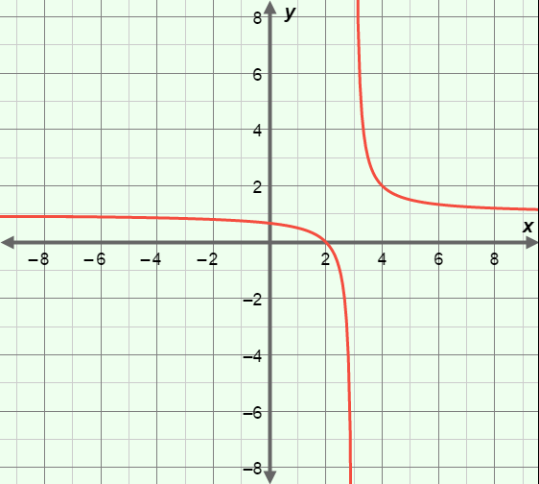In the *Rational Functions* Gizmo, **rational functions** of the form *y* =  + *k* can be graphed. The graph of a function having this form is called a **hyperbola** and has two unconnected branches.

You can vary the values of *a, h,* and *k* by dragging the sliders. To enter a specific value, select the number in the text field, type in the new value, and hit **Enter**.

1. Vary the values of *h* and *k.* Recall that a **translation** of a graph is a horizontal and/or vertical shift.
2. How does changing the value of *h* translate the graph?

1. How does changing the value of *k* translate the graph?

1. Set *h* = 0 and *k* = 0. Now vary the value of *a.*
2. When *a* > 0, in which quadrants are the branches of the graph?
3. When *a* < 0, in which quadrants are the branches of the graph?

|  |  |  |
| --- | --- | --- |
| **Activity A:**  **The function  *y* = + *k*** | Get the Gizmo ready:   * Be sure **Show center and asymptotes** and  **Show domain** are turned off. | 152SE2 |

1. Consider the function *y* = . (Do not use the Gizmo yet.)
2. What happens to the value of the function as the value of *x* gets very large?

1. For what value of *x* is the function undefined? Explain why.

1. In the Gizmo, graph the function *y* =  by setting *a* = 1, *h* = 0, and *k* = 0.
   1. How can you tell from the graph that the function is undefined at *x* = 0?

* 1. Turn on **Show domain**. What value is excluded from the domain?

1. With *y* =  graphed, select the **TABLE** tab. Set **MIN** = –0.06, **MAX** = 0.06, **STEP** = 0.01.
   1. What happens to the value of the function as *x* approaches zero from the left?

* 1. What happens to the value of the function as *x* approaches zero from the right?

1. An **asymptote** is a line that a graph approaches more and more closely.
2. What line appears to be the vertical asymptote of the graph?
3. What line appears to be the horizontal asymptote of the graph?

Check your answers in the Gizmo by choosing the **CONTROLS** tab and turning on **Show center and asymptotes.**

**(Activity A continued on next page)**

**Activity A (continued from previous page)**

1. In the Gizmo, be sure *a* = 1 and *k* = 0. With **Show domain** and **Show center and asymptotes** turned on, vary the value of *h*.
2. How does the value of *h* affect the domain of the function?

1. Why does it make sense that the value of *h* affects the domain in this way?

1. How does the value of *h* affect the vertical asymptote of the graph?

1. Set *a* = 1 and *h* = 0. Vary the value of *k*.
2. How does the value of *k* affect the horizontal asymptote of the graph?

1. Why does it make sense that the value of *k* affects the horizontal asymptote like this?

1. Graph *y* =  by setting *a* = 2, *h* = 0, and *k* = 0.
   1. What are the values of the function when *x* = 1? And *x* = 2?
   2. Now set *a* = 4. How does doubling the value of *a* affect the value of the function for a given *x*-value?
2. Predict the asymptotes and domain of each function. Check your answers in the Gizmo.
3. *y* =  + 4

Asymptotes: *x* = *y* =

Domain:

all real numbers except

1. *y* =  – 1

Asymptotes: *x* = *y* =

Domain:

all real numbers except

|  |  |  |
| --- | --- | --- |
| **Activity B:**  **Applying *a, h,* and *k*** | Get the Gizmo ready:   * Be sure **Show center and asymptotes** and **Show domain** are turned off. | 152SE3 |

1. Consider the rational function *y* =  + 1. (Do not use the Gizmo yet.)
   1. What value of *x* is excluded from the domain of the function?

Explain.

* 1. What are the equations of the vertical and horizontal asymptotes of the graph?

Vertical asymptote: Horizontal asymptote:

* 1. The given function has the form *y* =  + *k*. What are the values of *a, h,* and *k*?

*a* = *h* = *k* = Check your answers in the Gizmo.

1. 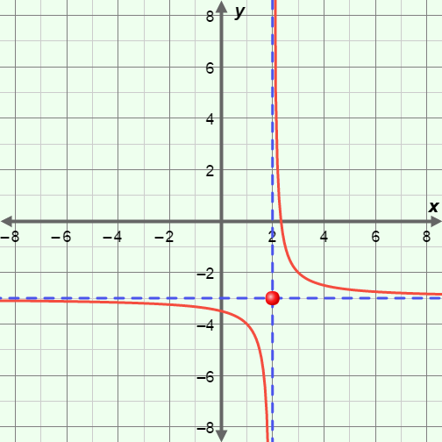The graph to the right shows a rational function of the form

*y* =  + *k.*

* 1. Given that *a* = 1, what is the equation of the function?

* 1. Explain how you know.

Then check your answer in the Gizmo.

1. A rational function of the form *y* =  + *k* has asymptotes at *x* = 4 and *y* = –2.
   1. Write the equations of *two different* functions that meet this description.

Check your answers in the Gizmo.

* 1. Why is it possible to have two different rational functions with the same asymptotes?