Name: Date:

Student Exploration: Reaction Time 1

Vocabulary: bar graph, data, dot plot, median, mode, range

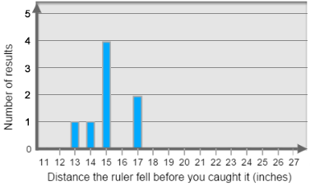
Prior Knowledge Questions
(Do these BEFORE using the Gizmo.)

Sally holds a yardstick in the air, and Mark gets ready to catch it when it drops. When Sally drops the yardstick, Mark tries to catch it as fast as possible. The distances that the yardstick dropped before being caught are shown on the graph.

- What was the most common result? _________

- What was Mark’s best result? _________

- How many times did Mark catch the ruler at 17 inches? _________ 15 inches? _________

- If you had to summarize Mark’s results with a single number, what would you use? _______

Explain. __________________________________________________________________

Gizmo Warm-up
The Reaction Time 1 Gizmo allows you to test your reaction time. Check that Catch the ruler (no sound) is selected and that the Display is a List.

- Select Begin experiment. Hit the spacebar on your keyboard to catch the ruler. After 5 catches, click End experiment. List your results below. (Be sure to include the unit, inches.)

_____________ _____________ _____________ _____________ _____________

- These results form a data set. What was your best result? _______ Worst result? _______

- The range of your data set is the difference between the best result and the worst result.

What was the range of your data? _______ – _______ = _______

Turn on Show statistic and select Range to check your answer.

Activity A:  Click that target! | Get the Gizmo ready:  - Select Click the target (stationary).  - Click Reset, and select the List display.

- In the Click the target (stationary) experiment, you will click on the target as many times as possible. Select Begin experiment, click the target 10 times, and click End experiment.

Results: _____ _____ _____ _____ _____ _____ _____ _____ _____ _____

- Select Click the target (moving). In this experiment, the target will move around as you try to click it. Do you think this will increase or decrease the number of clicks? ______________

- Select Begin experiment. Create a data set with 10 values, and click End experiment. Record your results below.

Results: _____ _____ _____ _____ _____ _____ _____ _____ _____ _____

- Compare the two sets of results. How did the moving target affect your number of clicks?

_________________________________________________________________________

- Select the Dot plot display. One way to describe a data set is the mode, or the most common value. (Note: A data set can have more than one mode. In fact, a data set can also have no mode at all, if all the data values occur the same number of times.)

  - What was the mode of your stationary target clicking experiment? ____________

  - What was the mode of your moving target clicking experiment? ____________

  - Do you think mode is a good way to summarize a data set? Explain why or why not.

___________________________________________________________________

___________________________________________________________________

- Turn on Show statistic and select Mode. Compare the different data displays (list, table, bar graph, dot graph). Which displays make it easiest to see what the mode is? Explain why.

_________________________________________________________________________

_________________________________________________________________________

_________________________________________________________________________

Activity B:  Sight vs. sound reflexes | Get the Gizmo ready:  - Select the Catch the ruler (no sound).  - Click Reset, and turn off Show statistic. | 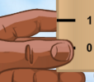
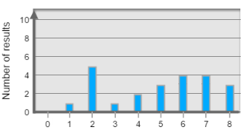
- Look at the “click the target” data set shown at right.

  - What is the mode of this data? ___________

  - Do you think that the mode is the best way to summarize this data set? _______________
  - Explain. ____________________________________________________________

___________________________________________________________________

- The Catch the ruler (no sound) experiment tests your sight reflexes. Click Begin experiment, and catch the ruler 5 times. (To catch the ruler, hit the spacebar on your keyboard.) Then click End experiment.

- List your results, in inches: ______ ______ ______ ______ ______

- Sort the data from smallest to largest: ______ ______ ______ ______ ______
- One way to summarize a data set is the median, or middle number. What is the median of this data set? _______ Turn on Show statistic and Median to check.

- Turn off Show statistic. Now you will test your reactions to sounds. Select the Catch the ruler (with sound) experiment. Check that the sound is on for your computer and speakers.
(If there are many people doing the experiment at once, use headphones if possible.)

Click Begin experiment, close your eyes, and hit the spacebar on your keyboard when you hear the sound. After 5 catches, open your eyes and click End experiment.

- List your results from smallest to largest: ______ ______ ______ ______ ______

- What is the median of this data set? _______ (Turn on Show statistic to check.)

- Based on median, which is faster, your reaction to sight or to sound? __________________

- In this experiment, is median or mode a better way to summarize the data? _____________

Explain. __________________________________________________________________

_________________________________________________________________________

Activity C:  Left hand vs. right hand | Get the Gizmo ready:  - Click Reset.  - Turn off Show statistic. | 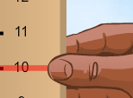

- Choose one of the four experiments – Catch the ruler (no sound) or (with sound), Click the target (stationary) or (moving) – from the dropdown list in the Gizmo.

    - Which experiment did you pick? _________________________________________

    - Are you left-handed or right-handed? _____________________________________

    - Do you think you will have better scores with your left or right hand? _____________

- Do the experiment with your right hand. Record your first 10 results. Check that the Display is a List. Select Show results from smallest to largest, and list them in order below.

Results: _____ _____ _____ _____ _____ _____ _____ _____ _____ _____

What is the unit of your data? ___________

- Look at the ordered list of data. Is there a single number in the middle of this list? ________

- When there is an even number of values in a data set, the median is halfway between the two middle numbers. Circle the two middle numbers in your data set above.

Which number is halfway between the two middle numbers? ________

This is the median of this data set. To check, turn on Show statistic and select Median.

- Turn off Show statistic, and click Reset. Repeat the experiment, but this time use your left hand. Record your results in order, from least to greatest. Circle the two middle numbers.

Results: _____ _____ _____ _____ _____ _____ _____ _____ _____ _____

- What is the median of your left-hand data? ________ (Turn on Show statistic to check.)

- Based on the medians, which hand achieved better results? _________________________

- Look at the four types of Display. Which does the best job of showing median? __________

Explain. __________________________________________________________________

