Vocabulary: Reaction Time 1

dictionary2

**Vocabulary**

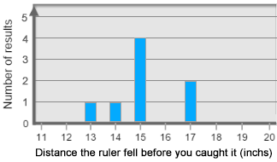

* Bar graph – a graph in which bars are used to represent data.
  + The bar graph at right shows that a distance of 13 inches happened 1 time, a distance of 14 inches happened 1 time, a distance of 15 inches happened 4 times, and a distance of 17 inches happened 2 times.
* Data – pieces of information.
  + A group of related measurements or values is called a *data set*.

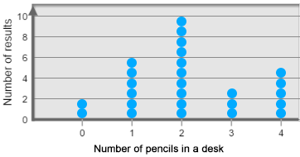

* Dot plot – a graph in which dots are used to represent data.
  + The dot plot at right shows that 2 students have 0 pencils, 6 students have 1 pencil, 10 students have 2 pencils, 3 students have 3 pencils, and 5 students have 4 pencils.
* Median – the middle value in a set of numbers.
  + Before finding the median, all data should be in order from least to greatest.
  + If there are an odd number of values, the median is the middle number. For example, the median of the data set 4, 4, 5, 7, 10 is 5.
  + If there are an even number of values, the median is the mean of the middle values. For example, the median of the data set 4, 5, 7, 10 is  =  = 6.
* Mode – the most common value in a data set.
  + For example, the mode of the data set 4, 4, 5, 7, 10 is 4 because 4 is the most common value.
* Range – the difference between the greatest and least value in a data set.
  + For example, the range of the data set 4, 4, 5, 7, 10 is 10 – 4 = 6.