Name: ______________________________________ Date: ________________________

Student Exploration: Reading Topographic Maps

Vocabulary: contour interval, contour line, depression contour, elevation, gradient, index contour, relief, topographic map

Prior Knowledge Questions (Do these BEFORE using the Gizmo.)
A house sits on the side of a small hill near a lake. The elevation, or height, of each point above the lake is shown by the contour lines on the landscape below.

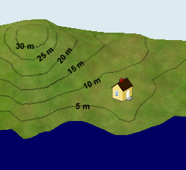
- Suppose it rained for a while, and the lake level rose up 5 meters. Would the house be safe? Explain.

_________________________________________

_________________________________________

- What would happen if the lake level rose 10 meters?

_________________________________________

_________________________________________

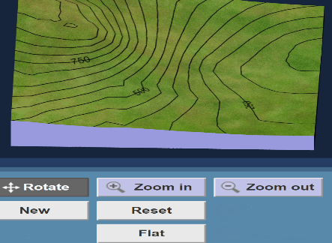
Gizmo Warm-up
A topographic map is a map that contains contour lines to show elevation. Each contour line connects points that are at the same elevation. The Reading Topographic Maps Gizmo allows you to see how a three-dimensional landscape can be represented by a two-dimensional map.

The controls at the top of the Gizmo allow you to manipulate the landscape on the left and the map on the right. Try each tool:
- With the Rotate tool selected, click and drag to turn the map or landscape.
- Select Zoom in and click the landscape several times. Then select Zoom out and click the landscape again to return it to its original size.
- Click the Add button, and then click several times on the landscape or map to add a hill. Then dig a hole using the Subtract tool.
- Change the Contour interval using the slider. The contour interval is the elevation change between contour lines.
- Now use the slider to change the Water level. Look out for a flood!
- Try out any remaining tools and buttons on your own.

Activity A:  Contour lines | Get the Gizmo ready:  - Click Flat to start with a flat landscape.  - Set the Contour interval to 50 m.  - Set the Water level to 0 m. | 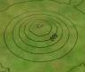

Question: How do contour lines indicate elevation?

- Observe: Select Add, and then click in the center of the landscape exactly four times. Click Horizontal view and use the Zoom in tool to magnify the landscape.

    - What feature have you created? _________________________________________

    - Look at each contour line on the horizontal view at left. What do you notice?

___________________________________________________________________

- Calculate: Notice that one contour line is labeled with an elevation. This is an index contour. The elevation is given in meters above sea level. Because the contour interval is 50 meters, each line above the index contour represents an elevation gain of 50 meters.

    - What is the elevation of the highest contour line on the hill? ____________________

    - What is the elevation of the lowest contour line you can see? __________________

    - What is the maximum height the hill could be? Explain. _______________________

___________________________________________________________________

___________________________________________________________________

    - Raise the Water level until the water is just at the top of the hill. To the nearest 10 meters, what is the actual elevation of the hill? ______________________________

- Create: Reduce the Water level to 0 m, and click Flat. Select the Subtract button and click the center of the landscape exactly three times. Choose the Isometric view.
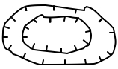
    - What feature have you created? ___________________

In real topographic maps, depression contours are indicated by hachure marks, shown at right.

    - Based on the contour lines, what is the lowest possible elevation of the deepest point in the depression? ________________
    - Check with the Water level slider. What is the lowest elevation? ________________

Activity B:  Slope | Get the Gizmo ready:  - Click Flat.  - Select the Horizontal View. | 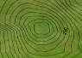

Question: How do contour lines indicate steepness?

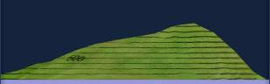
- Create: Use the Add and Subtract tools to create an asymmetrical mountain similar to the one shown at right. The right side of the mountain should be steep, and the left side of the mountain should be gentle.

Compare the landscape to the map. How does the spacing of contour lines relate to the steepness of the mountainside? _______________________________________________
_________________________________________________________________________

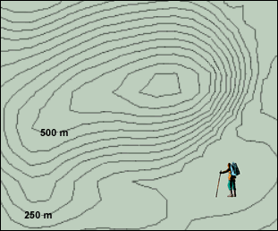
- Apply: A hiker wants to climb a mountain. He is afraid of slopes that are too steep, however.

  - On the map, draw the gentlest route from the hiker to the top of the mountain.

  - What is the contour interval of this map?

________________________________

  - What is the maximum possible elevation of the mountain? __________________

- Calculate: The gradient of a mountainside is a measure of its steepness. Like the slope of a graph, gradient is calculated by dividing the vertical rise by the horizontal distance, or run. If rise is measured in meters and distance in kilometers, the units of gradient are m/km.

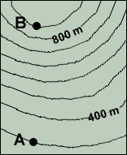
- What is the contour interval of the map at left? ___________

- What is the elevation of point A? ___________

- What is the elevation of point B? ___________

- What is the elevation change between A and B? ___________

- If the horizontal distance between point A and point B is
2.8 km, what is the gradient? _________________________

Activity C:  Interpreting maps | Get the Gizmo ready:  - Click New. | 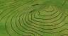

Question: How do we interpret contour maps?

- Observe: Look at the landscape and the corresponding topographic map. Then use the Add and Subtract tools to create each of the following features: a hill, a depression, a ridge, and a valley. Sketch the contour lines that represent each feature in the boxes below. (Note: Don’t forget to put hachure marks on the depression contour lines.)

Hill | Depression
Ridge | Valley

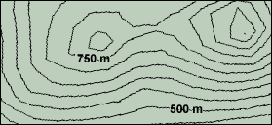
- Calculate: The relief of a contour map is the difference between its highest and lowest points.

What is the estimated relief of this map? ___________

- Practice: Click New. From the Tools menu at lower left, select Screen shot. Right-click the image and select Copy Image. Open a blank document and paste the screenshot. Click New, and repeat this until you have at least 4 maps. Print your document.

For each map in your document, label or state the following:
  - The tallest point on the map and its estimated elevation.
  - The lowest point on the map and its estimated elevation.
  - The relief of the map.
  - The steepest slope on the map.
  - A gentle slope on the map.

In addition, label any hills, ridges, valleys, or depressions that you see. You can even name the mountains, valleys, and other features if you like!

