Name: ______________________________________ Date: ________________________

Student Exploration: Real-Time Histogram

Vocabulary: absolute value, error, histogram, mean, normal distribution, percent error, pulse, range, standard deviation

Prior Knowledge Questions (Do these BEFORE using the Gizmo.)
Every time your heart contracts, it pushes blood through your arteries, causing them to briefly expand. This expansion, called your pulse, can be observed by placing two fingers on the inside of your wrist.

- Feel for your pulse until you find it. (You can ask your teacher for help.) Count the beats for exactly 1 minute. How many beats did you count? _______________________________

- How could you use your pulse to measure a 2-second time interval? __________________

_________________________________________________________________________

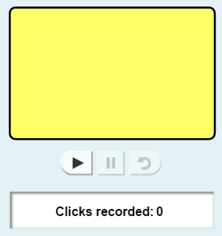
Gizmo Warm-up
To conduct his famous experiments on acceleration, Galileo Galilei needed a way to measure a short interval of time. This was before the invention of the pendulum clock and pocket watch, so Galileo measured time using his own pulse. This worked well as long as he didn’t get too excited about the results of his experiments!

The Real-Time Histogram Gizmo allows you to try your own hand at time estimation. Click Play () to begin. Try to click inside the yellow box every 2 seconds. After 10 clicks, select the TABLE tab on the right side of the Gizmo.

- List your click times below.

______ ______ ______ ______ ______ ______ ______ ______ ______ ______

- Were most of your times greater than or less than 2.00 seconds? _____________________

- The mean (μ) of a data set is a measure of the average value in the set. To find the mean, add up the values and divide by the number of values. (In this case, there are 10 values.)

What is the mean of your data set? _____________________

Activity A:  Feedback vs.  no feedback | Get the Gizmo ready:  - Click Reset ().  - A calculator is recommended for this activity. | 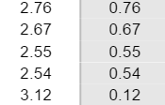

Question: It is possible to view your times as you are doing an experiment. How much does feedback help when you are estimating time?

- Predict: How do you think receiving feedback during the simulation will change your results?

_________________________________________________________________________

_________________________________________________________________________

- Gather data: Select the INSTRUCTIONS tab, and check that the Show statistics checkbox is not selected. Click Play, and test yourself with 10 clicks. When you are done, select the TABLE tab and list your times below.

______ ______ ______ ______ ______ ______ ______ ______ ______ ______

- Calculate: View your results on the TABLE tab.

    - What is the mean (μ) of your data set? ______________________

    - The range of a data set is equal to the difference between the highest and lowest values in the set. What is the range of your data? ______________________
    - The error is the difference between the actual time and the goal time (2 seconds). In the Gizmo, the absolute values of the errors are given.

What are the highest and lowest errors in your data set? ______________________

    - Percent error is a measure of relative error. It is used to compare the errors when you are approximating two different values. To calculate percent error, divide the error by the goal time and multiply by 100.

What are your highest and lowest percent errors? ______________________

- Calculate: Now, calculate the mean (average) error and mean (average) percent error for your data. (Hint: To calculate the mean error, add up all of the errors and divide by 10.)

Mean error: ___________________ Mean percent error: ___________________

Check your calculations by turning on Show statistics.

(Activity A continued on next page)
Activity A (continued from previous page)
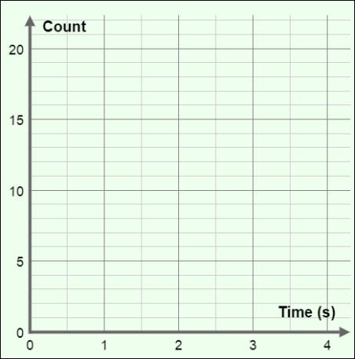
- Analyze: Select the HISTOGRAM tab. A histogram shows how many data points fall into each time interval. You can change the size of the interval using the # of bins slider. For now, set the slider to 8 bins.

    - Draw the histogram in the space at right.

    - According to the histogram, how many times were in the 1.5 – 2.0 second interval? How many were in the 2.0 – 2.5 second interval?

1.5 – 2.0 s: _______ 2.0 – 2.5 s: _______

- Interpret: Select the GRAPH tab. The graph shows the time of each interval between mouse clicks. Based on the graph, did your ability to estimate time improve over time? Explain.

_________________________________________________________________________

_________________________________________________________________________

- Gather data: Click Reset. Select either the TABLE, HISTOGRAM, or GRAPH tab for feedback. Click Play and run the experiment until you have 10 clicks. List the times below.

______ ______ ______ ______ ______ ______ ______ ______ ______ ______

- Calculate: Determine the following values, and then check your answers using the Gizmo.

Mean: ________ Range: ________ Mean error: ________ Mean % error: ________

- Analyze: Look at the histogram and graph of this experiment.

    - How did your ability to estimate time change when you had feedback? ___________

___________________________________________________________________

___________________________________________________________________

    - Why do you think having feedback affected your ability to estimate time in the way that it did? __________________________________________________________
___________________________________________________________________
___________________________________________________________________

Activity B:  Standard deviation | Get the Gizmo ready:  - Click Reset.  - Select the INSTRUCTIONS tab.  - Turn off Show statistics. | 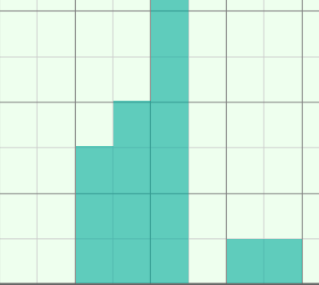

Introduction: Many large sets of data tend to have a normal distribution. A histogram of a normal distribution looks like a bell or a hill. The standard deviation (σ) can be used to describe the shape of a data set’s histogram.

Question: What is the standard deviation, and why is it a useful statistic?

- Interpret: Suppose you were testing two people’s ability to estimate time. The results of each test are shown below. In both data sets, the mean click time was 2.0 seconds and the range of each data set is the same.

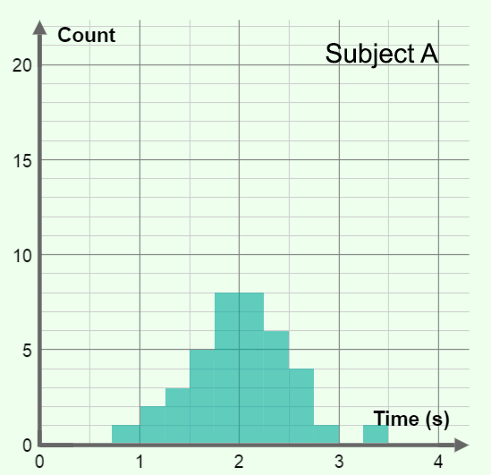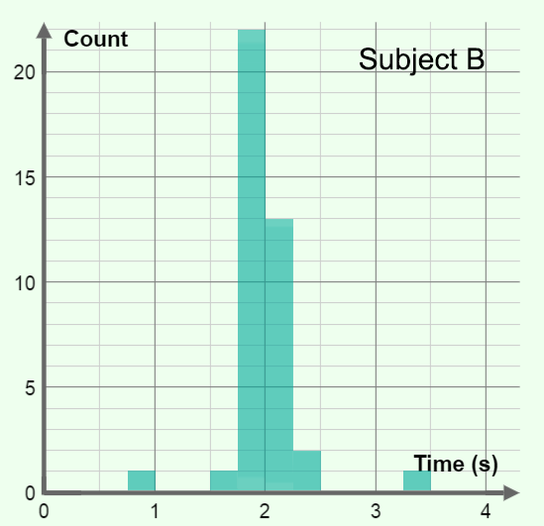

    - Which subject was better at estimating time? Explain. ________________________

___________________________________________________________________

___________________________________________________________________

    - Why is it not enough to know just the mean and range of a data set? ____________

___________________________________________________________________

___________________________________________________________________

- Gather data: Click Play, and run the simulation for just three clicks. Record the three times and the mean time in the space below.

Click times: ______ ______ ______ Mean time: ___________

(Activity B continued on next page)
Activity B (continued from previous page)

- Calculate: The standard deviation is a measure of the spread, or variation, of a data set. The formula for the standard deviation of a complete data set is:
In this formula, σ is the standard deviation. The symbol “Σ” tells you to find the sum of the terms to the right, x_{n} represents the three click times ( x₁, x₂, and x₃), μ is the mean, and n is the number of values.

- Find the value of each term: x₁ – μ = ______ x₂ – μ = ______ x₂ – μ = ______

- Square each of these terms, and then find their sum:

(x₁ – μ )² + (x₂ – μ )² + (x₃ – μ )² = __________

- Divide the sum of the squares by 3: __________

- Take the square root of the result. This is the standard deviation: __________

- Turn on Show statistics to check your answer.

- Gather data: Select the HISTOGRAM tab. Use the Gizmo to create a data set that is as inconsistent as possible. Click the camera () to take a snapshot of this histogram. Right-click the image, click Copy Image, and paste the snapshot into a blank document. List the standard deviation below.

Next, create a second data set in which you try to click as regularly as possible. Paste a snapshot of the associated histogram into your document, and list the standard deviation below. Turn in your document with this worksheet.

Standard deviation of data set 1: ________ Standard deviation of data set 2: ________

- Analyze: Compare the standard deviations and histograms of your two data sets.

    - How is the standard deviation related to the distribution of the data? _____________

___________________________________________________________________

    - Why is standard deviation a more useful statistic than range when describing the distribution of data? ___________________________________________________
___________________________________________________________________
___________________________________________________________________

Extension:  Design an experiment | Get the Gizmo ready:  - Click Reset. | 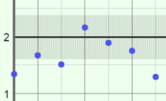

Introduction: There are many ways to estimate the length of a second. Galileo used his pulse. Some say “Mississippi” after each number as they count: one-Mississippi, two-Mississippi, etc. You can design an experiment to find the best technique or investigate a related topic. This experiment could be used as the basis of a science fair project on time estimation.

Choose a question
Here are a few suggestions to get you started. You can choose a topic from this list or come up with a topic on your own.

- What is the best technique for estimating a 2-second time interval?
  - Using your pulse
  - One-Mississippi, two-Mississippi
  - Survey your classmates, teachers, and others to learn of other techniques.
- How does listening to music affect our ability to estimate a 2-second time interval?
- How does feedback affect our ability to estimate a 2-second time interval?
- Are boys or girls better at estimating a 2-second time interval?
- Are children or adults better at estimating a 2-second time interval?

Which question are you going to investigate? ________________________________________

____________________________________________________________________________

Design your experiment
The key to designing a successful experiment is to control your variables. Everything in your experiments should be the same except for the one variable you are investigating. For example, if you are comparing different time-estimation techniques, have each subject try each technique. Feedback should not be available, and be sure that there are no clocks in the room.

Briefly describe your experimental design: __________________________________________

____________________________________________________________________________

____________________________________________________________________________

____________________________________________________________________________

____________________________________________________________________________

____________________________________________________________________________

____________________________________________________________________________

(Extension continued on next page)
Extension (continued from previous page)

Carry out your experiment
A well-designed experiment isn’t any good unless you carry it out according to your plan. Gather data from as many subjects as possible. In general, the more data you collect, the more reliable your results will be. After your data has been collected, analyze the data using the statistical tools (mean error, mean percent error, and standard deviation) discussed in the previous activities. Draw conclusions based on your data, not on what you expected to happen.

In the space below, summarize your results and state your conclusions: ___________________

____________________________________________________________________________

____________________________________________________________________________

____________________________________________________________________________

____________________________________________________________________________

____________________________________________________________________________

____________________________________________________________________________

Present your results
The last step is to present your experiment in a clear and visually appealing way. Include tables and graphs that show the trends in your data. If you are presenting at a school science fair, a nice touch might be to include a computer in your display so passersby can test their own time-estimation ability. Good luck and have fun!

