Vocabulary: Real-Time Histogram

Vocabulary

- Absolute value – the distance of a number from zero.
  - The symbol for absolute value is a pair of straight vertical brackets:
    - |x| is “the absolute value of x.”
  - The absolute value of a number is always positive:
    - |-5| = 5.
    - |3| = 3.

- Error – the difference between an estimated, measured, or observed value and the true value.
  - For example, if the true value is 2.00 seconds and the estimated value is 2.15 seconds, the error is 0.15 seconds.
  - Error is a number showing how much higher or lower a value is from the actual value.
  - Error can be calculated using the following formula:

error = observed value – actual value

- Histogram – a graph that shows how many data points are in each category.
  - On a histogram, the x-axis is divided into equal categories.
  - The y-axis shows how many values are in each category.

- Mean – the sum of a set of numbers divided by the number of items in the set.
  - The mean of a set of numbers is also known as the set’s average.
  - The symbol for the mean is μ.
  - For example, the mean of 4, 4, 5, 7, and 10 is .

- Normal distribution – a data distribution that has a “bell” shape when graphed as a histogram.
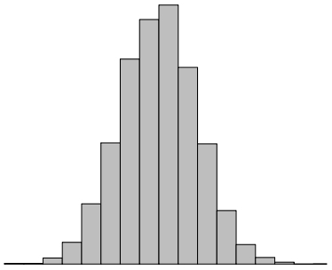

Normal distribution

  - Many kinds of data will tend to have a normal distribution. For example:
    - Weight of adult men
    - Height of adult women
    - Distance that 10-year-old boys can throw a football

- Percent error – the difference between an estimated value and the true value, expressed as a percentage.
  - To calculate percent error, divide the error by the true value and multiply by 100.
  - For example, if the true value is 2.00 seconds and the estimated value is 2.15 seconds, the percent error is:

- Pulse – the regular expansion of an artery caused by the movement of blood.
  - “Pulse” can also refer to the number of times an artery expands in 1 minute.
  - The pulse can be observed by placing fingers on the side of the neck, the inside of the wrist, or the inside of the bicep.

- Range – the difference between the greatest and least value in a data set.
  - For example, the range of the data set 4, 4, 5, 7, 10 is 10 – 4 = 6.

- Standard deviation – a statistic that describes how widely the points of a data set are distributed.
  - The symbol for standard deviation is σ.
  - If data points are very close, the standard deviation will be low.
  - If data points are spread out, the standard deviation will be high.
  - If the data set has a normal distribution, then about 68% of the data will be within one standard deviation of the mean (μ ± σ).

