Name: Date:

**Student Exploration:** **Reflections**

**Vocabulary:** image, line of reflection, perpendicular bisector, preimage, reflection

**Prior Knowledge Questions** (Do these BEFORE using the Gizmo.)

1. Suppose you look at the triangle shown to the right in a mirror. Make a sketch to show what you would see in a mirror represented by the dashed line segment.
2. Suppose you look at the word shown to the right in a mirror. Make a sketch to show what you would see in a mirror represented by the dashed line segment.

YES

**Gizmo Warm-up**

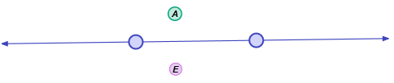In the *Reflections* Gizmo, you will examine the **reflection** (mirror image) of different figures. You will explore the relationship between the original figure (the **preimage**) and the reflected figure (the **image**).

1. Be sure **Point** is selected from the **Figure type** menu, and that **Show reflection** is checked.
2. Drag point *A* upwards. How does point *E* (the reflection of point *A*) move?

1. Drag point *A* downwards toward the line. Where does point *E* go?

1. Drag point *A* below the line. What happens to *E*?
2. The line in the Gizmo is the **line of reflection**.
3. Drag the line upward by the left point to rotate it clockwise. What happens to the distance between point *E* and the line as the line gets closer to point *A*?

1. Continue to rotate the line clockwise. What happens to point *E*?

|  |  |  |
| --- | --- | --- |
| **Activity A:**  **Reflections of points and segments** | Get the Gizmo ready:   * Be sure **Point** is selected in the **Figure type** dropdown menu. * Be sure **Show reflection** is checked. | 194SE2 |

1. 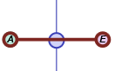Recall that point *E* is the reflection (image) of point *A* (the preimage). Select **Show ruler** to open a Gizmo ruler. Attach the ruler’s “donuts” to points *A* and *E*. Then drag one of the points on the line of reflection until it is on  as shown to the right.
2. What is the distance from *A* to *E*?
3. Use the Gizmo ruler to measure the distances from points *A* and *E* to the line of reflection. Record these distances below.

Point *A* to the line of reflection: Point *E* to the line of reflection:

1. Compare all of the distances you found above. What do you notice?

1. Turn off the ruler and select **Show angle measure tool** to open a Gizmo protractor. Attach the “donuts” to measure the angle that  makes with the line of reflection.

What is the measure of the angle that  makes with the line of reflection?

1. What two words describe the relationship between  and the line of reflection?

1. Turn off the protractor and select the ruler. Attach the ruler to points *A* and *E*. Drag point *A* and the points on the line of reflection. Watch the diagram as you do to convince yourself that the line of reflection is always the **perpendicular bisector** of . Make a labeled sketch in the space to the right to illustrate this fact.

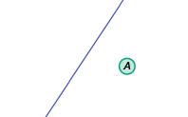

1. On the diagram to the right, sketch the reflection of point *A* over the segment. Label the image point *E*. Then check your sketch by duplicating it in the Gizmo.

**(Activity A continued on next page)**

**Activity A (continued from previous page)**

1. Select **Segment** from the **Figure type** menu. Check that **Show reflection** is turned on.
2. Drag the endpoints of . Watch  as you do. Which point is the image (reflection) of each of the endpoints of *?*

Image of point *A*: Image of point *B*:

1. Compare the lengths of  and . What appears to be true?

Use the Gizmo rulers to check.

1. If point *A* is closer to the line of reflection than point *B*, will point *E* or *F* be closer to the line of reflection? Why? Check your answer in the Gizmo.
2. Suppose  crosses the line of reflection. What will be true about  and the line of reflection? Why? Check your answer in the Gizmo.
3. Two segments that are not shown in the Gizmo are formed by the corresponding endpoints of  and . The line of reflection is the perpendicular bisector of these two segments. Make a labeled sketch of this in the space to the right, using dashed lines for the segments not shown in the Gizmo.
4. Name the segments that are not shown in the Gizmo.
5. On the diagram to the right, sketch the reflection of  over the segment. Label the image . Then check your sketch by duplicating it in the Gizmo.

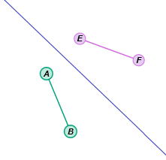

|  |  |  |
| --- | --- | --- |
| **Activity B:**  **Reflections of triangles and quadrilaterals** | Get the Gizmo ready:   * Be sure **Show reflection** is turned on. * Select **Triangle** from the **Figure type** menu. | 194SE6_ |

1. With **Triangle** selected and **Show reflection** turned on, drag the vertices of Δ*ABC* (the preimage) around. Watch the vertices of Δ*DEF* (the image) as you do.
2. List the corresponding vertices of Δ*ABC* and Δ*DEF*.

and and and

1. Does Δ*ABC* appear to be congruent to Δ*DEF*? Use the Gizmo protractors and rulers to check your answer.
2. State whether Δ*EFG* is oriented the same as, or appears to be “backwards” from, Δ*ABC*. Then make a sketch in the space to the right to show this.

1. If one of the vertices of Δ*ABC* lies on the line of reflection, where will one of the vertices of Δ*EFG* lie? Why? Check your answer in the Gizmo.
2. Suppose the line of reflection passes through Δ*ABC*. Will the line of reflection also pass through Δ*EFG*? Explain. Check your answer in the Gizmo.
3. The line of reflection is the perpendicular bisector of segments formed by the corresponding vertices of Δ*ABC* and Δ*EFG*. Name the segments. (The segments are not shown in the Gizmo.)

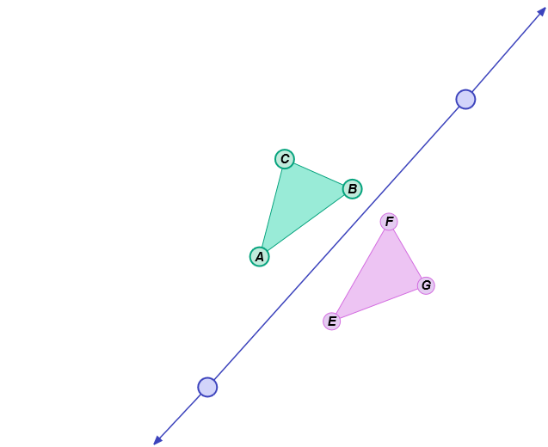

1. On the diagram to the right, sketch the reflection of Δ*ABC* over the segment. Label the image Δ*EFG*. Then check your sketch by duplicating it in the Gizmo.

**(Activity B continued on next page)**

**Activity B (continued from previous page)**

1. Select **Quadrilateral** from the **Figure type** dropdown menu. Be sure **Show reflection** is turned on. Drag the vertices of *ABCD* around. Watch the vertices of *EFGH* as you do.
2. List the corresponding vertices of *ABCD* and *EFGH*.

and and and and

1. Earlier in this activity, you learned that a triangle and its reflection are congruent. Is the same thing true about quadrilaterals? Check in the Gizmo.
2. You also learned that the reflection of a triangle is “backwards” from the triangle. Is this also true about the reflection of a quadrilateral?
3. 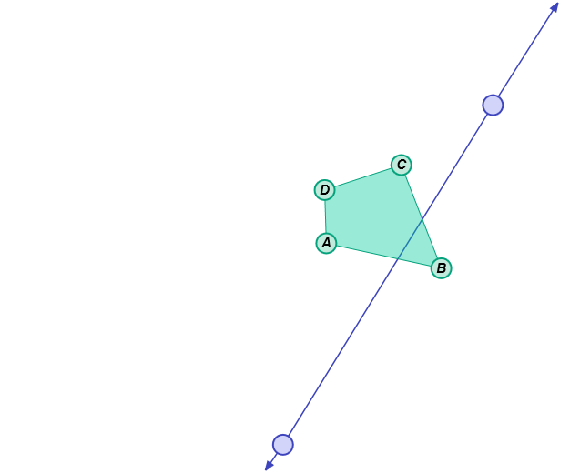On the diagram to the right, sketch the reflection of quadrilateral *ABCD* over the segment. Label the image *EFGH*. Then check your sketch by duplicating it in the Gizmo.
4. Answer each of the following questions about reflections. Then use the Gizmo to check your answers.
5. If  lies on the line of reflection, where does its image  lie? Why?
6. Triangle *EFG* is a reflection of triangle *ABC*. If the line of reflection bisects one side of Δ*ABC*, will it also bisect a side of Δ*EFG*? Make a sketch in the space below to show that your answer is correct.