Vocabulary: Reflections

Vocabulary

- Image – a figure that has been transformed, compared to the original figure (the preimage).
  - Transformations include resizing, reflecting, rotating, or translating a figure.

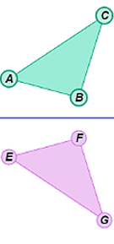
- Line of reflection – a line that a figure is flipped over to create its mirror image.
m
  - In the figure shown to the right, ΔEFG is the reflection of ΔABC, and line m is the line of reflection.
  - If you fold the figure shown to the right along line m, the triangles will match perfectly.

- Perpendicular bisector – a line, segment, or ray that is perpendicular to and bisects a line segment.

- Preimage – the original figure, before being transformed.

- Reflection – a mirror image.
  - In the figure shown above, ΔEFG is the reflection of ΔABC over line m, so ΔEFG is a mirror image of ΔABC.

