Vocabulary: Riemann Sum

Vocabulary

- Riemann sum – an approximation of the area under a curve, often using rectangles.
- The left-hand sum uses a series of equal-width rectangles with their left-hand corners on the curve.
- The right-hand sum uses a series of equal-width rectangles with their right-hand corners on the curve.
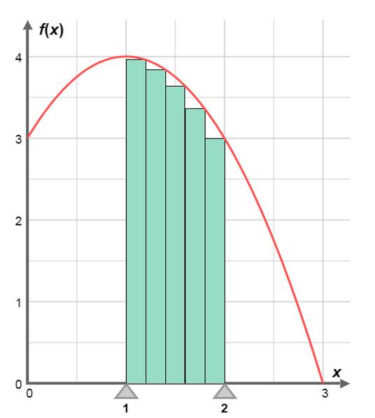
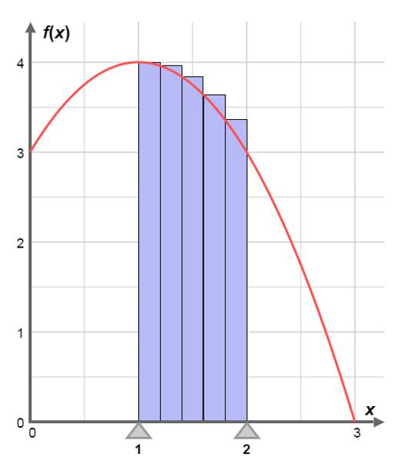
Rectangles for right-hand sum
Rectangles for left-hand sum

