Name: ______________________________________ Date: ________________________

Student Exploration: Ripple Tank

Vocabulary: constructive interference, crest, destructive interference, diffraction, Huygens’ Principle, interference, law of superposition, node, refraction, trough, wave, wavelength

Prior Knowledge Questions (Do these BEFORE using the Gizmo.)

- The image below shows small ripples, or waves, moving through water in a pond. Circle the description below that you think describes the motion of a wave most accurately.

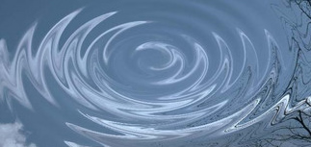
- Each wave consists of a set of water molecules moving outward from the center.

- When a wave passes, water molecules move up and down before returning to near their original position.

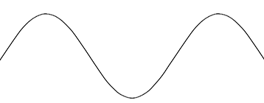
- Waves have crests (high points) and troughs (low points). The wavelength of a wave is the distance between adjacent crests (or troughs). Label the crests, the trough, and the wavelength on the image at left.

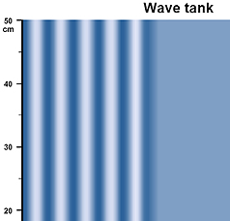
Gizmo Warm-up
A ripple tank, such as the one shown in the Ripple Tank Gizmo, is a shallow pan of water with a vibrating motor that produces waves. The tank is lit from above so that the wave crests and troughs are visible. Ripple tanks are particularly useful because many properties of water waves are shared by other kinds of waves that are harder to see.

Check that Open tank is selected and the Wavelength is
4.0 cm. Click Play () and observe. Click Pause () when the first wave reaches the right edge of the tank.

- The light regions represent troughs while the dark areas represent crests.

About how much simulation time does it take the wave to cross the tank? ____________

- Click Reset (). Set the Wavelength to 16.0 cm, and click Play. Click Pause when the waves reach the edge. How did increasing the wavelength affect the shape and speed of the waves?

_________________________________________________________________________

Activity A:  Wave motion | Get the Gizmo ready:  - Select Barrier with 3-cm gap from the Scenario menu.

Question: What causes wave motion?

- Predict: In this activity, you will test two hypotheses for wave motion. Circle the hypothesis you think is closest to the truth.

Hypothesis 1: Waves are sets of particles moving together due to their forward momentum.

Hypothesis 2: Waves occur when particles transmit energy to other particles in all directions but don’t move far from their original positions.

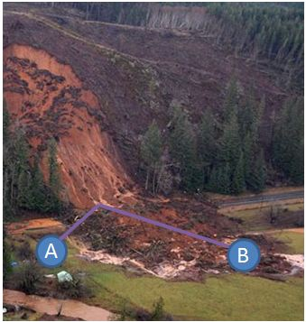
- Make connections: The hypothesis describes how some materials flow. For example, consider the mudslide shown at left. Compared to point A, point B is nearly three times farther from where the mudslide landed at the bottom of the mountain.

Why did the mudslide miss point A but hit point B?

_________________________________________

_________________________________________

Which hypothesis is demonstrated by the motion of the mud? _________________________________

- Predict: The Gizmo shows a barrier with a small gap that waves can pass through. Points A and B are equal distances from the gap.

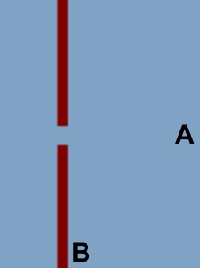
    - If hypothesis 1 is true, which point do you think will be hit by a wave first? Explain.

____________________________________________

____________________________________________

    - If hypothesis 2 is true, which point do you think will be hit by a wave first? Explain.

____________________________________________

____________________________________________

(Activity A continued on next page)
Activity A (continued from previous page)

- Observe: Check that the Wavelength is 9.0 cm, the Wave strength is 1.20, and the waves are Planar. Drag arrows (found on the left side of the Gizmo) to the positions of points A and B on the diagram. Press Play. Click Pause when the first wave reaches point A.

  - What do you notice about the shape of the wave after it passes through the barrier?

___________________________________________________________________

___________________________________________________________________

  - Do the waves reach point A first, point B first, or do they reach points A and B at about the same time? _________________________________________________

- Infer: What do your observations suggest regarding the two hypotheses? _______________

_________________________________________________________________________

The ability of waves to spread from a point such as the gap in the barrier is called diffraction. This ability allows waves to turn corners in ways that individual particles cannot. The fact that waves reached point B at the same time as point A demonstrates that waves in water move differently from the mud in the landslide.

- Challenge: Water waves are caused by individual water molecules moving back-and-forth and up-and-down locally. Because the particles do not move in sync, water piles up in some places and troughs appear in other places. The individual molecules themselves do not move very far compared to the wave we see.

Water piled up in one region (a crest), tends to drain into nearby regions. In fact, each individual point on a crest can be thought of as the source of a new wave. This idea, called Huygens’ Principle, was discovered by the great 17th-century Dutch physicist Christiaan Huygens.

Use Huygens’ Principle to explain how water waves can diffract. If you like, draw a sketch to illustrate your point and attach it to this worksheet.

_________________________________________________________________________

_________________________________________________________________________

_________________________________________________________________________

_________________________________________________________________________

_________________________________________________________________________

_________________________________________________________________________

Activity B:  Diffraction | Get the Gizmo ready:  - Click Reset. Check that the Barrier with 3-cm gap is selected and the Wave strength is 1.20.  - Remove the arrows from the tank.  - Set the Wavelength to 6.0 cm. | 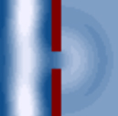

Question: What factors control diffraction?

- Investigate: Click Play, wait for the waves to reach the right side of the tank, and click Pause. Sketch the waves in the left picture. Click Reset, and repeat the procedure with the Barrier with 6-cm gap selected. (You will have to set the Wavelength to 6.0 cm again.)

- Predict: Which wave to you think will diffract through a larger angle when it passes through a barrier with a 10-cm gap: A wavelength of 5.0 cm or a wavelength of 30.0 cm? __________

- Test: Select the Barrier with 10-cm gap. Play simulations with wavelengths of 5.0 cm and
30.0 cm. What do you notice? _________________________________________________
_________________________________________________________________________

- Summarize: In general, what is the relationship between diffraction and the ratio of wavelength to gap width? ____________________________________________________
_________________________________________________________________________

- Apply: A typical sound wave has a wavelength of 1 meter. The wavelength of green light is about 500 billionths of a meter. Which type of wave will tend to diffract more through a narrow gap that is about 1 centimeter wide? Explain.

_________________________________________________________________________

_________________________________________________________________________

Activity C:  Interference | Get the Gizmo ready:  - Select Single central source. Check that the Wavelength is 16.0 cm.  - Set the Wave strength to 1.00. | 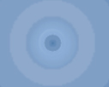

Question: What happens when waves combine?

- Observe: Press Play. Describe the waves you see: _______________________________

_________________________________________________________________________

Where might you see waves like this in nature? ___________________________________

- Observe: Select Two central sources and set the Wave strength to 1.00. Press Play. What do you notice when the waves from the two sources collide? ____________________
_________________________________________________________________________

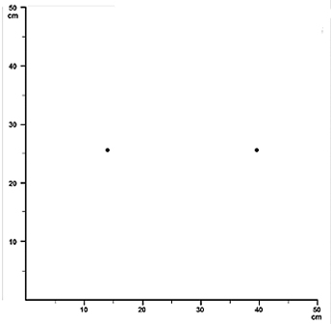
- Sketch: In the box at right, shade in any areas that seem to stay at the same height all the time. (Note: The two wave sources are marked with dots.)

- Conjecture: Why do you think there are places that stay near an average height all the time?

_________________________________________

_________________________________________

_________________________________________

- Analyze: A helpful characteristic of combined waves is that they can be analyzed separately. To calculate the height of a point that is affected by two waves, simply add the heights of each wave. This idea is called the law of superposition.

Suppose the two waves shown below are combined. Sketch what the resulting wave would look like. (Hint: Add up the two waves at each point, and then trace the resulting curve.)
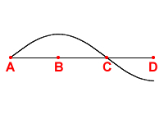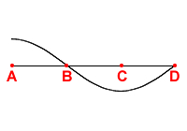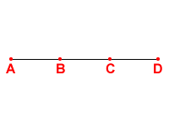
=
+
(Activity C continued on next page)
Activity C (continued from previous page)

- Apply: When two waves affect an area at once, they experience interference. In some cases interference results in larger waves. This is constructive interference. When the result is smaller waves (or no wave at all) it is called destructive interference.

  - In the example from question 5, where did you find constructive interference?

___________________________________________________________________

  - Which region experienced destructive interference? __________________________

- Observe: Click Reset. Set the Wavelength to 32.0 cm and the Wave strength to 1.00. The sources shown in the Gizmo are 24 cm apart. Click Play. Focusing only on the area between the sources, drag arrows to two points where the depth never changes. These points are called nodes and experience destructive interference at all times.

- Sketch: To understand the position of the nodes, consider the first image below. The image shows the waves produced by the left source on top and the waves produced by the second source on the bottom. “C” stands for crest, “T” for trough, and “N” for node. Note that the waves are in sync—crests are produced at both sources at the same time.
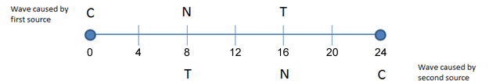
In a certain period of time, both waves will move 4 centimeters. In the image below, label the crests, troughs, and nodes for each wave at this time. (Remember that the top wave moves to the right while the bottom wave moves to the left.)
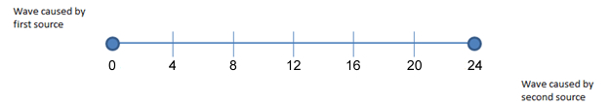

- Observe: In the second image, what do you notice at points 4 and 20? ________________

_________________________________________________________________________

How do these points compare to the nodes you marked in the Gizmo? _________________

_________________________________________________________________________

(Activity C continued on next page)
Activity C (continued from previous page)

- Analyze: In the previous example, points 4 and 20 are nodes because the two waves always cancel out at these points. If there is a crest from the first wave source, there is a trough from the second wave source. Consider the first node, at point 4.

  - How far did the first wave travel to get to point 4? __________

  - How far did the second wave travel to get to point 4? __________

  - What is the difference in these two distances? __________

  - How does this distance relate to the wavelength? ____________________________

In general, if the difference in distances is 0.5 wavelengths, 1.5 wavelengths, 2.5 wavelengths, and so on, the waves will interfere perfectly and the points will be nodes.

- Calculate: Click Reset. Change the Wavelength to 12.0 cm. Fill in the table below. (Note: x is the distance of a point from the left source.) Recall that the sources are 24 cm apart.

x | Distance wave must travel from first source (cm) | Distance wave must travel from second source (cm) | Difference in distances (cm) | Distance difference  Wavelength
3
6
9
12

- Predict: Based on your chart, which distances from the first source will be nodes?

_________________________________________________________________________
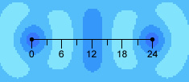
- Test: Click Play and observe. The image at right is taken from the Gizmo with a distance scale superimposed. What do you notice?

_______________________________________

_______________________________________

- On your own: Interference occurs any time waves interact. Explore the interference patterns that occur in the Two gaps and Barrier at edge configurations in the Gizmo. Click the camera () icon to take a snapshot of interesting interference patterns. Right-click the image, and click Copy Image. Paste the images into a blank word document to present your discoveries.

Activity D:  Refraction | Get the Gizmo ready:  - Select Rectangular submerged rock.  - Check that the Wavelength is 10.0 cm and the Wave strength is 1.80.

Question: What happens when a wave is slowed down?

- Observe: Press Play. What happens to the wave when it reaches the submerged rock?

_________________________________________________________________________

- Find a pattern: Try different values for the rock’s Depth. How does this affect the results?

_________________________________________________________________________

_________________________________________________________________________

- Conjecture: Select Slanted submerged rock. Check that the Depth is 25%. What do you think will happen when the wave reaches the rock?

_________________________________________________________________________

_________________________________________________________________________

- Test: Press Play. Click Pause when the waves are halfway across the rock and observe the pattern. Click Play, and then click Pause again when the waves are leaving the rock.

  - What happened to the direction of the waves when they hit the rock? ____________

___________________________________________________________________

  - What happened to the direction of the waves when they moved past the rock?

___________________________________________________________________

- Investigate: Click Reset. The change of direction a wave experiences when it’s speed changes is called refraction. Investigate how the depth of the submerged rock affects the amount of refraction that occurs. Describe your results below.

_________________________________________________________________________

_________________________________________________________________________

_________________________________________________________________________

(Activity D continued on next page)
Activity D (continued from previous page)

- Predict: Select the Elliptical submerged rock. What do you think will occur to the waves as they move past this rock? ____________________________________________________
_________________________________________________________________________

- Observe: Press Play. What did the waves do? ____________________________________

_________________________________________________________________________

- Make connections: How does this scenario relate to the lenses of eyeglasses? __________

_________________________________________________________________________

_________________________________________________________________________

- Analyze: In activity A, it was noted that each point on the crest of a wave can be thought of as the source of a new wave. In fact, a stronger statement can be made. Huygens’ Principle states that the wave formed by all those secondary waves acts exactly like the original wave. This means you can determine what the original wave will do by simply looking at the secondary waves spreading out from points on a crest.
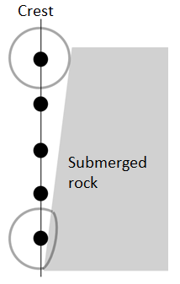
In particular, for each point on the crest, draw a curve representing the wave that will spread out from it. The edge formed by those “mini” waves shows how the whole wave will travel.

The image at the right shows five points on the crest of a wave. A small circle drawn around the top shows a small wave coming out from it. It is a circle because the speed of the wave is the same all around it. Contrast that with the curve drawn around the bottom point. Outside the “Submerged rock” region, it is the same circle, but over the rock it is flattened because the wave moves more slowly there.

Draw similar curves around the other 3 points and then draw a line connecting the right-most edge of each curve. This line describes the angle the wave will have when the water goes over the rock.

