Name: Date:

Student Exploration: Rock Art

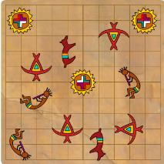
Vocabulary: clockwise, congruent, counterclockwise, image, preimage, reflection, rotation, transformation, translation

Prior Knowledge Questions
(Do these BEFORE using the Gizmo.)

The ruins of a village have been found in a northern New Mexico canyon. The walls of the canyon are covered by colorful artwork. After studying one painting for a while, you realize that it is made of a few different images.

- How many different images do you see? _____

- Draw a rough sketch of the images here:

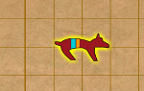
Gizmo Warm-up
The Rock Art Gizmo will help you analyze and then recreate ancient paintings by transforming six images. The art is made by transforming images. A transformation changes the position or direction of an image. There are three transformations you can try in the Gizmo: translations, reflections, and rotations.

- Click on the “dog” so that it is selected. (It should have a yellow glow.) Click each transformation button (Translate, Reflect, and Rotate) and drag the dog around.

Which transformation(s) make the dog face a new direction? _________________________

In the Gizmo, which ones change the dog’s location? ______________________________

- Turn on Show old paintings and check that painting A is selected. Under Art symbols, use the checkbox to add the dog. Then transform the dog to match the painting.

What did you do to match the painting? _________________________________________

_________________________________________________________________________

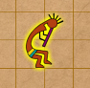  Activity A:  Basics of transformations | Get the Gizmo ready:  - Turn off the Show old paintings checkbox.  - Click New rock.  - Turn on the checkbox below the “flute player.”

To learn about the ancient rock artists, you decide to make some art yourself.

- Select Translate and drag the flute player up 6. Notice that there are now two pictures of the flute player. The original (darker) picture is the preimage. The new picture is the image.

How does a translation affect the image? ________________________________________

_________________________________________________________________________

- Click Remove last. Select Reflect and drag the flute player to the left, across the center.

How does a reflection affect the image? _________________________________________

_________________________________________________________________________

- Click Remove last. Select Rotate and drag the flute player in a circle to the right.

How does a rotation affect the image? __________________________________________

_________________________________________________________________________

- Click Remove last. A rotation can be clockwise (like the hands of a clock) or counterclockwise (the other way around). Practice both kinds of rotations in the Gizmo.

What clockwise rotation is equivalent to a 90° counterclockwise rotation? _______________

- Summarize what you’ve learned about these transformations by answering the following:

  - Do translations, reflections, or rotations affect the size or shape of an image? _____

Explain. ____________________________________________________________

___________________________________________________________________

  - Which transformations change the direction an image is facing? ________________

___________________________________________________________________

  - Which transformation causes an image to “flip over”? ________________________

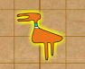  Activity B:  Combinations of transformations | Get the Gizmo ready:  - Click New rock.  - Turn on the checkbox below the “duck.”

Sometimes a single transformation can allow you to achieve your goal. Other times you need to use more than one.
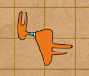
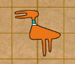
- Look at the images at right. What two transformations will put the duck into the finish position shown?

Transformation 1: ____________________________

Transformation 2: ____________________________ start finish

- Experiment with the Gizmo. How else could you get the duck to the finish position above?

_________________________________________________________________________

- Click New rock, and add the “dog” to the screen. Click Reflect and drag the dog diagonally down to the left, across both axes. This is a Reflection: horizontal and vertical.

What 2 transformations are equivalent to Reflection: horizontal and vertical for the dog?

____________________________________ ___________________________________

- Click New rock, and select the “flute player.” What three transformations are equivalent to Reflection: horizontal for the flute player?

_______________________ _______________________ ______________________

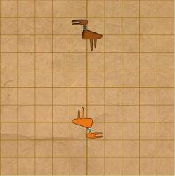
- Click New rock, and select the “duck.” Find three different combinations of transformations that will move the duck to this position.

1. _____________________________________

_______________________________________

2. _____________________________________

_______________________________________

3. _____________________________________

_______________________________________
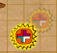  Activity C:  Ancient art | Get the Gizmo ready:  - Click New rock.  - Turn on the Show old paintings checkbox.

Now that you’ve explored transformations, let’s see if you can remake some ancient paintings found on a cliff wall.

- Select painting B. Turn on the “duck” and the “sun” and transform them until you match the ancient painting (the faded images) exactly. When you have finished, list the transformations you used below. (Note: You probably won’t need all 4 transformations for each object.)

“Duck”

  - ____________________________

  - ____________________________

  - ____________________________

  - ____________________________

“Sun”

- ____________________________

- ____________________________

- ____________________________

- ____________________________

- Select the “duck.” Click Replay to see the duck’s transformations in motion again. Then click Remove last until the duck is back where it started. Then do the same transformations you just did, but in the opposite order.

Does the duck’s final position change with the new order of transformations? ____________

Explain. __________________________________________________________________

_________________________________________________________________________

- Select painting C. Select the Art symbols you need and transform them until you match the ancient painting exactly. When you have finished, list the transformations you used below.

“Strongman”

1. __________________

2. __________________

3. __________________

4. __________________

“Flute player”

1. __________________

2. __________________

3. __________________

4. __________________

“Eyeball”

1. __________________

2. __________________

3. __________________

4. __________________

On your own: Click the Random button to try matching other ancient rock paintings. Do as many as you like. Try to solve each challenge using the fewest transformations possible.

