Name: ______________________________________ Date: ________________________

Student Exploration: Rock Cycle

Vocabulary: deposition, erosion, extrusive igneous rock, intrusive igneous rock, lava, lithification, magma, metamorphic rock, rock cycle, sediment, sedimentary rock, soil, weathering

Prior Knowledge Questions (Do these BEFORE using the Gizmo.)

- What happens to hot lava after it erupts from a volcano? _________________________
_________________________________________________________________________

- How does rock turn into soil? _________________________________________________

_________________________________________________________________________

- The Mississippi River carries tons of tiny rock fragments called sediments into the Gulf of Mexico. What do you think will happen to these sediments after a few million years?

_________________________________________________________________________

_________________________________________________________________________

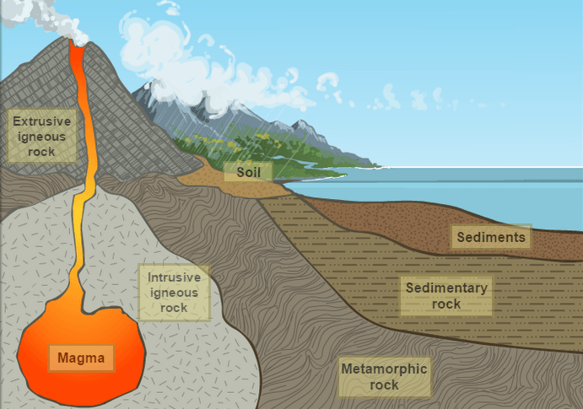
Gizmo Warm-up
Over millions of years, rocks are broken down and transformed into other rocks. The Rock Cycle Gizmo illustrates the different transformations that make up the rock cycle. Before exploring the Gizmo, take a look at the image.

- What types of rocks are shown? __________ ____________________________________
____________________________________

- Magma is molten (liquid) rock under Earth’s surface. Based on the image, how do you think magma turns into extrusive igneous rock? ______________________________________

- Click Extrusive igneous rock button to the right of the image. Were you correct? ________

Activity:  The rock cycle | Get the Gizmo ready:  - Click Start again. | 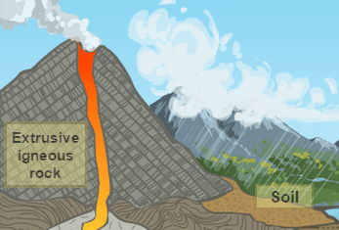

Question: What is the rock cycle?

- Observe: A cycle is a path with the same start and end. Create a rock cycle with the Gizmo.

    - Click Magma. How hot is magma? _______________________________________

    - Click Crystallization (below ground). What kind of rock is formed when magma cools below the surface? _______________________________________________
    - Click Exposure and weathering. What forms when rocks break down? __________

    - Click Erosion and deposition. In what ways are sediments transported? _________
___________________________________________________________________
    - Click Lithification and compaction. (Lithification is hardening into rock.) What kind of rock is formed from sediments? ____________________________________
    - Click Increase temp. and pressure. What kind of rock is formed? ______________

    - Click Melt. What is formed when rocks melt deep underground? ________________

- Describe: Select the PATH tab. What are the steps in this rock cycle? _________________

_________________________________________________________________________

- On your own: On the SIMULATION tab, click Start again. In the spaces below, list three rock cycles. You can start anywhere, but each cycle must begin and end at the same point.

Cycle 1: __________________________________________________________________

_________________________________________________________________________

Cycle 2: __________________________________________________________________

_________________________________________________________________________

Cycle 3: __________________________________________________________________

_________________________________________________________________________

(Activity continued on next page)
Activity (continued from previous page)

- Diagram: The image below summarizes the different stations in the rock cycle. Draw an arrow to represent each possible transition from one rock type to another. Then label each arrow with the process that occurs, such as “weathering” or “erosion and deposition.”

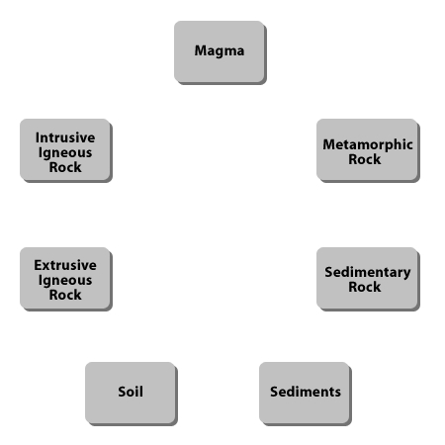

- Practice: List the steps that would cause each transformation below.

    - Intrusive igneous rock sedimentary rock: _____________________________

___________________________________________________________________

    - Metamorphic rock sediment: _________________________________________

___________________________________________________________________

    - Sediment sedimentary rock: __________________________________________

___________________________________________________________________

    - Sedimentary rock sediment: __________________________________________

___________________________________________________________________

