Name: ______________________________________ Date: ________________________

Student Exploration: Roller Coaster Physics

Vocabulary: friction, gravitational potential energy, kinetic energy, momentum

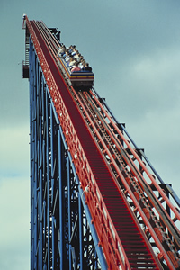
Prior Knowledge Questions (Do these BEFORE using the Gizmo.)
Sally gets onto the roller coaster car, a bit nervous already. Her heart beats faster as the car slowly goes up the first long, steep hill.

- What happens at the beginning of every roller coaster ride?

- Does the roller coaster ever get higher than the first hill?

Explain.

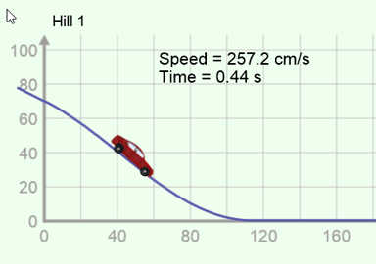
Gizmo Warm-up
The Roller Coaster Physics Gizmo models a roller coaster with a toy car on a track that leads to an egg. You can change the track or the car. For the first experiment, use the default settings (Hill 1 = 70 cm,
Hill 2 = 0 cm, Hill 3 = 0 cm, 35-g car).

- Press Play () to roll the 35-gram toy car down the track. Does the car break the egg?

- Click Reset (). Set Hill 1 to 80 cm, and click Play. Does the car break the egg?

- Click Reset. Lower Hill 1 back to 70 cm and select the 50-gram toy car. Click Play. Does the 50-gram car break the egg? _________

- What factors seem to determine whether the car will break the egg?

Activity A:  Roller coaster speed | Get the Gizmo ready:  - Click Reset.  - Select the 35-g toy car. | 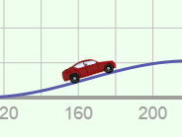

Question: What factors determine the speed of a roller coaster?

- Observe: Set Hill 1 to 100 cm, Hill 2 to 0 cm, and Hill 3 to 0 cm. Be sure the Coefficient of friction is set to 0.00. (This means that there is no friction, or resistance to motion.)

- Click Play. What is the final speed of the toy car?

- Try the other cars. Does the mass of the car affect its final speed?

- Collect data: Find the final speed of a toy car in each situation. Leave the last column blank.

Hill 1 | Hill 2 | Hill 3 | Final speed

40 cm | 0 cm | 0 cm
40 cm | 30 cm | 0 cm
60 cm | 50 cm | 20 cm

60 cm | 0 cm | 0 cm
60 cm | 45 cm | 0 cm
90 cm | 75 cm | 30 cm

- Analyze: Look at the data carefully. Notice that it is organized into two sets of three trials.

- What did each set of trials have in common?

- Did hill 2 have any effect on the final speed?
- Label the last column of the table Total height lost. Fill in this column by subtracting the height of hill 3 from the height of hill 1.

- What do you notice about the Total height lost in each set of trials?

- Draw conclusions: When there is no friction, what is the only factor that affects the final speed of a roller coaster?
What factors do not affect the final speed of a roller coaster?

Activity B:  Energy on a roller coaster | Get the Gizmo ready:  - Click Reset. Select the 50-g car.  - Check that the Coefficient of friction is 0.00.  - Set Hill 1 to 100 cm, and Hill 2 and 3 to 0 cm. | 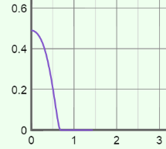

Question: How does energy change on a moving roller coaster?

- Observe: Turn on Show graph and select E vs t to see a graph of energy (E) versus time. Click Play and observe the graph as the car goes down the track.

Does the total energy of the car change as it goes down the hill?

- Experiment: The gravitational potential energy (U) of a car describes its energy of position. Click Reset. Set Hill 3 to 99 cm. Select the U vs t graph, and click Play.

    - What happens to potential energy as the car goes down the hill?

    - What happens to potential energy as the car goes up the hill?

- Experiment: The kinetic energy (K) of a car describes its energy of motion. Click Reset. Select the K vs t (kinetic energy vs. time) graph, and click Play.

- What happens to kinetic energy as the car goes down the hill?
- What happens to kinetic energy as the car goes up the hill?

- Compare: Click Reset. Set Hill 1 to 80 cm, Hill 2 to 60 cm, and Hill 3 to 79 cm. Be sure the 50-g toy car is selected, and press Play. Sketch the U vs t, K vs t, and E vs t graphs below.

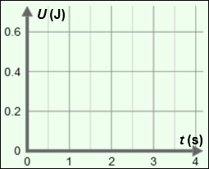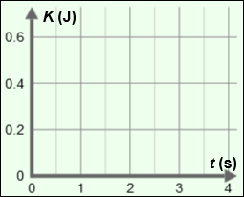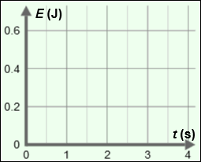

- Draw conclusions: How are potential energy, kinetic energy, and total energy related?

(Activity B continued on next page)
Activity B (continued from previous page)

- Calculate: Gravitational potential energy (U) depends on three things: the object’s mass (m), its height (h), and gravitational acceleration (g), which is 9.81 m/s² on Earth’s surface:
U = mgh
Energy is measured in joules (J). One joule is equal to one 1 kg•m²/s². When calculating the energy of an object, it is helpful to convert the mass and height to kilograms and meters. (Recall there are 1,000 grams in a kilogram and 100 centimeters in a meter.)

- What is the mass of the 50-gram car, in kilograms?

- Set Hill 1 to 75 cm and the other hills to 0 cm. What is the height in meters?

- What is the potential energy of the car, in joules?

- Calculate: Kinetic energy (K) depends on the mass and speed (v) of the object. The equation for kinetic energy is:
K = mv²
With Hill 1 set to 75 cm, click Play and allow the car to reach the bottom.

- What is the final speed of the car, in meters per second?

- What is the kinetic energy of the car, in joules? (Use the mass in kg.)

- How does the car’s kinetic energy at the bottom of the hill compare to its potential energy at the top?

- Challenge: With no friction, you can use the relationship between potential and kinetic energy to predict the speed of the car at the bottom of this hill from its starting height. To do this, start by setting the kinetic and potential energy equations equal to one another:
K = U
mv² = mgh
- Use algebra to solve for the speed. v =

- With no friction, does the final speed depend on the mass of the car?

- With no friction, does the final speed depend on the steepness of the hill?

- What is the final speed of the car if the height of the hill is 55 cm (0.55 m)?

Use the Gizmo to check your answer.

Activity C:  Breaking the egg | Get the Gizmo ready:  - Click Reset.  - Check that the Coefficient of friction is 0.00. | 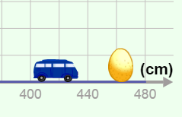

Introduction: As the car rolls down a hill, it speeds up, gaining kinetic energy. The car also gains momentum. The magnitude of an object’s momentum (p) can be found by multiplying the mass and speed (p = mv).

Question: What determines whether the car will break the egg?

- Form hypothesis: Which factor(s) do you think determine whether the car breaks the egg?
- The mass of the car only
- The speed of the car only
- The momentum of the car
- The kinetic energy of the car

- Collect data: Use the Gizmo to find the minimum hill height at which each car breaks the egg. In the table below, fill in the hill height (in centimeters and meters), and the speed of the car (in cm/s and m/s). Leave the last two columns blank for now.

Car mass (kg) | Height (cm) | Height (m) | Speed (cm/s) | Speed (m/s) | Momentum (kg•m/s) | Kinetic energy (J)
0.035 kg
0.050 kg
0.100 kg

- Analyze: Using the equations p = mv and K = mv², calculate the momentum and kinetic energy of each car. Remember to use the kg and m/s values for each calculation. Fill in the last two columns of the table.

    - Does the car’s mass alone determine whether the egg breaks?

    - Does the car’s speed alone determine whether the egg breaks?

    - Does the car’s momentum determine whether the egg breaks?

    - Does the car’s kinetic energy determine whether the egg breaks?

Explain your answers:

- Draw conclusions: What is the minimum energy required to break the egg?

