Name: ______________________________________ Date: ________________________

Student Exploration: Seasons in 3D

Vocabulary: axis, equinox, latitude, Northern Hemisphere, revolve, rotate, solar energy, solar intensity, Southern Hemisphere, summer solstice, winter solstice

Prior Knowledge Question (Do these BEFORE using the Gizmo.)
Both New Zealand and Argentina are in the Southern Hemisphere (south of the equator).

- What time of year would you plan a ski vacation in New Zealand? _____________________

- What time of year would you visit the beaches of Argentina? _________________________

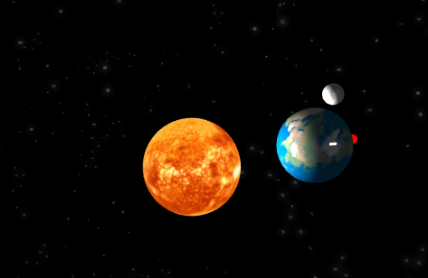
Gizmo Warm-up
Seasons in the Southern Hemisphere are different from seasons in the Northern Hemisphere (north of the equator.) Using the Seasons in 3D Gizmo, you will discover what causes the seasons and learn why seasons are different in each hemisphere.

To begin, move the Sim. speed slider all the way to the right. Click Play () and observe the SIMULATION pane.

- Describe Earth’s movements: _________________________________________________

_________________________________________________________________________

Earth revolves around the Sun and rotates on its axis. On the SIMULATION pane, the axis is represented by a red line.

- Click Reset (), and then click Play again. Look at the side view of Earth at the bottom of the SIMULATION pane.

    - What do you notice about Earth’s axis as Earth revolves around the Sun? ________

___________________________________________________________________

    - When is the Northern Hemisphere tilted toward the Sun? ______________________

    - When is the Southern Hemisphere tilted toward the Sun? _____________________

Activity A:  Height of the Sun | Get the Gizmo ready:  - Click Reset. | 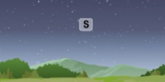

Question: How do seasons compare in the Northern and Southern Hemispheres?

- Compare: A location’s latitude gives its distance north or south of the equator. On the DESCRIPTION pane, set the Latitude to 45.0° (45.0° N). Next, drag the slider at the bottom of the DESCRIPTION pane to set the date to June 21.

- Is the Northern Hemisphere tilted toward or away from the Sun? ________________
- How much light is falling on the Northern Hemisphere compared to the Southern Hemisphere? ________________________________________________________
- Change the date to December 21. On this date, which hemisphere is receiving more sunlight? ___________________________________________________________

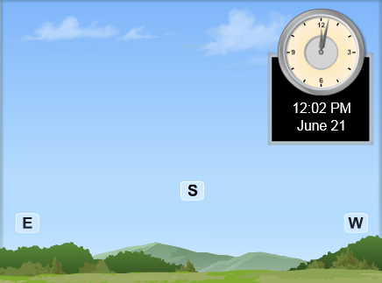
- Observe: Move the Sim. speed slider all the way to the left. Select the 2D VIEW tab and make sure Facing south is selected. Using the slider at the bottom of the Gizmo, set the date to June 21.

Click Play. Click Pause () when the Sun reaches its highest point in the sky. (You can use the Step Back and Step Ahead buttons to get the position exact.) Draw and label that position in the picture at right. Then, find the Sun’s highest point in the sky for December 21, and draw and label that position.

- Analyze: On which date was the noon Sun higher in the sky? ________________________

This date is the summer solstice in the Northern Hemisphere. The date on which the noon sun is lowest is the winter solstice.

- Explain: How does the orientation of Earth’s axis relate to the position of the Sun in the sky?

_________________________________________________________________________

_________________________________________________________________________

_________________________________________________________________________

(Activity A continued on next page)
Activity A (continued from previous page)

- Predict: On the DESCRIPTION pane, set the Latitude to -45° (45° S). For this latitude, on which date do you expect the noon Sun to be highest? Circle your choice.

June 21 December 21

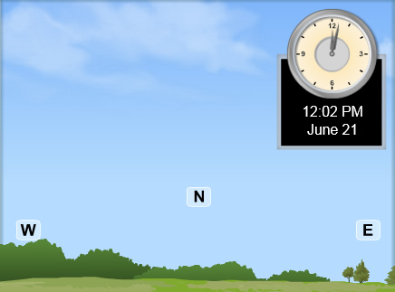
- Observe: Select the 2D VIEW tab and select Facing north.

Set the date to June 21, and click Play. Click Pause when the Sun reaches its highest point in the sky. Draw and label that position in the picture at right. Then, find the Sun’s highest point in the sky for December 21, and draw and label that position.

- Analyze: On which date was the noon Sun higher in the sky? ________________________

- Explain: Why were your results for the Southern Hemisphere opposite of what you found for the Northern Hemisphere?

_________________________________________________________________________

_________________________________________________________________________

_________________________________________________________________________

_________________________________________________________________________

- Infer: Based on the height of the Sun in the sky, at what time of year is it summer in the Southern Hemisphere? When is it winter in the Southern Hemisphere? Explain.

_________________________________________________________________________

_________________________________________________________________________

_________________________________________________________________________

Activity B:  Solar intensity | Get the Gizmo ready:  - Click Reset and make sure the Sim. speed slider is all the way to the left. | 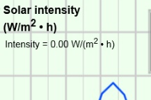

Question: Why is it warmer in summer than in winter?

- Describe: Look up the latitude of your city or town. Set the Latitude to this value.

    - What town do you live in, and what is its latitude? ___________________________

    - What is the temperature of a typical summer day in your town? _________________

    - What is the temperature of a typical winter day in your town? ___________________

- Observe: Select the GRAPH tab. The Day graph shows solar intensity, or the amount of solar energy striking a location in an hour. Set the date to March 21, which is the spring equinox in the Northern Hemisphere. Click Play, and then Pause before 24 hours pass.

    - At what time of day is solar intensity greatest? ______________________________

    - What is the solar intensity at night? _______________________________________

    - Why do you think the solar intensity follows this pattern? ______________________

___________________________________________________________________

- Gather data: Record the solar intensity at noon on March 21. Then record the times of sunrise (solar intensity begins to rise) and sunset (solar intensity returns to zero). Based on these times, calculate the hours of daylight. Repeat for each solstice and equinox.

Date | Noon solar intensity (W/m²h) | Sunrise | Sunset | Hours of Daylight
March 21
June 21
September 23
December 21

- Analyze: Use the table to compare the hours of daylight on the equinoxes (March 21 and September 23) and solstices (June 21 and December 21).

    - What is the longest day of the year? _______________ Shortest? ______________

    - What do you think the word equinox means? _______________________________

(Activity B continued on next page)
Activity B (continued from previous page)

- Explain: Why is the noon solar intensity greater on the summer solstice than on the winter solstice? __________________________________________________________________
_________________________________________________________________________

_________________________________________________________________________

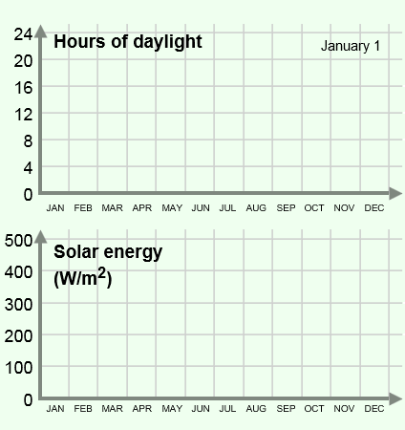
- Observe: Click Reset and move the Sim. speed all the way to the right. On the GRAPH tab, select the Year graph. Click Play. After a year has passed, sketch the resulting graphs at right.

What factors are responsible for the changes you see in the Solar energy graph?

_________________________________________

_________________________________________

_________________________________________

_________________________________________

- Summarize: Seasonal changes are related to the length of a day and the height of the Sun in the sky. Describe how these two factors change throughout a year, and how this relates to the seasonal changes you observe in your home town.

_________________________________________________________________________

_________________________________________________________________________

_________________________________________________________________________

_________________________________________________________________________

_________________________________________________________________________

- On your own: Change the Latitude to the opposite of its current value, and create a year graph for this latitude. Sketch this graph on a separate sheet of paper, describe the patterns that you see in this graph, and explain why the graph looks the way it does. Turn in this graph with this sheet.

