Name: Date:

Student Exploration: Eyes and Vision 1 – Seeing Color

Vocabulary: absorb, cyan, magenta, primary color, prism, reflect, spectrum, secondary color, transparent

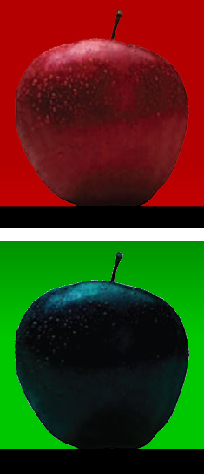
Prior Knowledge Questions (Do these BEFORE using the Gizmo.)
Look at the two photographs. In the top photo, red light is shining on the apple. In the bottom photo, green light is shining on the same apple.

- What do you notice about the two pictures?

- Why do you think the same apple looks red in one photo and nearly black in the other?

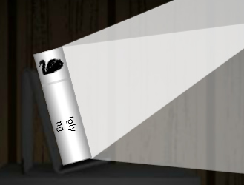
Gizmo Warm-up
The eye is one of nature’s most amazing inventions. In the Eyes and Vision Gizmo, you will explore how the eye sees. The first lesson, Seeing Color, focuses on the light that enters the eye.

- On the LIGHT tab, drag the white The Ugly Duckling book from the shelf onto the stand. Check that the Light mode is White.

- What color of light is hitting the book?

- What color of light is reflecting, or bouncing, off the book?

- What color of light is entering the eye?

- Turn on Show what the eye sees. Does the eye see the book?

- Turn off Show what the eye sees. Click on the light to turn it off.

- Is any light reflecting off the book now?

- Turn on Show what the eye sees. Does the eye see the book now?
Activity A:  Colors of Light | Get the Gizmo ready:  - Remove The Ugly Duckling book from the stand.  - Select the Color light mode.

Introduction: Eyes are designed to detect light. If no light gets in, the eye can’t see. In this activity, you will learn that the colors you see come from light.
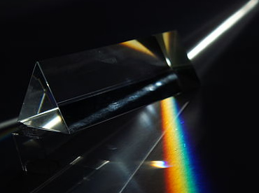
Question: What are the colors of light?

- Observe: The image shows white light going through a solid, triangle-shaped piece of glass called a prism.

What happens to the white light?

The colors you see (red, orange, yellow, green, blue, and violet) are called a spectrum. White light is actually a mixture of all colors. The prism separates white light into these colors, just like rain droplets separate sunlight into the colors of a rainbow.

- Observe: The Gizmo shows three colored lights. These colors are called the primary colors of light. What are the three primary colors of light?

- Explore: Click the blue light to turn it off. What color do you get from mixing red and green light? (Note: Mixing light is not the same as mixing paint.)

- Explore: When primary colors are mixed, secondary colors are made.

- Magenta is a pinkish color that looks like this:

Which two colors of light combine to make magenta?

- Cyan is an aqua color that looks like this:

Which two colors of light combine to make cyan?

- Observe: Now turn on the red, green, and blue lights.

What kind of light is produced where all three light colors come together?

At the start of this activity, you learned that white light can be separated into different colors. White light can also be made by combining equal amounts of red, green, and blue light. These ideas will help you understand why different objects appear to have different colors.
Activity B:  Reflected light | Get the Gizmo ready:  - With Color mode selected, turn off all three lights. | 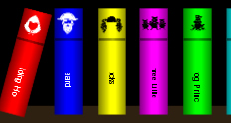

Introduction: When light hits an object, several things can happen. If the object is transparent, like glass, the light will go right through it. If the light doesn’t pass through, it can either be reflected from the surface or it can be absorbed by the object.

Question: Which light colors are absorbed by an object, and which colors are reflected?

- Create a hypothesis: So far, you have learned that white light is a mixture of different colors. What do you think is happening when we see a red apple?

- Observe: Drag Red Riding Hood in the stand, and turn on the red light.

- Is the red light reflected or absorbed by the book?

- Turn off the red light and turn on the green light. Is the green light reflected or absorbed by the book?
- Now try the blue light. Is blue light reflected or absorbed?

- Turn on all three lights. What do you see?

- Change to the White light mode. Recall that white light is a mixture of red, green, and blue light. What do you think is happening when white light hits the red book?

- Predict: Think about what might happen if you did the same experiment with a blue book.

- Which colors of light will be absorbed by the blue book?

- Which color of light will be reflected by the blue book?

- Think about a green book. Which light colors will be absorbed?

- Which color of light will be reflected by the green book?

(Activity B continued on next page)
Activity B (continued from previous page)

- Experiment: Select the Color light mode. Experiment with the blue Blue Beard book and the green The Frog Prince book. After you turn each color on and off, fill in which colors were absorbed and reflected by each book.

Blue Beard Absorbed: Reflected:

The Frog Prince Absorbed: Reflected:

Do these results agree with your prediction?

- Summarize: Circle “absorbed” or “reflected” to fill in each blank.

If the light color is the same as the object’s color, the light will be by the object.

absorbed reflected

If the light color is different from the object’s color, the light will be by the object.

absorbed reflected

- Explain: Think about the apple in different colors of light. Why does the apple appear red in red light, and nearly black in green light?

- Summarize: In general, why do objects have color?

Activity C:  Mixtures of light | Get the Gizmo ready:  - With Color mode selected, turn on all three lights. | 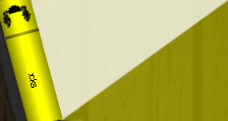

Introduction: Some colors are mixtures of light. What happens when light hits objects that are mixtures of colors?

Question: How do objects that are mixtures of colors absorb and reflect light?

- Think about it: It’s a hot summer day. Your mom tells you not to wear a black shirt because you will get too hot. Why is it better to wear a white shirt than a black shirt when it is hot?

- Predict: Remember that yellow light is a combination of red and green light.

- Which color do you think will be absorbed by a yellow book?

- Which colors do you think will be reflected by a yellow book?

- Experiment: Drag Goldilocks to the stand. Turn each light on and off.

Which color is absorbed? Which colors are reflected?

- Observe: Select Show what the eye “sees” and turn on only the red light.

Why does the yellow book appear red?

Turn off the red light and turn on the green light. Under green light, why does the yellow book appear green?

- Predict: Predict the colors of light that will be absorbed and reflected by the cyan book and then the magenta book. (Hint: Cyan is blue-green and magenta is red-blue.)

Cyan book Absorbed: Reflected:

Magenta book Absorbed: Reflected:

- Experiment: Test your prediction using the cyan book (The Little Mermaid) and the magenta book (The Three Little Pigs). Were your predictions correct?
(Activity C continued on next page)
Activity C (continued from previous page)

- Predict: Which colors do you think will be absorbed and reflected by the white book, The Ugly Duckling?
Try it out with the Gizmo. What did you find?

- Predict: Which colors do you think will be absorbed and reflected by the black book, Cinderella?
Try it out with the Gizmo. What did you find?

- Explain: A pure black surface will absorb all the colors of light and won’t reflect any light. A pure white surface will reflect all the colors and won’t absorb any light. How does this explain why you shouldn’t wear a black shirt on a hot day?

- Summarize: Based on what you have learned, explain why different objects appear to be different colors.

