Vocabulary: Eyes and Vision 1 – Seeing Color

Vocabulary

- Absorb – to take in.
  - Light that is absorbed by an object cannot be seen.

Cyan Magenta
- Cyan – a green-blue color, similar to turquoise.
  - Cyan is a combination of blue and green light.

- Magenta – a pinkish color.
  - Magenta is a combination of red and blue light.

- Primary colors – a set of colors that can be mixed to produce all other colors.
  - The three primary colors of light are red, green, and blue. If all three are combined, the result is white light.
  - Paint and ink have different primary colors. Color printers use cyan, magenta, and yellow ink. Artists use red, yellow, and blue paint.
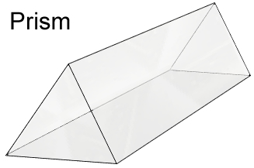
- Prism – a solid glass or plastic object that can divide white light into a spectrum of colors.
  - Prisms often have triangle-shaped bases and rectangular sides.

- Reflect – to bounce back from a surface.
  - Light that is reflected from an object can enter the eye and be seen.

- Secondary color – a color produced by combining two primary colors.
  - If the primary colors are red, green, and blue, then the secondary colors are cyan, magenta, and yellow.

- Spectrum – a band of colors made when white light goes through a prism.
  - The order of colors in a spectrum is red, orange, yellow, green, blue, and violet.

- Transparent – allowing light to pass through.
  - Glass, some plastics, and water are transparent.

