Vocabulary: Segment and Angle Bisectors

dictionary2

**Vocabulary**

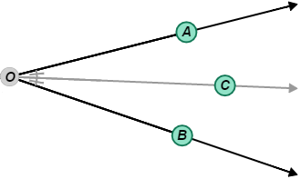

* Angle bisector – a line, or part of a line, that divides an angle into two congruent angles.
  + For example, in the figure to the right, ∠*AOC* is congruent to ∠*COB*, so  bisects ∠*AOB.*
* Perpendicular bisector – a line, or part of a line, that is perpendicular to and passes through the midpoint of a segment.
  + 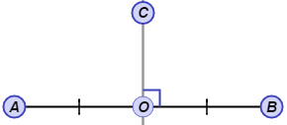For example, in the figure to the right,  is perpendicular to  and point *O* is the midpoint of , so is the perpendicular bisector of .