Name: Date:

Student Exploration: Senses

Vocabulary: auditory cortex, auditory nerve, cerebrum, cone, gustatory cortex, hair cells, hypothalamus, involuntary, nerve impulse, neural pathway, neuron, olfactory cortex, olfactory bulb, optic nerve, rod, sensory neuron, somatosensory cortex, somatosensory nerves, spinal cord, stimulus, thalamus, visual cortex

Prior Knowledge Questions (Do these BEFORE using the Gizmo.)

- What are different types of information that your body can detect from the outside world?

- What organs does your body use to collect the information described in the last question?

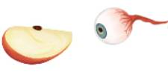
Gizmo Warm-up
Stimuli are changes inside or outside the body that cause a response. In the Senses Gizmo, you will explore how different sense organs detect stimuli from the environment and send messages about that stimulus to the brain.

On the NEURAL PATHWAYS tab, drag the apple slice into the white Stimulus box. Drag the eye into the Sense organ box. Click Play ().

- What do you observe?

- How do you know that the eye senses the apple?

- The neural pathway represents the nerves that connect the sense organ to the brain. What happens along the neural pathway when the eye sees the apple?

Activity A:  Senses and the brain | Get the Gizmo ready:  - On the NEURAL PATHWAYS tab, click  Reset (). | 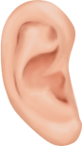

Introduction: The brain is organized into different regions that have different functions. Most sensory information is processed in the cerebrum, the “wrinkly” area that forms the outer part of the brain. The nerves that connect a sense organ to the part of the brain responsible for that sense is called the neural pathway.

Question: What happens when stimuli are detected by sense organs?

- Observe: Drag the apple into the Stimulus box and the tongue into the Sense organ box. Click Play.

- What does the tongue detect?

- What happens along the neural pathway when the tongue detects the stimulus?

The glowing dot represents the transmission of a nerve impulse along the nerves that make up the neural pathway. A nerve impulse is an electrical signal that travels from one nerve cell to another.

- Which part of the brain processes this signal?

- Compare: Click Reset. Select the speaker for the stimulus and the ear. Click Play.

- What part of the brain detects the signal from the ear?

- What are similarities between this pathway and the pathway in question 1?

- Test other stimuli that produce sound. Are all of these stimuli processed in the same part of the brain?

- Explore: Test different combinations of stimuli and sense organs. Are there any cases where the signal is processed by more than one brain region? Are there any cases where the signal is not processed in the brain at all? Explain.

(Activity A continued on next page)
Activity A (continued from previous page)
- Label: Click Reset. Drag the apple to the white “Stimulus” box. Below is a diagram of the brain with arrows to different brain regions. Test each sense organ. Label each part of the brain with its name and the sense organ from which it receives a signal.

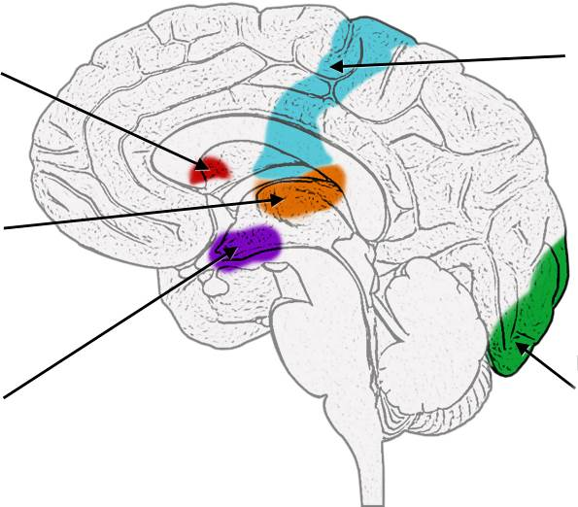

- Compare: Select the pin for the stimulus and the hand for the sense organ. Click Play to watch how the signal is handled by the spinal cord. Click Next, and then Play, to watch how the signal is handled by the brain.

- How are the two pathways different?

- Which path would occur faster, and why is this advantageous?

When a signal is processed by the spinal cord, it is called a reflex. These responses are involuntary, which means they occur without thought.

- Observe: Select the ice cube and the hand. Click Play and observe.

- Which part of the brain processes hot and cold?

- Click Next and Play again. What happens when the signal travels back to the hand?

When the body is cold, a part of the brain called the hypothalamus sends a signal through the spinal cord to the muscles, which start to shiver to generate heat.

Activity B:  Vision and hearing | Get the Gizmo ready:  - Select the SENSE ORGANS tab.  - With Eye selected, click the left circle to enlarge. | 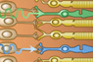
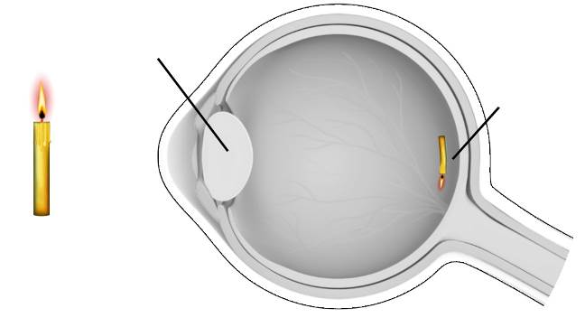

Question: How do the eye and ear detect stimuli?

- Observe: Select Show labels. On the image to the right, label the lens and retina.

Watch the yellow light waves enter the eye. On the image to the right, draw two lines to represent light waves.

What do you notice when light passes the lens?
The focusing of light by the lens results in an upside-down image on the retina.

- Observe: Select the central circle. The squiggly lines represent light waves of different colors. As on the first tab, the glowing yellow dots represent nerve impulses.

- What do you see?

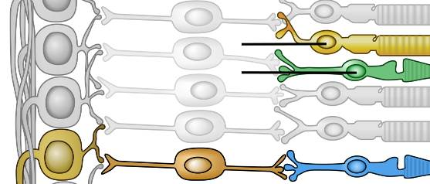
- Turn on Show labels. The retina contains two types of sensory neurons, rods and cones. Label these on the diagram. Turn off Show labels and view the animation carefully.

Which cells detect colors?

- On the diagram, label one path that a signal can follow in order from 1 to 3.

- Describe: Select the right circle. Signals from the eye travel to the brain via the optic nerve.

  - Turn on Show labels. Describe the path of the signal (yellow dot) through the brain.

Most sensory signals are routed through a region of the brain called the thalamus.

  - Read the description above the circles. What happens when the signal reaches the visual cortex?
(Activity B continued on next page)
Activity B (continued from previous page)

- Label: Select Ear. Click on the left circle to watch what happens when sound waves enter the ear. Turn on Show labels.

- Notice there are three main parts to the ear. The outer ear consists of the pinna and ear canal. The middle ear includes everything between the eardrum and cochlea. The inner ear consists of the cochlea and semicircular canals. On the diagram below, label the anvil, cochlea, ear canal, ear drum, hammer, pinna and stirrup.

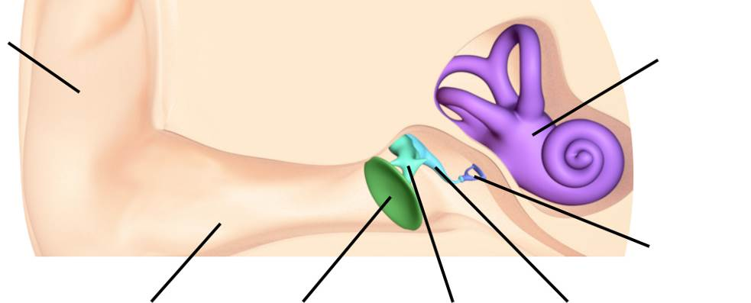

- Describe what sound waves do to the parts of the middle ear.

- Observe: Select the central circle. This is a cellular view of the inside of the cochlea.

- What happens to the hair cells when the basilar membrane vibrates?

- Where does the signal go after leaving the hair cells?

- Observe: Select the right circle. Nerve impulses exit the ear via the auditory nerve and travel to the brain.

  - Describe the path of the signal (yellow dot) through the brain.

  - Read the description above the circles. What happens when the signal reaches the auditory cortex?
Activity C:  Touch, smell, and taste | Get the Gizmo ready:  - On the SENSE ORGANS tab, select Skin. | 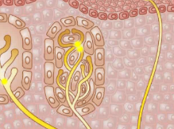

Question: How do the skin, nose, and tongue detect stimuli?

- Observe: Click on the left circle and turn on Show labels.

- Name a few different types of receptors in the skin.

- Why do you think light-touch receptors are found at the skin’s surface while strong-pressure receptors are found deeper down?

- Watch the remaining circles and describe how signals travel from somatosensory nerves to the somatosensory cortex.

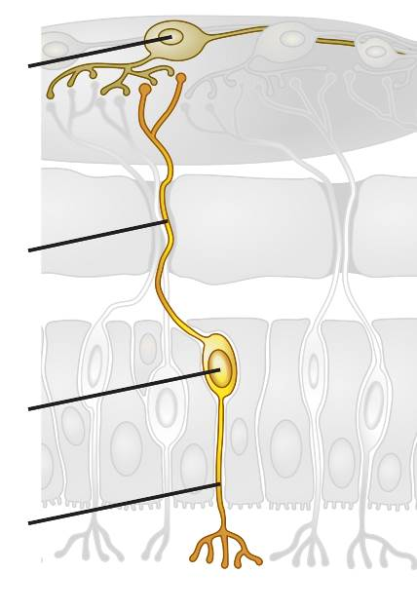
- Observe: Select Nose and enlarge the left circle. Where do the scent particles travel?

- Label: Select the center circle to see the pathway from chemoreceptor cells to the olfactory bulb. Observe the neural signals that are produced when scent particles (white dots) hit the top of the nose.

On the diagram, label the pathway from 1 to 4.

- Observe: Select the right circle. Describe how the signal travels from the olfactory bulb to the olfactory cortex.

Unlike other sensory signals, olfactory signals are not routed through the thalamus.

(Activity C continued on next page)
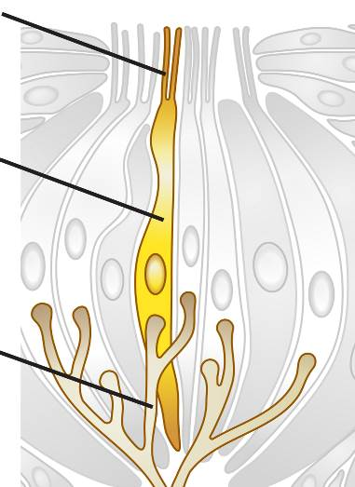
Activity C (continued from previous page)

- Describe: Select Tongue. Click on the left circle. What is the function of lingual papillae?

- Label: Select the central circle to zoom in on a taste bud. Observe the neural signals that are produced when taste particles (white dots) hit the taste bud.

On the diagram, label the path that a signal can follow in order from 1 to 3.

- Observe: Select the right circle. Describe how the signal travels from the sensory neurons in the tongue through the brain to the gustatory cortex.

- Compare: Think about the similarities and differences between the five senses.

- How are the sensory receptors for smell and taste similar?

- How are the sensory receptors for hearing and touch similar?

- In what ways are the sensory receptors for vision different from the others?

- Compare the neural pathways of each sense organ to the brain. How are these pathways similar? Different?

