Name: ______________________________________ Date: ________________________

Student Exploration: Sight vs. Sound Reactions

Vocabulary: histogram, mean, normal distribution, range, standard deviation, stimulus

Prior Knowledge Questions (Do these BEFORE using the Gizmo.)
Most professional baseball pitchers can throw a fastball over 145 km/h (90 mph). This gives the batter less than half a second to read the pitch, decide whether to swing, and then try to hit the ball. No wonder hitting a baseball is considered one of the hardest things to do in sports!

- What are some things in your life you must react to quickly? _________________________

_________________________________________________________________________

- In general, do you think you have quick, slow, or average reactions? __________________

Explain. __________________________________________________________________

Gizmo Warm-up
A stimulus is something that can cause you to react. A stimulus can be something you see (visual stimulus), something you hear (auditory stimulus), something you touch (tactile stimulus), or something you smell (olfactory stimulus). In the Sight vs. Sound Reactions Gizmo, you will compare your reactions to visual and auditory stimuli.

To start, check that the Test is Sight. Click the Start button. When you see a red circle, immediately click your mouse. Take the test until the results appear.

- The Time from each event is the time (in seconds) between when the symbol appears and when you clicked the mouse. This is your reaction time.

What was your best reaction time? _____________________

- The mean (μ) of a data set is a measure of the average value in the set.

What is the mean of your data set? _____________________

- In many cases, the results of a test follow a normal distribution, or a bell-shaped curve.

Select the GRAPH tab. Is this graph shaped like a bell? _____________________

Activity A:  Interpreting data | Get the Gizmo ready:  - Click Clear data.  - Check that the Test is Sight, the symbol is a Circle, and the color is Red. | 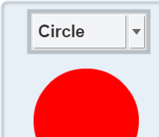

Question: How can you describe a data set?

- Gather data: Click Start and run a test with the Gizmo. Record your results below.

Reaction times (seconds)

- Calculate: To calculate the mean of a data set, add the values and then divide by the number of values in the set.

    - What is the sum of the reaction times in the table above? _____________________

    - How many values are in the data set? _____________________

    - What is the mean of this data set? _____________________

- Calculate: The range of a data set is equal to the difference between the highest and lowest values in the set. To find the range, subtract the lowest value from the highest value.

    - What is the highest value in your data set? ____________ Lowest? ____________

    - What is the range of this data set? _____________________

- Calculate: The standard deviation (σ) of a data set describes how closely the values in the set are bunched together. The standard deviation is listed on the SIMULATION pane.

    - What is the standard deviation of this data set? _____________________

    - Add and subtract the standard deviation (σ) from the mean (μ).

μ + σ = ____________ μ – σ = ____________

    - How many values in the set are within one standard deviation of the mean? _______

(Activity A continued on next page)
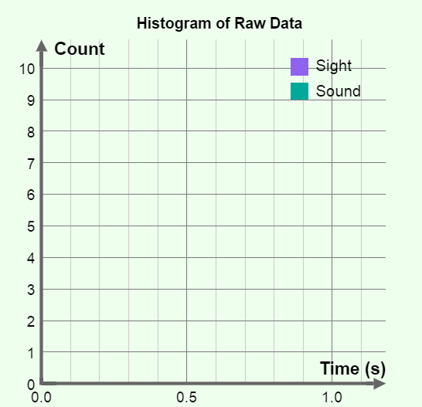
Activity A (continued from previous page)

- Interpret: Look at the GRAPH tab. This graph is called a histogram. It shows how many values in the data set fall into each time category. Sketch the histogram of your data set in the diagram at right.

What is the shape of this histogram? ___________

_________________________________________

_________________________________________

_________________________________________

- Analyze: If a data set has a normal distribution, then approximately 68% of the values in the set should be within one standard deviation of the mean (μ ± σ).

    - What percentage of the values in your data set is within one standard deviation of the mean? ____________
    - Based on this fact and the shape of the histogram above, do you think your data set has a normal distribution? Explain. _______________________________________
___________________________________________________________________
___________________________________________________________________

- Experiment: On the GRAPH tab, click Clear data. This time, try to vary your response times randomly as you take the test. Click Start and take the test.

    - What is the mean of this new set of values? _____________________

    - What is the range of this set? _____________________

    - What is the standard deviation of this set? _____________________

- Analyze: How does the standard deviation relate to the consistency and range of a data set?

_________________________________________________________________________

_________________________________________________________________________

_________________________________________________________________________

_________________________________________________________________________

Activity B:  Visual and auditory stimuli | Get the Gizmo ready:  - Click Clear data.

Introduction: We perceive stimuli through nerve cells in our eyes, ears, nose, tongue, and skin. When a nerve cell is stimulated, it sends an electrical signal to the brain. After the signal is processed by the brain, other signals are sent to our muscles as we react to the stimulus.

Question: Do we react more quickly to visual or auditory stimuli?

- Form hypothesis: Do you think you will react more quickly to sights or sounds? Explain why.

_________________________________________________________________________
_________________________________________________________________________
_________________________________________________________________________

- Gather data: Select the TABLE tab. Use the Gizmo to run five trials of the Sight test and five trials of the Sound test. Click Same exam to start another trial, and New exam to switch to a different type of test. Use the same visual symbol and the same sound for each trial.

In the tables below, record the mean reaction time and standard deviation (σ) for each trial.
In addition, record the maximum value and minimum value from each test. You will have to record these from the SIMULATION pane at the end of each test.

Sight tests

Trial | Mean | σ | Max. | Min.
1
2
3
4
5

Sound tests

Trial | Mean | σ | Max. | Min.
1
2
3
4
5

- Analyze: What patterns do you notice in your data? ________________________________

_________________________________________________________________________

_________________________________________________________________________

_________________________________________________________________________

(Activity B continued on next page)
Activity B (continued from previous page)

- Interpret: Select the GRAPH tab to see a histogram of your data. Use the zoom controls (the “+” and “–” symbols to the right of the graph) to adjust the graph so the data is clearly visible.

What does this histogram show? _______________________________________________

_________________________________________________________________________

_________________________________________________________________________

- Summarize: Based on the results of your experiments, do you react more quickly to visual or auditory stimuli? Explain. _____________________________________________________
_________________________________________________________________________

_________________________________________________________________________

_________________________________________________________________________

- Think and discuss: The auditory nerve connects your ears to your brain. It measures about 2.5 cm long. The optic nerve connecting your eyes to your brain measures about 5.5 cm long. How does this information relate to the results of your experiment?

_________________________________________________________________________

_________________________________________________________________________

_________________________________________________________________________

- Apply: Based on what you’ve learned, describe a safety device that could be used to warn drivers or pilots of an impending collision.

_________________________________________________________________________

_________________________________________________________________________

_________________________________________________________________________

_________________________________________________________________________

Extension:  Design an experiment | Get the Gizmo ready:  - Click Clear data. | 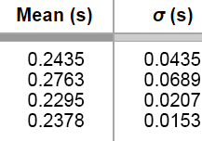

Introduction: The Sight vs. Sound Reactions Gizmo can be used for a science fair project or other experiment. The first step is to come up with an interesting question to investigate.

Choose a question
Here are a few suggestions to get you started. You can choose a topic from this list or come up with a topic on your own.

- Which is faster, our reaction to sights or our reaction to sounds?
- Does the type of symbol or color of symbol affect reaction time?
- Does the volume of a sound affect reaction time?
- Does the type of sound affect our reaction time?
- Does age affect reaction time?
- Does gender affect reaction time?
- Do some groups of people (such as athletes or video game players) have better reaction times than others?
- Does what we eat or drink affect reaction time?
- How do various distracters (music, talking, flashing lights, etc.) affect reaction time?
- Do different types of computers result in different reaction time measurements?

Which question are you going to investigate? ________________________________________

____________________________________________________________________________

Design your experiment
The key to designing a successful experiment is to control your variables. Everything in your experiments should be the same except for the one variable you are investigating. For example, if you are comparing the visual reaction times of boys and girls, they should use the same symbol and color. Be sure that the test environment is the same for each participant.

Before beginning the experiment, explain your project and experimental design to your teacher. Ask if there is any paperwork that you need to fill out. (Many science fairs require specific paperwork to be filed for any project involving human subjects.)

Briefly describe your experimental design: __________________________________________

____________________________________________________________________________

____________________________________________________________________________

____________________________________________________________________________

____________________________________________________________________________

(Extension continued on next page)
Extension (continued from previous page)

Carry out your experiment
A well-designed experiment isn’t any good unless you carry it out according to your plan. Gather data from as many subjects as possible. In general, the more data you collect, the more reliable your results will be. After your data has been collected, analyze the data using the statistical tools (mean, range, and standard deviation) discussed in the previous activities. Draw conclusions based on your data, not on what you expected to happen.

In the space below, summarize your results and state your conclusions: ___________________

____________________________________________________________________________

____________________________________________________________________________

____________________________________________________________________________

____________________________________________________________________________

____________________________________________________________________________

____________________________________________________________________________

Present your results
The last step is to present your experiment in a clear and visually appealing way. Include tables and graphs that show the trends in your data. If you are presenting at a school science fair, a nice touch might be to include a computer in your display so passersby can test their own reaction times. Good luck and have fun!

