Vocabulary: Similarity in Right Triangles

dictionary2

**Vocabulary**

* Geometric mean – the positive number *x* such that  = , where *a* and *b* are positive numbers.
  + For example, the geometric mean of 2 and 18 is 6, because  = .
* Note that 2 • 3 = 6, and 6 • 3 = 18.
* Also note that the *arithmetic mean* of 2 and 18 is 10, since  = 10.
  + The two *x*’s are called the *means* of the proportion  = , and *a* and *b* are called the *extremes*.

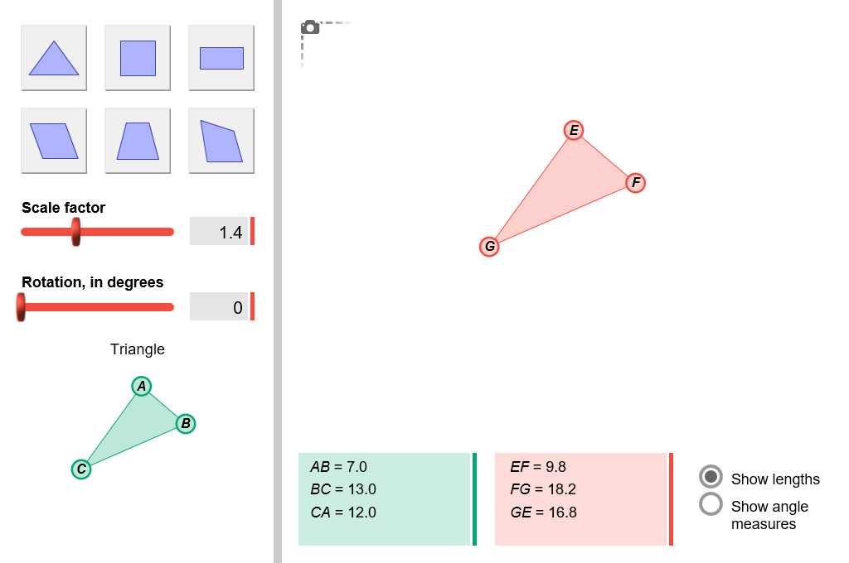

* Similar – having the same shape, but not necessarily the same size.
  + The symbol ∼ means “is similar to.”
  + Two polygons are similar when all corresponding angles are congruent.
* For example, in the figure to the right,   
  Δ*ABC* ∼ Δ*EFG*.