Name: Date:

**Student Exploration:** **Simplifying Trigonometric Expressions**

**Vocabulary:** identity, trigonometric function

**Prior Knowledge Questions** (Do these BEFORE using the Gizmo.)



***a***

***b***

***c***

The Pythagorean Theorem states that for all right triangles   
*a*2 + *b*2 = *c*2, where *a* and *b* are the lengths of the legs, and *c* is the length of the hypotenuse.

1. The right triangle shown at the right is drawn on a unit circle (radius = 1). Use the diagram to help you fill in the blanks:

*a* = *y* = *b* = *x* = *c* =

1. Substitute your answers from above into the Pythagorean Theorem. What do you get?

*a*2 + *b*2 = *c*2 + =

**Gizmo Overview**

In the *Simplifying Trigonometric Expressions* Gizmo, you will be given expressions involving the six **trigonometric functions**. Your job is to simplify them. To do so, you can make strategic substitutions, using trigonometric **identities** (equations that are always true).

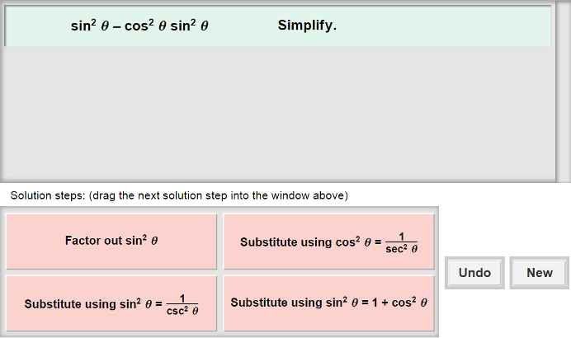Here’s how the Gizmo looks at first:

The expression for you to simplify is here.

The tiles give you four choices for the next step. Choose the one you think is correct and drag it into the white area above.

Click **New** to go to a different problem.

Click **Undo** to undo your last choice.

Read your feedback in the Gizmo.

(No feedback is given for correct answers.)

Click **Proceed** to go to the next step.

Continue until the expression is simplified. Then click **New** for a new problem to work on.

|  |  |  |
| --- | --- | --- |
| **Activity:**  **Simplifying expressions** | Get the Gizmo ready:   * You should see the expression cos *θ* csc *θ* . If not, click **Refresh** in your browser. |  |

1. 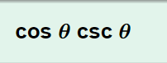When you begin, you should see the expression shown to the right at the top of the Gizmo.
2. What is the relationship between sine and cosecant?
3. In the Gizmo, choose the correct first step. If your choice is incorrect, read the given feedback and try again. What simplified expression did you get?
4. Choose the next correct step. What is the answer?
5. If you were working this by hand, how would you know that this is the final answer?

1. Click **New**. You should now see the expression shown at the right in the Gizmo.
2. Do you think a Pythagorean identity would be helpful in this case?

Explain.

1. Choose the correct substitution. What is the new expression?
2. How can you use the relationship between cosine and secant to simplify the expression?
3. Choose the next correct step. The expression should now be  • cos2 *θ* . What is the product of any expression and its reciprocal?
4. Choose the correct last step. What is the final answer?
5. Click **New**. Work through more problems in the Gizmo. Be sure to read the feedback.

**(Activity continued on next page)**

**Activity (continued from previous page)**

1. Simplify each expression below. Write all your steps in the space below each problem.
2. sin *θ* cot *θ*
3. 
4. sec *θ* cos *θ* – cos2 *θ*
5. sec2 *θ* – tan2 *θ*
6. cos2 *θ* + tan2 *θ* cos2 *θ*
7. 
8. sin *θ* sec *θ* cot *θ*
9. tan2 *θ* – sin2 *θ*