Name: Date:

**Student Exploration: Sine Function**

**Vocabulary:** odd function, period, radian, reference triangle, sine, trigonometric function,   
unit circle

**Prior Knowledge Questions** (Do these BEFORE using the Gizmo.)

sin(*θ*) = 

1. The **sine** of angle *θ* of a right triangle is the length of the opposite leg divided by the hypotenuse.

**5**

**4**

**3**

***θ***

The legs of the right triangle to the right have lengths of 3 units and 4 units, and the hypotenuse is 5 units.

What is the sine of angle *θ*? sin(*θ*) =

***θ***

***x***

***y***

***r***

**(*x*, *y*)**

1. A right triangle is placed in a circle whose center is at the origin of a coordinate plane, as shown to the right.
2. What is sin(*θ*)? sin(*θ*) =
3. What is sin(*θ*) if *r* = 1? sin(*θ*) =

**Gizmo Warm-up**

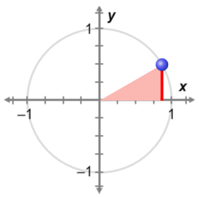

***θ***

The sine function *y* = sin(*θ*) is a **trigonometric function**. When *θ* is in standard position, with its vertex at the center of a circle, sin(*θ*) is the   
*y*-value of the point where *θ* intersects the circle. In the *Sine Function* Gizmo, you will explore the sine function and its graph.

1. On the **SINE** tab, turn on **Show reference triangle**. Then, with **Degrees** selected, drag the slider slowly from 0° to 180°.
2. What happens to the value of sin(*θ*) as *θ* goes from 0° to 180°?

1. When does the maximum value of sin(*θ*) occur?
2. Explain why the behavior of sine from 0° to 180° makes sense, based on the unit circle.

|  |  |  |
| --- | --- | --- |
| **Activity A:**  **The basics of sine** | Get the Gizmo ready:   * On the **SINE** tab, be sure **Degrees** and **Show reference triangle** are selected. * Set ***θ*** to 0°. | D:\157\157(2).png |

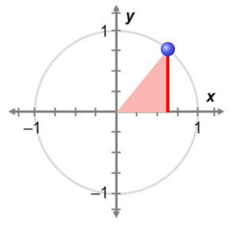

***θ***

**(cos(*θ*), sin(*θ*))**

***y***

***x***

**1**

The circle shown in the Gizmo has a radius of 1, so it is a **unit circle**. Angle *θ* is formed by the radius of the circle and the positive *x*-axis. The sine of *θ* is the *y*-value of the corresponding point on the unit circle.

The right triangle formed by the perpendicular segment drawn from the terminal ray of *θ* to the *x*-axis is called a **reference triangle**.

1. Set ***θ*** to 0°, so the blue point is at (1, 0). (To quickly set ***θ*** to a specific value, type the value in the text box, and hit **Enter**.) Then drag the point counterclockwise around the circle once.

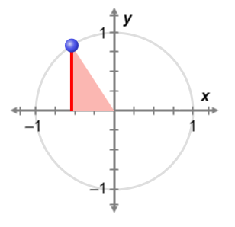

***θ***

**(cos(*θ*), sin(*θ*))**

***x***

***y***

**1**

1. When is sin(*θ*) positive?
2. When is sin(*θ*) negative?
3. Explain why that makes sense, based on the unit circle.

1. Describe how the *y*-coordinate changes in one full rotation around the circle.

1. What do you think will happen to the value of sin(*θ*) if you keep dragging the point around the circle?

Why?

Check your answer in the Gizmo.

1. How often do the values of the sine function repeat?

This is called the **period** of the sine function. A function that repeats in regular intervals like this is *periodic*.

**(Activity A continued on next page)**

**Activity A (continued from previous page)**

1. Set ****** to 90°. Notice that sin(90°) = 1.
2. List three angles greater than 90° with a sine of 1.
3. List three angles less than 90° with a sine of 1.
4. Justify your answers above.

1. Drag the point on the unit circle to check your answers above. Then fill in the blanks.

sin(90°) = sin(90° + ) = sin(90° + ) = sin(90° + )

sin(90°) = sin(90° – ) = sin(90° – ) = sin(90° – )

1. In the Gizmo, check that this relationship is true for angles other than 90°. Then fill in the blank to generalize this relationship. sin(*θ*) = sin(*θ* ± ( *n*)°)
2. 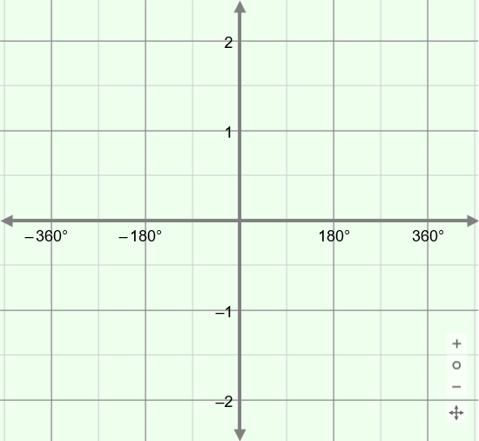The sine function is *y* = sin(*θ*). This means that, when you graph it, *θ* goes on the   
   *x*-axis and sin(*θ*) on the *y*-axis.

What do you think the graph of *y* = sin(*θ*) looks like? Sketch your graph to the right.

After you are done, select **Show curve** in the Gizmo. Adjust your sketch as needed.

1. Angles can be measured in **radians** instead of degrees. A radian is a unit of angle measure, such that one full rotation (360°) equals 2** radians.
2. If 360° = 2**, what is the radian measure of a 180° angle?
3. A 30° angle is  of 180°. What does 30° equal in radians?
4. Fill in the radian measure equal to each degree measure below. Check your answers in the Gizmo. (Select **Degrees**, type the degree measure, and select **Radians**.)

|  |  |  |  |  |  |
| --- | --- | --- | --- | --- | --- |
| **Degree measure** | 0° | 30° | 45° | 60° | 90° |
| **Radian measure** |  |  |  |  |  |

1. State the identity sin(*θ*) = sin(*θ* ± (360*n*)°) using radians.

|  |  |  |
| --- | --- | --- |
| **Activity B:**  **The sine function and identities** | Get the Gizmo ready:   * On the **SINE** tab, be sure **Show curve** and **Show reference triangle** are turned on. * Select **Degrees** and **Common angles only**. | D:\EL_SVN\Project Execution\13 Curriculum Material\Batch 30\157\Images\157SE6.png |

1. Label the legs of the 30-60-90 and 45-45-90 triangles to the right with their lengths. (Hint: If you don’t remember these values, use the Pythagorean Theorem. The short leg of the 30-60-90 triangle is exactly half of the hypotenuse.)

**1**

**45°**

**45°**

**1**

**60°**

**30°**

1. Start with ***θ*** at 0°, and drag the point on the circle counterclockwise from 0° to 180°.

|  |  |  |  |
| --- | --- | --- | --- |
| ***θ*** | 30° | 45° | 60° |
| **sin(*θ*)** |  |  |  |

1. Fill in the table to the right with the sine values of 30°, 45°, and 60°.
2. What reference triangle (30-60-90 or 45-45-90) would you use for each angle below?

30° 45° 60°

|  |  |  |  |
| --- | --- | --- | --- |
| ***θ*** | 120° | 135° | 150° |
| **sin(*θ*)** |  |  |  |

1. Fill in the table to the right with the sine values of 120°, 135°, and 150°.
2. What reference triangle (30-60-90 or 45-45-90) would you use for each angle below?

120° 135° 150°

1. For the angles above, what is true about sin(*θ*) for the same reference triangle?

1. Turn off **Common angles only**. Set ***θ*** to 0°. Drag the point around the circle.
2. In which quadrants is sine positive? negative?
3. Explain why, using the unit circle.

1. Use what you know about reference triangles and quadrants to find the sine values.

sin(210°) = sin(315°) = sin(480°) =

**(Activity B continued on next page)**

**Activity B (continued from previous page)**

1. Set ***θ*** back to 0°. Drag the point around the circle. Examine pairs of angles whose measures add to 180°, or ** radians (for example, 60° and 120°, or 210° and –30°).
2. What do you notice about their sine values?

1. Two angles have a sum of 180°. If one angle is *θ,* what expression represents the other angle?
2. Fill in the blanks below to show how the sine values of angles that add to 180° relate to each other. (Write it once in degrees, and once in radians.)

sin(*θ*) = sin(*θ*) =

1. Set ***θ*** back to 0°. Drag the point around the circle.
2. Examine pairs of opposite angles (for example, 30° and –30°). What is true about their sine values?
3. Use what you noticed to write an equation about the sine values of opposite angles.

This makes sine an **odd function**, and its graph is symmetric about the origin.

1. Examine pairs of angles that are 180° apart (for example, 30° and 210°). What is true about their sine values?

1. Use what you noticed to write two equations to show how the sine values of angles that are 180° apart are related. (Write one in degrees, and one in radians.)

1. It is also true that sin(*θ*) = –sin(360° – *θ*) = –sin(2** – *θ*). Explain why this makes sense, using the unit circle.

|  |  |  |
| --- | --- | --- |
| **Activity C:**  **Practice with the sine function** | Get the Gizmo ready:   * On the **SINE** tab, select **Degrees**. | D:\EL_SVN\Project Execution\13 Curriculum Material\Batch 30\157\Images\157SE7.png |

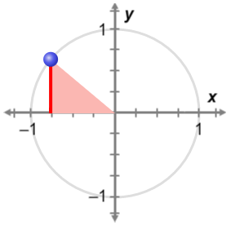

**(–0.766, 0.643)**

**140°**

1. The angle shown on the unit circle to the right has a measure of 140°.
2. What is sin(140°)?
3. 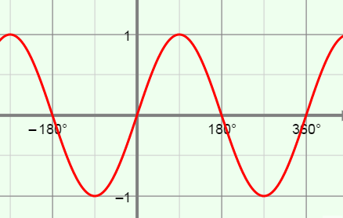The graph of *y* = sin(*θ*) is shown to the right. Plot and label the point that shows sin(140°) on this graph. Check in the Gizmo.
4. Plot three other points on the graph with a   
   *y*-value of 0.643. Write the coordinates of the points below. Then check in the Gizmo.

1. Plot four points on the graph with a *y*-value of –0.643. Write the coordinates of the points below. Then check in the Gizmo.

1. Give the sine value of each angle below. Then list four different angles (two positive and two negative) with the same sine value. Check your answers in the Gizmo.
2. sin() = Angles with same sine value:
3. sin() = Angles with same sine value:
4. sin() = Angles with same sine value:
5. Use the fact that sin(25°) ≈ 0.423 to find each value. Check your answers in the Gizmo.
6. sin(–25°) ≈
7. sin(–155°) ≈
8. sin(155°) ≈
9. sin(–385°) ≈
10. sin(335°) ≈
11. sin(–205°) ≈

|  |  |  |
| --- | --- | --- |
| **Extension:**  **Sine and cosine** | Get the Gizmo ready:   * Select the **COSINE** tab. |  |

1. The cosine of angle *θ* in a right triangle is the length of the adjacent leg divided by the hypotenuse. On the unit circle, cos(*θ*) is the *x*-value of the point where *θ* intersects the circle.

cos(*θ*) = 

Drag the point counterclockwise. How does the *x*-coordinate change in one full rotation?

1. Set ***θ*** to 0°. Drag the point around the circle. Examine pairs of angles whose measures add to 90°. (Be sure to look at angles with both positive and negative measures.)
2. What do you notice about the sine of one angle and the cosine of the other?

1. Two angles add to 90°. If one angle is *θ,* what is the other angle?
2. Write two equations to summarize how the sine and cosine values of angles that add to 90° relate to each other.

sin(*θ*) = cos(*θ*) =

1. If *a* and *b* are the legs of a right triangle with hypotenuse *c*, then the Pythagorean Theorem states that *a*2 + *b*2 = *c*2.

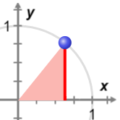

***x***

**(*x*, *y*)**

***y***

**1**

***θ***

1. Use the Pythagorean Theorem to write an equation for the reference triangle shown to the right.
2. Use cos(*θ*) and sin(*θ*) to write the *Pythagorean Identity*.
3. Use the Pythagorean Identity to find each value. Show your work, and check in the Gizmo.
4. sin(*θ*) =  cos(*θ*) =
5. cos(*θ*) = 0.819 sin(*θ*) ≈