Name: Date:

**Student Exploration: Slope**

**Vocabulary:** coordinates, rise, run, slope

**Prior Knowledge Questions** (Do these BEFORE using the Gizmo.)

Beth has to choose which trail to hike. Trail A is 3 miles long, all uphill, with an elevation change of 900 feet. Trail B is 1 mile long, also uphill, with an elevation change of 700 feet.

1. Which trail do you think would be more difficult to hike up?
2. Explain your answer to question 1.

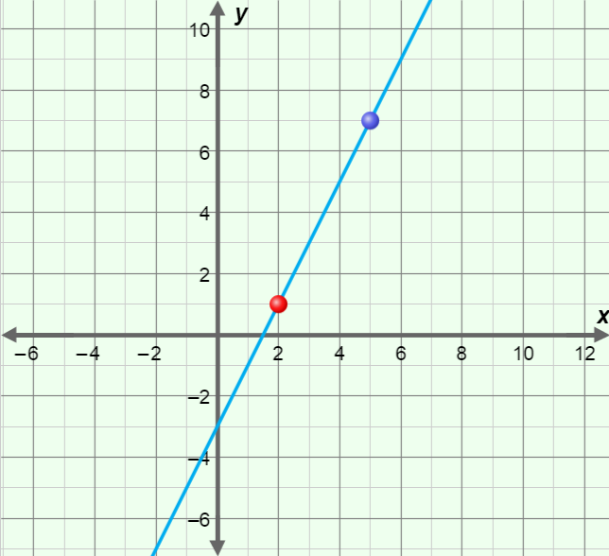**Gizmo Warm-up**

In the *Slope* Gizmo, you can find the rise, run, and slope of the line through two points. If you hover over a point, you will see its (*x*, *y*) **coordinates**, which describe of the location of the point.

To move a point, you can drag it freely on the graph. To vary a point’s *x*- or *y*-coordinate individually, drag the sliders. To enter a specific coordinate, click on the number in the text field, type a new value, and hit **Enter**.

Drag the red point to (2, 1) and the blue point to (5, 7). Turn on **Show rise and run**. (In simple terms, **rise** is the vertical distance between two points. **Run** is the horizontal distance.)

1. Vary the *y*1 and *y*2 sliders. This will move the points vertically.
   1. How do you find the rise between two points?
   2. Can the rise be negative? Explain.

1. Vary the *x*1 and *x*2 sliders. This will move the points horizontally.
2. How do you find the run between two points?
3. Can the run be negative? Explain.

|  |  |  |
| --- | --- | --- |
| **Activity A:**  **Steepness** | Get the Gizmo ready:   * Be sure **Show rise and run** is turned on. | 102SE2 |

1. In the Gizmo, graph an example of each line described below. Then sketch each line on the axes to the right. For each line, tell how the rise and run compare.



* 1. Has a rise of 4 and a run of 4

* 1. Has a rise of 4 but is flatter than the first line

* 1. Has a rise of 4 but is steeper than the first line

1. The ratio  describes the steepness of a line. This ratio is called the **slope** of the line.
2. Find the slopes of the three lines you graphed above. Show all of your work. Then write the slope next to each line in the graph above.

Line A Line B Line C

1. Turn on **Show slope computation**. In the Gizmo, graph each line from question 1 again, and check the slopes you found above. What is the relationship between the slope of a line and its steepness?

1. Experiment with a variety of lines in the Gizmo. Then answer the questions below. Be sure to talk about rise and run in your explanations.
2. Which is steeper, a line with a slope of 2 or a line with a slope of 3?

Explain.

1. Which is steeper, a line with a slope of  or a line with a slope of ?

Explain.

|  |  |  |
| --- | --- | --- |
| **Activity B:**  **Sign of the slope** | Get the Gizmo ready:   * Turn on **Show rise and run** and **Show slope computation**. | 102SE3 |

1. In the Gizmo, graph many different lines that all go “uphill” (up from left to right). Pay attention to the rise and run as you do. Then fill in the blanks below.
   1. For “uphill” lines, if the rise is positive, the run must be .
   2. For “uphill” lines, if the rise is negative, the run must be .
   3. Because slope = , the slope of an “uphill” line must be .
2. In the Gizmo, graph many different lines that all go “downhill” (down from left to right). Then fill in the blanks below.
3. For “downhill” lines, if the rise is positive, the run must be .
4. For “downhill” lines, if the rise is negative, the run must be .
5. Because slope = , the slope of a “downhill” line must be .
6. In the Gizmo, graph several lines that are horizontal (flat). Then fill in the blanks below.
7. What is true about the rise of all horizontal lines?
8. What must be true about the slopes of all horizontal lines?
9. In the Gizmo, graph several lines that are vertical (straight up and down). Then fill in the blanks below.
10. What is true about the run of all vertical lines?
11. What must be true about the slopes of all vertical lines?

Explain.

1. How can the coordinates of two points on a line tell you if the line is horizontal or vertical?