Name: Date:

**Student Exploration:** **Solving Formulas   
for any Variable**

**Vocabulary:** formula, solve

**Prior Knowledge Questions** (Do these BEFORE using the Gizmo.)

Laura has $18.45 left after buying a shirt for $16.80 and a sweater for $24.75.

1. How much money did Laura start with? ____________
2. Explain how you figured this out.

**Gizmo Overview**

In the *Solving Formulas for any Variable* Gizmo, you will be given a **formula** (a rule or relationship between variables) expressed as an equation. You will **solve** each formula for a variable, by isolating that variable, step-by-step.

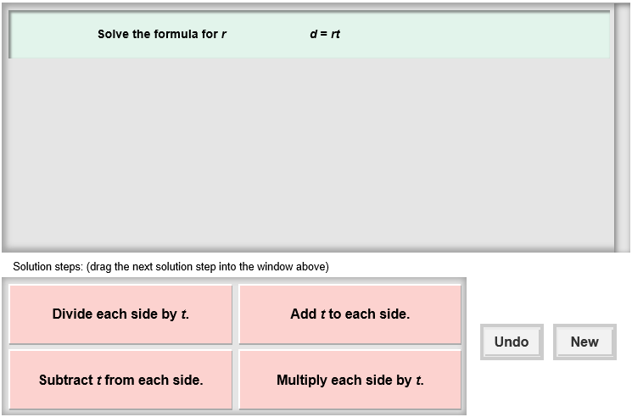Here’s how the Gizmo looks at first:

The formula for you to solve is here.

Click **Undo** to undo your last choice.

The tiles give you four choices for the next step. Choose the one you think is correct and drag it into the white area above.

Click **New** to go to a different problem.

Read your feedback in the Gizmo. (No feedback is given for correct answers.)

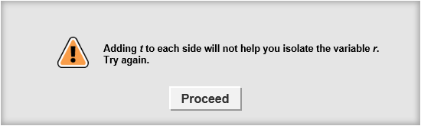

Click **Proceed** to go to the next step.

Continue until you solve the formula for the correct variable. Then click **New** for a new problem to work on.

|  |  |  |
| --- | --- | --- |
| **Activity:**  **Solving the formula** | Get the Gizmo ready:   * You should see the formula *d* = *rt*. If not, click **Refresh** in your browser. |  |

1. 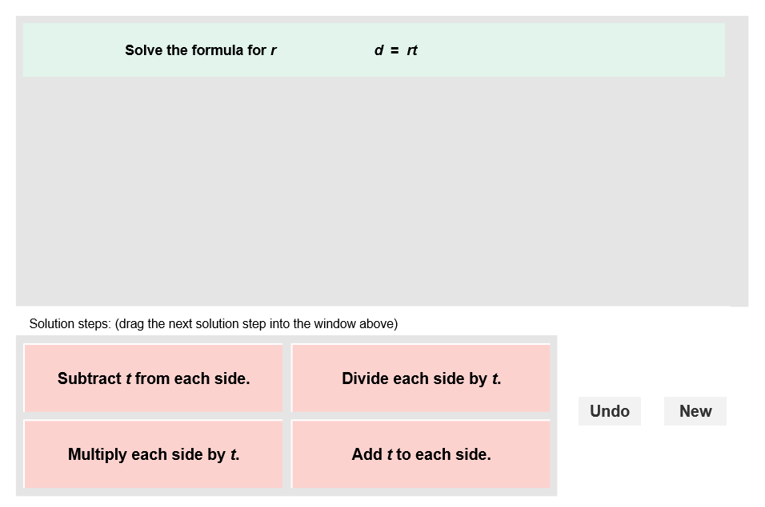When you begin, you should see the formula shown to the right. This is short for “distance = rate • time.”
2. What mathematical operation “attaches” *r* and *t* in this formula?
3. What operation undoes the operation that “attaches” *r* and *t*?
4. Choose the correct step to solve the formula for *r*. If your choice is incorrect, read the given feedback and try again. What is *r* equal to? ____________
5. 309SE5Click **New**. You should now see the formula shown at the right in the Gizmo. This is the slope-intercept formula.
6. The first thing you want to do is isolate the *mx* term. What should your first step be?

1. Choose the correct first step. The equation should now be *y* – *b* = *mx*. What should you do next to isolate *x*?
2. What is *x* equal to? ______________________
3. Click **Undo** twice to get back to the beginning. You should still be solving *y* = *mx* + *b* for *x*. This time, divide each side by *m* first. Choose the correct tile for this step.
4. What simplified equation do you get after dividing?
5. Choose the next correct step. What is *x* equal to?
6. The result should be the same as the first one. Both methods (subtracting *b* first or dividing by *m* first) are valid. Tell which method you prefer and why.
7. Click **New**. Work through more problems in the Gizmo. Be sure to read the feedback in the Gizmo along the way.

**(Activity continued on next page)**

**Activity (continued from previous page)**

1. Solve each formula for the indicated variable. Write all your steps in the space below each problem.
2. Solve *C* = 2π*r* for *r*.
3. Solve *f* =  for *T*.
4. Solve *K* = *C* + 273 for *C*.
5. Solve *A* + *B* + *C* = 180 for *B.*
6. Solve *V* = *lwh* for *w*.
7. Solve *S* = 180(*n* – 2) for *n*.