Vocabulary: Solving Using Trend Lines

Vocabulary

- Correlation – a measure of the relationship between two variables.
- If the variables tend to vary together (as one goes up, the other goes up), they are positively correlated.
- If the variables tend to vary in opposite directions (as one goes up, the other goes down), they are negatively correlated.
- If the variables are unrelated, they have no correlation.

- Scatter plot – a graph of (x, y) points that shows the general relationship between two variables, x and y.
  - Generally, the variable on the horizontal (x) axis is the independent variable, and the variable on the vertical (y) axis is the dependent variable.

- Trend line – a line that fits the points in a scatter plot well.
- Another name for a trend line is a line of best fit.
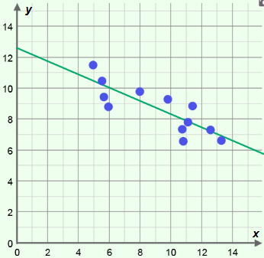
- The slope of the trend line indicates the type of correlation the variables have.
trend line
- A positive slope indicates a positive correlation, a negative slope indicates a negative correlation, and a slope of zero indicates no correlation.
- For example, the trend line shown on the scatter plot to the right has a negative slope, so it suggests negative correlation between the variables.

