Name: Date:

Student Exploration: Solving Equations on the Number Line

Vocabulary: equation, expression, solution

Prior Knowledge Questions (Do these BEFORE using the Gizmo.)
Brenda and Andrea want to share a submarine sandwich for lunch. Andrea has $2.70 and Brenda will pay for the rest.

- If x is the amount Brenda pays, write an expression that describes the amount Brenda and Andrea pay for the submarine sandwich.

- The sub costs $4.10. Use the expression you wrote above and the cost of the submarine sandwich to write an equation to model this situation.

Gizmo Overview
In the Solving Equations on the Number Line Gizmo, you will be given equations like
x + 2.7 = 4.1 and use number lines to find their solutions, the values that make them true.
The equation for you to solve is here.

The sides of the rectangle will be the factors of the polynomial.
Here’s how the Gizmo works:

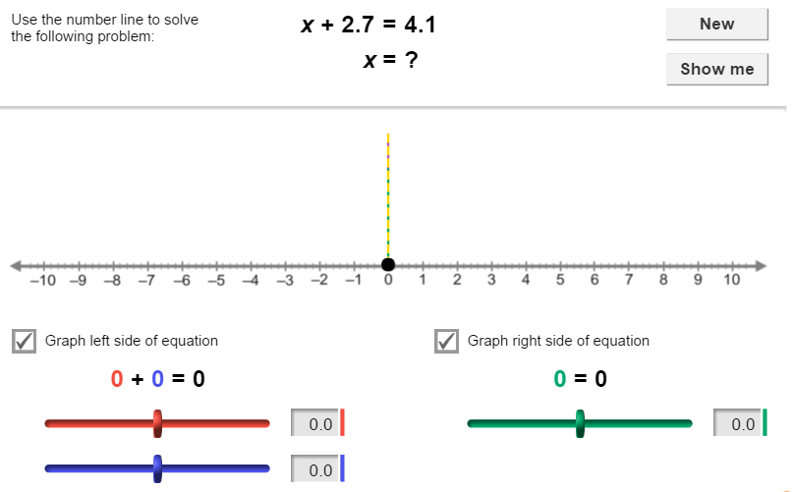

Each value in the equation will be represented by an arrow above the number line.

You will use these sliders to model the values on the left side of the equation.
You will use this slider to model the value on the right side of the equation.

Once you model each side of the equation, you will drag the slider that models the missing value until the two sides of the equation are equal.

Activity:  Solutions on a number line | Get the Gizmo ready:  - You should see the equation x + 2.7 = 4.1. If not, click Refresh in your browser. | 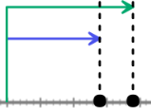

- In this question, you will solve the equation x + 2.7 = 4.1.

- Use the blue slider on the bottom left to model 2.7, the number on the left side of the equation. (To quickly set the value of a slider, type the number into the text box to the right of the slider and press Enter.) Use the green slider on the bottom right to model 4.1, the number on the right side of the equation.

- To solve x + 2.7 = 4.1, you need to find the value of x that makes x + 2.7 equal to 4.1. Drag the red slider on the top left back and forth until the vertical dashed lines line up. (The lines turn yellow when they are lined up.) Sketch the result on the number line below.

- What is the solution of x + 2.7 = 4.1? Click Show me to check.

- Substitute the solution into x + 2.7 = 4.1. In the space to the right, show that the solution makes the equation true.

- Click New. You should see the equation –4.6 + 1.9 = n – 1.2.

- On the left, set the top (red) slider to –4.6 and the bottom (blue) slider to 1.9. On the right, set the bottom (purple) slider to –1.2. Drag the green slider on the left until the vertical dashed lines line up. Sketch the result on the number line below.

- What is the solution of –4.6 + 1.9 = n – 1.2? Click Show me to check.

- Substitute the solution into –4.6 + 1.9 = n – 1.2. In the space to the right, show that the solution makes the equation true.

(Activity continued on next page)
Activity (continued from previous page)

- Click New. Work through more problems in the Gizmo. After you have completed at least five problems, choose two equations from the Gizmo to solve.

Fill in each blank with the equation you are solving. Solve each equation on the number line in the Gizmo and sketch the result on the number line provided. Then write the solution and click Show me to check your answer.

- Equation: Solution:

- Equation: Solution:

- Click New until the Gizmo has a problem that uses all four sliders (red and blue on the left, and green and purple on the right). Ignoring the problem given in the Gizmo, use the sliders to model and solve each equation below. Sketch the results on each number line.

- –1.8 + n = 2.6 – 3.9 Solution:

- –2.1 – 1.5 = x + 1.3 Solution:

