Name: Date:

**Student Exploration:** **Solving Linear Inequalities   
in One Variable**

**Vocabulary:** boundary point, inequality, solution

**Prior Knowledge Questions** (Do these BEFORE using the Gizmo.)

1. Larry has at least 3 more books than Pat. If Pat has 6 books, what do you know about the number of books Larry has?
2. Suppose Larry has 16 books and Pat has *x* books. (Larry still has at least 3 more than Pat.)
3. Use <, ≤, >, or ≥ to write an **inequality** to compare the number of books Larry has to the number of books Pat has.
4. What do you know about the number of books Pat has?

**Gizmo Overview**

In the *Solving Linear Inequalities in One Variable* Gizmo, you will be given inequalities like   
*x* + 3 ≤ 16 and find their **solutions**, the values that make the inequalities true.

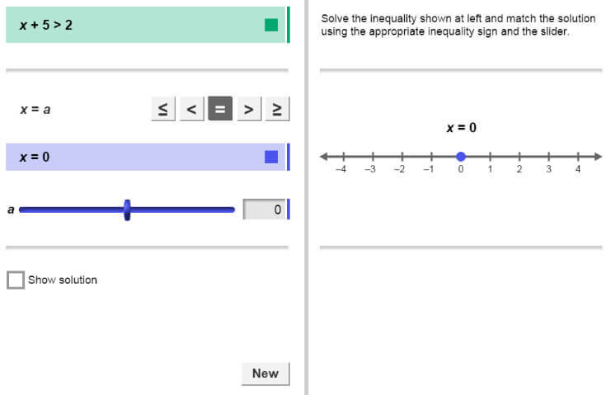

The graph of your solution will be shown on this number line.

The sides of the rectangle will be the factors of the polynomial.

The graph of the solution will appear here.

Here’s how the Gizmo works:

The inequality for you to solve is here.

Use the buttons and the slider to show your solution.

Click here to check your work.

After your have solved the inequality correctly, click **New** for a new inequality to solve.

|  |  |  |
| --- | --- | --- |
| **Activity A:**  **Solutions to inequalities** | Get the Gizmo ready:   * You should see the inequality *x* + 5 > 2. If not, click **Refresh** in your browser. | 119SE2 |

1. In this question, you will solve the inequality *x* + 5 > 2.
2. What do you have to do to each side to solve *x* + 5 > 2?
3. Solve *x* + 5 > 2 for *x*. Show your work to the right.

4Set ***a*** to the number in your solution and select . (To quickly set the value of a slider, type the number into the text box to the right of the slider and press **Enter**.) Sketch your solution below. Select **Show solution**to check your work.

119SE4

1. The open point on the number line is the **boundary point** of the graph. Is the boundary point a solution of *x* + 5 > 2? Explain.

1. Click **New**. You should see the inequality *x* – 4 ≤ –3.
2. What do you have to do to each side to solve *x* – 4 ≤ –3?
3. Solve *x* – 4 ≤ –3. Show your work to the right. Graph your solution in the Gizmo and sketch the graph below. Select **Show solution**to check your work.

119SE4

1. Click **New**. You should see the inequality 5*x* < 20.
2. What do you have to do to each side to solve 5*x* < 20?
3. Solve 5*x* < 20. Show your work to the right. Graph your solution in the Gizmo and sketch the graph below. Select **Show solution**to check your work.

119SE4

**(Activity A continued on next page)**

**Activity A (continued from previous page)**

|  |  |  |
| --- | --- | --- |
| ***x*** | ***–x*** | **Is –*x* < –2 true?** |
| 1 |  |  |
| 2 |  |  |
| 3 |  |  |
| 4 |  |  |
| 5 |  |  |

1. So far, you have solved inequalities in the same way you solve equations. However, an interesting thing happens when the coefficient of *x* is negative. Before doing the next problem in the Gizmo, consider the inequality –*x* < –2.
2. Fill in the table for the values of *x* shown. What values of *x* make –*x* < –2 true?

1. Write an inequality to describe the values of *x* that make –*x* < –2 true.
2. Look at the inequality signs in –*x* < –2 and in the inequality you wrote above.

What do you notice?

1. Click **New**. You should see  ≥ –1.
2. Rewrite  ≥ –1 so the negative sign in the fraction is with *x*.
3. Multiply each side by 4. What inequality do you get?
4. If –*x* is greater than or equal to –4, then what must be true about *x*?

Test several values of *x* to check your answer.

1. You can also solve  ≥ –1 by multiplying each side by –4. What do you think will happen to the “≥” sign when you multiply each side by –4?
2. Solve  ≥ –1. Show your work to the right. Graph your solution in the Gizmo and sketch the graph below. Select **Show solution**to check your work.

119SE4

1. Click **New**. Work through more problems in the Gizmo. Be sure to practice solving a variety of inequalities, including several in which *x* is multiplied or divided by a negative number.

In general, what happens to the inequality sign when you multiply or divide each side of an inequality by a negative number?

|  |  |  |
| --- | --- | --- |
| **Activity B:**  **Solving inequalities** | Get the Gizmo ready:   * Click **New** if you need more practice solving inequalities. | 119SE3 |

Solve each inequality. Show your work in the space below each problem. Then graph the solution on the number line.

1. *x* + 9 < 12

119SE5

1. *x* – 6 ≥ 1

119SE5

1. 0.5*x* ≤ 4

119SE5

1. –5*x* > –20

119SE5

1.  ≤ –1

119SE5

1.  > –2

119SE5