Vocabulary: Special Parallelograms

dictionary2

**Vocabulary**

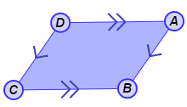

* Parallelogram – a quadrilateral with two pairs of parallel sides.
* In the quadrilateral shown to the right,  is parallel to , and  is parallel to , so *ABCD* is a parallelogram.
* 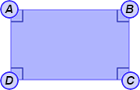Rectangle – a quadrilateral with four right angles.
* Quadrilateral *ABCD* shown to the right has four right angles, so it is a rectangle.
* A rectangle is also a parallelogram.
* 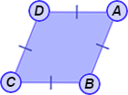Rhombus – a quadrilateral with four congruent sides.
* Quadrilateral *ABCD* shown to the right has four congruent sides, so it is a rhombus.
* A rhombus is also a parallelogram.
* 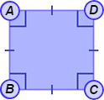Square – a quadrilateral with four right angles and four congruent sides.
* Quadrilateral *ABCD* shown to the right has four right angles and four congruent sides, so it is a square.
* A square is also a parallelogram and a rectangle.