Name: ______________________________________ Date: ________________________

Student Exploration: Spin the Big Wheel!

Vocabulary: certain, impossible, outcome, probability, sample space, trial

Prior Knowledge Questions (Do these BEFORE using the Gizmo.)
Walking through the fair, the carnies tempt you to try your luck at their booth. “Step right up, step right up. Spin the wheel and win a prize, there’s nothing to it!”

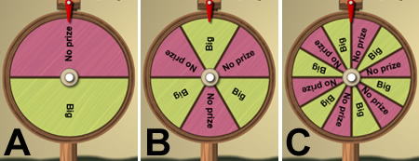

- Which wheel gives you the best chance of winning? _______________________________

- Why did you choose that wheel? _______________________________________________

_________________________________________________________________________

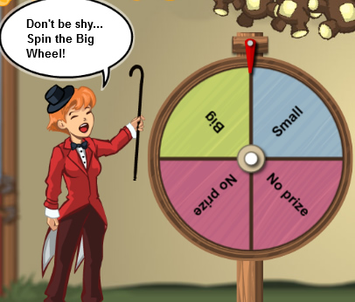
Gizmo Warm-up
The Spin the Big Wheel! Gizmo allows you to test your luck and try to win a prize. First, observe the wheel.

- How many sections is the wheel divided into? _______

- How many sections result in a small prize? _______

How many sections result in a big prize? _______

- Spin the wheel by dragging it sideways. What did you win? __________________________

- Click Clear. Then, in the top right corner, next to Players, click 10 and press Go.

How many players won a small prize? _______ Big prize? _______ No prize? _______
Activity A:  What is the most likely outcome? | Get the Gizmo ready:  - Be sure that Run the game is selected at the top.  - Make sure you still have the original wheel (4 sections – 2 No prize, 1 Big prize, 1 Small prize). If not, click Refresh or Reload in your browser. | 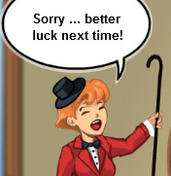

The carnies make it sound like everyone will win. But what is really the most likely outcome?

- The sample space of an experiment is the set of all possible outcomes, or results.

  - What is the sample space of the given wheel? ______________________________

___________________________________________________________________

  - Which outcome do you think is most likely? ________________________________

- What do you think will happen if you spin the wheel once? __________________________

Spin the wheel. What happened? __________________ Is that what you predicted? _____

- Click Clear. Select 100 Players, and click Go. Each spin is called a trial.

  - How many players won a small prize? ______ Big prize? ______ No prize? ______

  - Based on this, what is the most likely outcome? _____________________________

- Select Design the game. Here you can design your own wheel. First, set the number of Sections with the up and down arrows. Then click any section to change the prize.
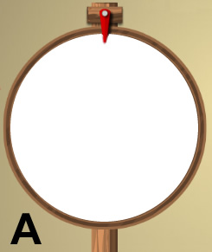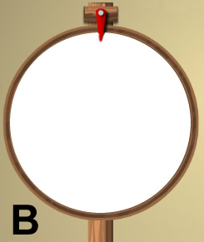
  - An outcome is certain if it always happens. Design a wheel on which it is certain that you will win a big prize. Sketch this to the right, on Wheel A:

  - An outcome is impossible if it cannot happen. Design a wheel on which it is impossible that you will win a big prize. Sketch this to the right, on Wheel B:
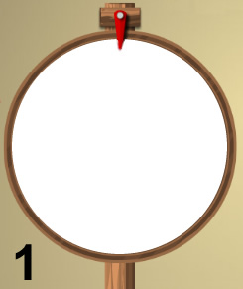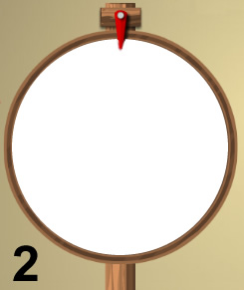

- Design and sketch two wheels. Predict the most likely outcomes. Test each prediction with 100 spins, and record the most common outcomes.

Wheel 1 prediction: ________ Actual: ________

Wheel 2 prediction: ________ Actual: ________

Activity B:  Probability of winning | Get the Gizmo ready:  - Click Clear.  - Select Design the game. | 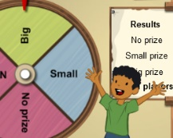

The dancing monkey is on strike, so the fair needs a new booth. You are in charge of designing a new attraction called “Spin the Big Wheel!”
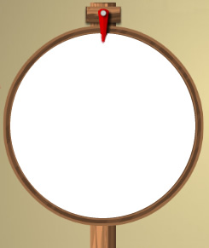

- Design a wheel. It should have all 3 possible outcomes: No prize, Big prize, and Small prize. Draw your wheel to the right. (Label your sections B for Big prize, S for Small prize, or N for No prize.)

- The probability of an outcome is a number between 0 and 1. If the probability is 0, the outcome is impossible. If the probability is 1, the outcome is certain. Look at your wheel.

  - Which outcome do you think is most probable? _____________________________

  - Which outcome do you think is least probable? _____________________________

- Turn on Make your own sign. The first sign reads: “Probability of winning a prize: # / #.”
  - Set the denominator of the fraction to the total number of sections.
  - Set the numerator to the number of sections that will win a prize.

Click Submit to show your sign to the inspector. What is the probability of winning? ______

- Select Run the game, and choose Circle graph to view the results.

  - If 100 people spin your wheel, how many do you think will win something? ________

  - Select 100 players, and click Go. When they have finished spinning, add up the Small prize and Big prize winners. How many total winners were there? _________
  - How close was your prediction? _________________________________________
  - Look at the circle graph. How does the circle graph compare to the wheel? ________
___________________________________________________________________

- Click Go until the Total players reaches 1,000. How does the circle graph compare to the wheel now? _______________________________________________________________
_________________________________________________________________________

Activity C:  Making wheels | Get the Gizmo ready:  - Click Clear.  - Select Design the game.  - Check that Make your own sign is turned on. | 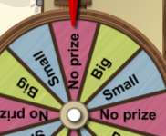

Your spinning wheel was so successful that fairs from all over the country are ordering them! Your job now is to design wheels to fulfill your orders and satisfy your customers.

- The Main Street Fair wants all 3 outcomes – Big prize, Small prize, and No prize – to have the same probability. Sketch 3 different possible wheels below. (Use the Gizmo to help.)

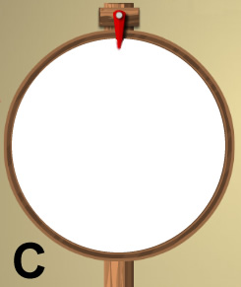

- Design 3 different signs that describe these wheels and click Submit. List them below.

_________________________________________________________________________

_________________________________________________________________________

- Select Run the game. Test each of your wheels with 100 players. What were the results?

 | Wheel A | Wheel B | Wheel C
No Prize
Small Prize
Big Prize

- Main St. Fair thinks your wheel is broken – the 3 outcomes (Big, Small, and No prize) are not coming out exactly equal. Your wheel maker says that’s normal – the numbers should be close to each other but probably not exactly equal. Who do you think is right? Explain.

_________________________________________________________________________

_________________________________________________________________________

_________________________________________________________________________

_________________________________________________________________________

