Name: Date:

**Student Exploration: Square Roots**

**Vocabulary:** distributive law, perfect square, square (of a number), square root

**Prior Knowledge Questions** (Do these BEFORE using the Gizmo.)

1. A carpet installer needs to know the square footage of a room to calculate the price. What is the square footage of each of the three rooms shown below?

**8 ft**

**12 ft**



**6 ft**

**6 ft**



**4 ft**

**6 ft**



1. A customer requests a square carpet with an area of 25 square feet. What are the dimensions of the carpet?

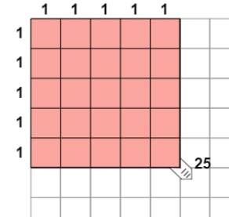**Gizmo Warm-up**

The **square** of a number is equal to the number multiplied by itself. For example, the square of 5 is 25 because 5 • 5 = 25, or 52 = 25. The **square root** of a number is the value that, when squared, gives the number. For example, the square root of 25 is 5, or  = 5.

The *Square Roots* Gizmo uses actual squares to model squares and square roots. You can pull the tab in the lower right corner to create squares of different sizes.

1. Adjust the tab so the number next to the tab is 9.
2. What is the area of the shaded square?
3. What is the side length of the square?
4. What is the square of the side length?
5. What is the square root of 9? =
6. How does the side length of the square relate to the square root?

|  |  |  |
| --- | --- | --- |
| **Activity A:**  **Square roots** | Get the Gizmo ready:   * Create a square with an area of 36 units. * Check that **Show grid** is on. | 103SE2 |

1. Observe the square shown on the Gizmo.
   1. What is the length of one side of the square?
   2. What is the square root of 36?
   3. How does the area of the square relate to the side length of the square?

* 1. How does the side length of the square relate to the area of the square?

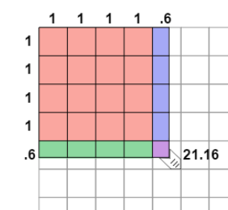

1. Fill in the two equations that are illustrated by the image at right.

2 =

 =

1. Use the Gizmo to find the squares of the following numbers:

72 = 122 = 6.42 = 10.12 =

1. Use the Gizmo to find the square roots of the following numbers:

 = ________  = ________  = ________ = ________

1. Challenge: Use the Gizmo to estimate the square root of 39. If possible, use a calculator to check your estimate. Show your work and describe your method in the space below.

 ≈ ________ (estimated)

 = ________ (calculated)

Method:

|  |  |  |
| --- | --- | --- |
| **Activity B:**  **Perfect squares** | Get the Gizmo ready:   * Create a square with an area of 1 unit. * Check that **Show grid** is on. | 103SE5 |

1. The numbers 1 and 4 are called **perfect squares** because they are equal to an integer squared (1 = 12 and 4 = 22). Use the Gizmo to find the other perfect squares between 1 and 100. List the square of each integer in the table below. (The first two are given.)

|  |  |  |  |  |  |  |  |  |  |  |
| --- | --- | --- | --- | --- | --- | --- | --- | --- | --- | --- |
| **Integer** | 1 | 2 | 3 | 4 | 5 | 6 | 7 | 8 | 9 | 10 |
| **Perfect square** | 1 | 4 |  |  |  |  |  |  |  |  |

1. Find the difference between each perfect square and the next one in the sequence. (For example, the first difference is 4 – 1 = 3.) Write these differences in the spaces below.

__3

1. What pattern do you notice in these differences?

1. Based on the pattern you found, predict the values of the next five perfect squares.

Check your work in the Gizmo.

1. The square of 356 is 126,736 and the square of 357 is 127,449. What is 3582? Try to solve this problem without multiplying. Show your work.

3582 =

1. Explain the pattern you found based on the geometry of squares. Add pictures if you like. (Hint: Think about what you have to add to a 1 × 1 square to get to a 2 × 2 square, and so on to a 3 × 3 square and a 4 × 4 square.)

|  |  |  |
| --- | --- | --- |
| **Activity C:**  **The distributive law** | Get the Gizmo ready:   * Create a square with an area of 6.25 units. * Check that **Show grid** is on. | 103SE4 |

1. Check that the tab is dragged to 6.25. What is the square root of 6.25?
2. The **distributive law** is a rule that states that *a*(*b* + *c*) = *ab* + *ac*. For example, 3 • 12 is the same as 3(10 + 2), which, by the distributive law, equals 3 • 10 + 3 • 2, or 30 + 6, or 36.

The distributive law can be used to find 2.52. Notice that the area representing 2.52 has been divided up into four colored sections. In the table below, state the product represented by each section. Then find each area. The first has been done for you.

|  |  |  |  |  |
| --- | --- | --- | --- | --- |
| **Section** | Pink | Blue | Green | Purple |
| **Product** | 2 • 2 |  |  |  |
| **Area** | 4 units2 |  |  |  |

1. What is the total area of all four regions?
2. How does this value relate to the area of the whole square?
3. How does this value relate to the square of 2.5?
4. Suppose you were squaring 6.7. (Do not model this in the Gizmo yet.)
5. What four products make up this square?
6. Calculate each of the products separately, then add them up to find 6.72. Show your work below, and check your work with the Gizmo.

6.72 =

1. Write the square root equation that this calculation gives you.  =
2. Find the square root of each number using the Gizmo. Then, write the sum of products that add back up to the original number.

= Sum:

= Sum: