Name: Date:

Student Exploration: Standard Form of a Line

Vocabulary: slope, slope-intercept form, standard form, x-intercept, y-intercept

Prior Knowledge Questions (Do these BEFORE using the Gizmo.)

- The rectangle to the right has a length of l and a width of w.
w
w
l
l

- Write a formula for the perimeter of the rectangle, P, in terms of l and w. P =
- What is the perimeter if the length is 6 feet and the width is 4 feet?

- Suppose a rectangle with unknown length and width has a perimeter of exactly 100 feet. Write an equation that describes this. 100 =
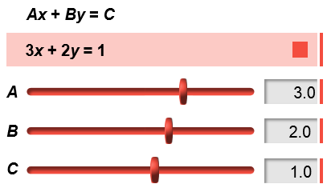
Gizmo Warm-up
The formula you wrote for the perimeter of a rectangle is an example of a linear equation written in standard form (Ax + By = C). You can explore the graph of an equation in standard form with the Standard Form of a Line Gizmo.

- Drag the A slider to change the value of A. (You can also change the value by clicking in the text field, typing in a new value, and hitting Enter.)

- What changes about the graph?

The measure of the steepness of a line is its slope.

- What stays the same about the graph?

The y-coordinate where a graph intersects the y-axis is the y-intercept.

- Drag the B slider to change the value of B.

- What changes about the graph?

- What stays the same about the graph?

The x-coordinate where a graph intersects the x-axis is the x-intercept.

Activity A:  The equation  Ax + By = C | Get the Gizmo ready:  - Be sure Show slope and Show intercepts are turned off. | 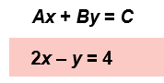
x | y
–2
–1
0
1
2

- In the Gizmo, set A to 2.0, B to –1.0, and C to 4.0 to graph the equation 2x – y = 4.

  - Write 2x – y = 4 in slope-intercept form (y = mx + b).

  - Substitute the x-values shown in the table to the right into the equation to find several points on the line. Click on the TABLE tab in the Gizmo to check your work.

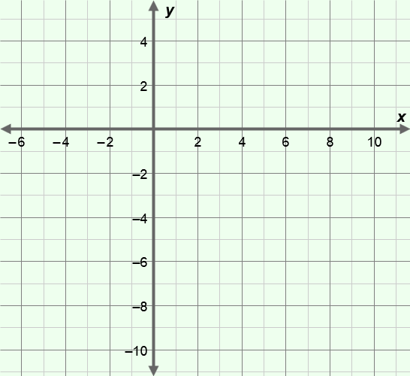
  - Plot the points on the grid to the right and draw the line.

  - Use your graph to find the x-intercept.

  - Use your graph to find the y-intercept.

  - How can you use the table find the x- and y-intercepts?

  - Once you’ve converted 2x – y = 4 to slope-intercept form, what two pieces of information about the graph are easy to find?

- The standard form of a linear equation is Ax + By = C.

- Write Ax + By = C in slope-intercept form.

- How can you find the slope of the line Ax + By = C?

Select the CONTROLS tab. Test your answer on a variety of lines in the Gizmo. Turn on Show slope to check the slope of each line.

- How can you find the y-intercept of the line Ax + By = C?

Test your answer on a variety of lines in the Gizmo. Turn on Show intercepts to check the y-intercept of each line.

(Activity A continued on next page)

Activity A (continued from previous page)

- Turn off Show slope and Show intercepts.

- Substitute 0 for x in 2x – 3y = 6 and solve for y. What are the coordinates of the point you found? What is the y-coordinate of this point called?

( , )
- Substitute 0 for y in 2x – 3y = 6 and solve for x. What are the coordinates of the point you found? What is the x-coordinate of this point called?

( , )

- Graph the points you found on the grid to the right. Connect the points to graph the equation 2x – 3y = 6. In the Gizmo, set A to 2.0, B to –3.0, and C to 6.0, and turn on Show intercepts to check your graph.

- Substitute 0 for y in Ax + By = C and solve for x. How can you find the x-intercept of the line Ax + By = C?

- Solve the following problems. Show your work in the space below each problem. Then check your answers in the Gizmo.

- Find the slope, x-intercept, and y-intercept for the line with equation 5x + 2y = –6.

- A line has an x-intercept of 4 and a y-intercept of 3. Find the slope and equation in standard form of this line.

Activity B:  Horizontal and vertical lines | Get the Gizmo ready:  - Select the CONTROLS tab.  - Turn off Show slope and Show intercepts. | 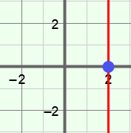

- In the Gizmo, set A to 2.0, B to 3.0, and C to 6.0 to graph the equation 2x + 3y = 6. Slowly drag the A slider until the line is perfectly horizontal.

  - What value of A creates a horizontal line?

  - Find the slope, y-intercept, and equation of your horizontal line. Check your answers in the Gizmo by turning on Show slope and Show intercepts.

slope: y-intercept: equation:

  - What do all points on this line have in common?

  - Vary B and C. How does each variable affect the location of the y-intercept?

  - Write the general equation of a horizontal line in standard form.

- Turn off Show slope and Show intercepts. Then graph x + y = 3. Slowly drag the B slider until the line is perfectly vertical.

- What value of B creates a vertical line?

- Find the slope, x-intercept, and equation of the line. Check your answers in the Gizmo by turning on Show slope and Show intercepts.

slope: x-intercept: equation:

- What do all points on this line have in common?

- Vary A and C. How does each variable affect the location of the x-intercept?

- In the Gizmo, graph a variety of vertical lines. Write the equations of 3 of your lines.

- Write the general equation of a vertical line in standard form.

Activity C:  Using  Ax + By = C | Get the Gizmo ready:  - Click on the CONTROLS tab.  - Turn off Show slope and Show intercepts. | 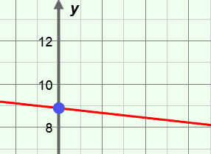

- Jason has some $1 bills and $5 bills in his wallet.

  - If Jason has seven $1 bills, how much money does he have in $1 bills?

  - If he has x $1 bills, how much money does he have in $1 bills?

  - If he has four $5 bills, how much money does he have in $5 bills?

  - If he has y $5 bills, how much money does he have in $5 bills?

  - If he has x $1 bills and y $5 bills, how much money does he have?

- Jason counts the $1 bills and $5 bills in his wallet, and finds that he has $46 total. You can write an equation in standard form to describe this situation. In your equation, let x represent the number of $1 bills and let y represent the number of $5 bills.

- What values will you use for A, B, and C in the equation Ax + By = C?

A = B = C =

Explain.

- What is the equation in standard form?

- In the Gizmo, enter the values of A, B, and C in the text boxes next to the sliders. On the TABLE tab, set MIN to 0.00, MAX to 46.00, and STEP to 1.00.

Look for x-values that have an integer value for y. Write these solutions as ordered pairs below.

- Can Jason have zero $1 bills in his wallet? Explain.

(Activity C continued on next page)
Activity C (continued from previous page)

- Jason added more bills to his wallet. The amount in his wallet increased from $46 to $53.

- What you need to change in the standard form equation?

Explain.

- What is the new equation in standard form?

- Explain what bills Jason could have added to his wallet.

- Farmer John needs to build a fence to surround his goat pen. The perimeter of the pen is 55 feet. The fencing he plans to buy is sold in 3-foot and 8-foot sections.

- You can write an equation in standard form to model this situation. What will x and y represent in the equation?

x = y =

- Write an equation in standard form to model this situation.

- In the Gizmo, enter the values of A, B, and C in the text boxes next to the sliders and hit Enter. On the TABLE tab, set MIN to 0.00, MAX to 55.00, and STEP to 1.00.

Farmer John wants exactly 55 feet of fence without having to cut any sections. What do you need to look for in the Gizmo table to find solutions that satisfy this condition?

- What are the possible solutions that satisfy this?

- Plug the solutions into your original equation to check your answers. Show your work in the space below.

