Name: Date:

**Student Exploration: Stem-and-Leaf Plots**

**Vocabulary:** histogram, mean, median, mode, range, stem-and-leaf plot

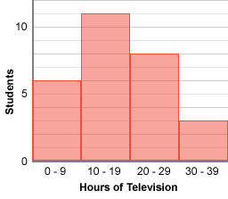**Prior Knowledge Questions** (Do these BEFORE using the Gizmo.)

Mrs. Lee asks her 6th grade students how many hours they spent watching television last week. The **histogram** to the right shows the survey results.

1. What can you learn from this histogram?

1. What information about TV viewing hours cannot be determined from this histogram?

**Gizmo Warm-up**

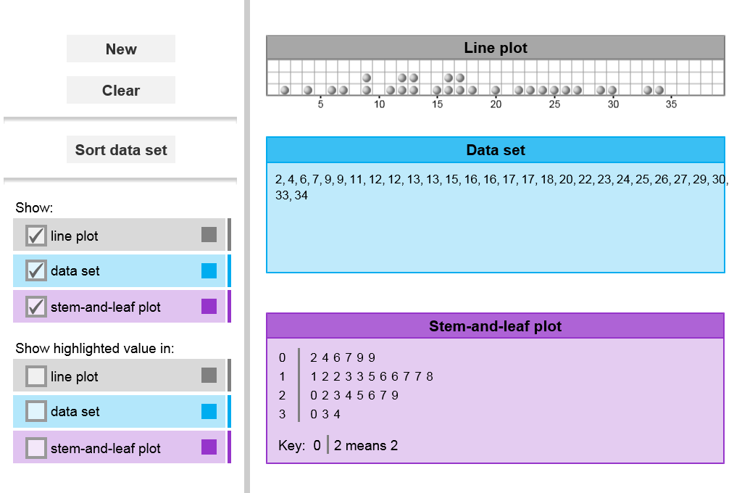

Histograms are useful for summarizing data, but they do not show the value of each data point. You can show both the shape of a data set *and* individual values on a **stem-and-leaf plot**. These graphs are explored in the *Stem-and-Leaf Plots* Gizmo.

To begin, check that **line plot**, **data set**, and **stem-and-leaf plot** are selected under **Show** and **Show highlighted value in**.

1. Click **Clear**. Then click inside the line plot to place a point on the plot. Notice that the point appears in the **Data set** and in the **Stem-and-leaf plot** below.
2. 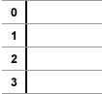Drag the point to 6. Record this value on the stem-and-leaf plot to the right.
3. Place a second point at 13. Record the value on your plot.
4. Place a third point at 27, and show it on your plot.
5. How would you show 34 on your stem-and-leaf plot?

Graph this point on your plot above and check your answer with the Gizmo.

|  |  |  |
| --- | --- | --- |
| **Activity A:**  **Stems and leaves** | Get the Gizmo ready:   * Click **Clear**. | 236SE2 |

1. Click inside the line plot to create the following data set: 7, 13, 20, 20, 29, and 33. Graph these values on the stem-and-leaf plot to the right.
2. How is 7 graphed on the stem-and-leaf plot?

1. How is 20 graphed on the stem-and-leaf plot?
2. How can you tell that 20 appears twice in the data set?
3. On the stem-and-leaf plot, what do the numbers 0, 1, 2, 3 to the left of the vertical line represent?

These numbers make up the “stems” of the stem-and-leaf plot.

1. On the stem-and-leaf plot, what do the numbers 7, 3, 0, 0, 9, and 3 to the right of the line represent?

These numbers are the “leaves” of the plot.

1. Under **Show**, deselect **stem-and-leaf plot** to hide the stem-and-leaf plot. Click **New** to generate a random data set. Click **Sort data set** and list the values below.

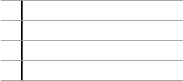

Graph these points on the stem-and-leaf plot to the right. Fill in both the stems and the leaves. When you are finished, turn on **stem-and-leaf plot** under **Show** to check your answer.

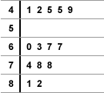

1. Click **Clear**. Based on the stem-and-leaf plot to the right, determine the corresponding data set. List the data set in order below. When you are finished, use the Gizmo to check your work.

|  |  |  |
| --- | --- | --- |
| **Activity B:**  **Interpreting stem-and-leaf plots** | Get the Gizmo ready:   * Click **Clear**. Under **Show**, check that **line plot**, **data set**, and **stem-and-leaf plot** are selected. | 236SE3 |

1. 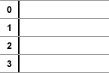Click inside the line plot to create the following data set:

5, 9, 14, 14, 14, 16, 19, 22, 22, 29, and 35

Graph these numbers on the stem-and-leaf plot to the right. You can use the plot to find several important statistics.

1. The **range** of a data set is the difference between the highest and lowest values.

What is the range of this data set?

1. The **mode** of a data set is the most common value in the set. To find the mode on a stem-and-leaf plot, look for the value that occurs most frequently.

What is the mode of this set? Circle the mode on the plot.

1. The **median** of a data set is the middle number in the set. To find the median on a stem-and-leaf plot, count down from the highest value and count up from the lowest value. Where these counts meet is the median. (If there is an even number of terms in the data set, find the mean of the two middle values to find the median.)

What is the median of this set? Circle the median on the plot.

1. 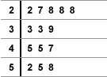Find the range, mode, and median of the data set shown in the stem-and-leaf plot to the right. Show any work below if you like.

Range: Mode: Median:

1. 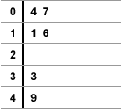The **mean** of a data set is found by adding up all the terms in the set and dividing by the number of terms. (For example, the mean of 1, 2, 2, and 7 is  =  = 3.)
2. Based on the stem-and-leaf plot, list the data in order.

1. Find the mean of this data set.

Show your work to the right.

Mean: