Name: Date:

Student Exploration: Sticky Molecules

Vocabulary: adhesion, capillary action, capillary tube, cohesion, hydrogen bond, intermolecular force, molecule, newton, nonpolar, partial negative charge, partial positive charge, polar,
surface tension, tensiometer
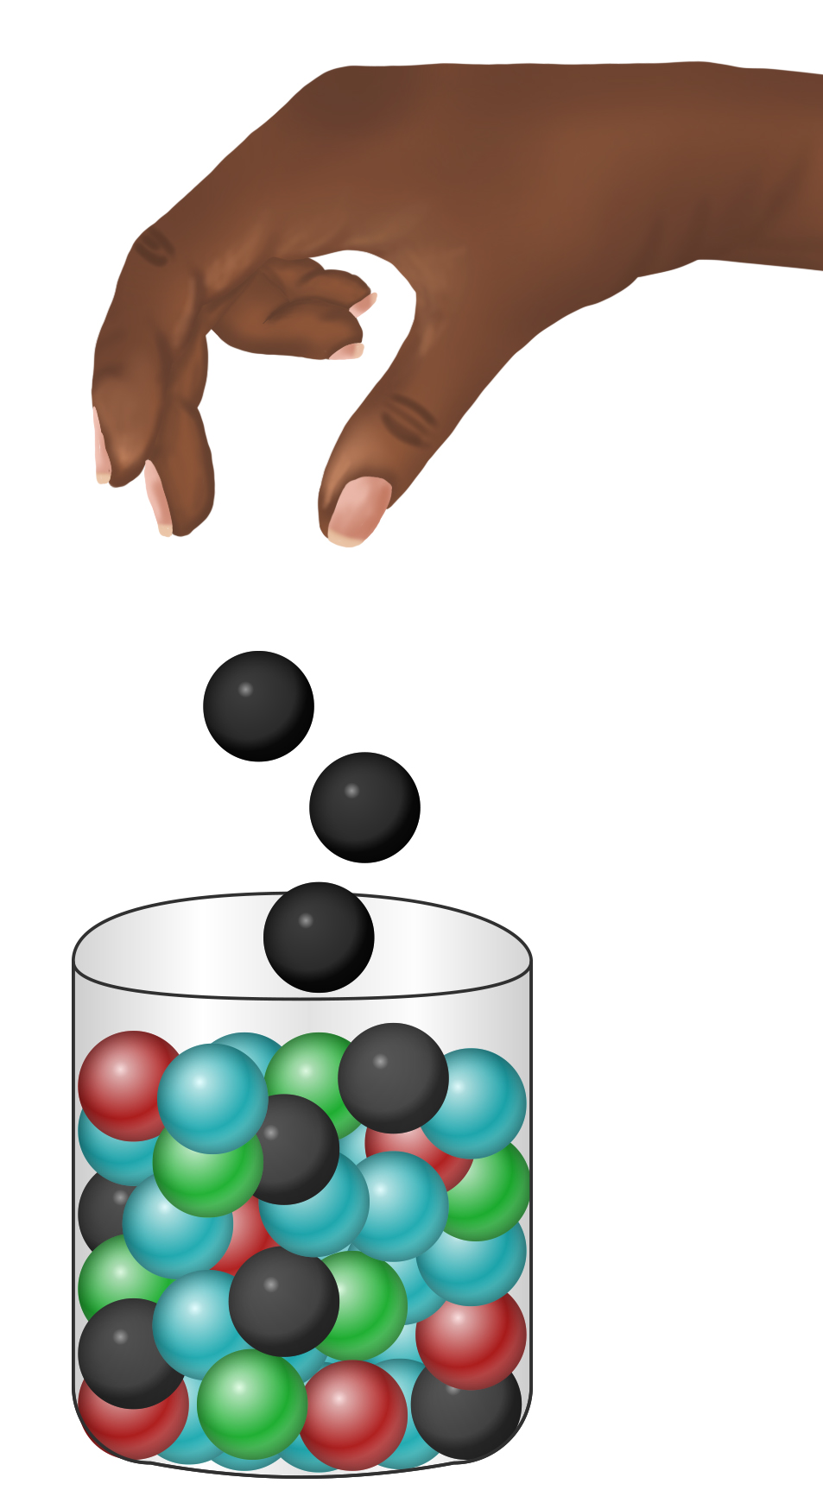

Prior Knowledge Questions (Do these BEFORE using the Gizmo.)

- James adds some magnetic marbles to a glass jar full of ordinary marbles, and then shakes up the jar.

What do you think will happen to the magnetic marbles?

- James then dumps the marbles on a steel cookie sheet and tilts it.

Which type of marble will roll off more easily?

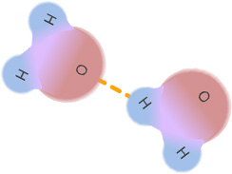
Gizmo Warm-up
Just as some marbles are attracted to one another while others are not, certain molecules stick together more than others. In the Sticky Molecules Gizmo, you will discover what causes this “stickiness.” You will investigate a variety of phenomena that result from the attraction of molecules to one another.

To begin, drag a dropper bottle of Water and a Petri dish (labeled Polarity) to the simulation area. Drag the dropper over the dish to add water. Examine the molecules.

- What do you notice about the water molecules?

Different areas of the water molecules are electrically charged. The red portions of the molecules are negatively charged, while the blue regions are positive. Purple is neutral.

- Note the yellow lines which show attractions between the molecules. Why do you think these attractions occur?

Activity A:  Polarity | Get the Gizmo ready:  - Check that the Petri dish contains water. | 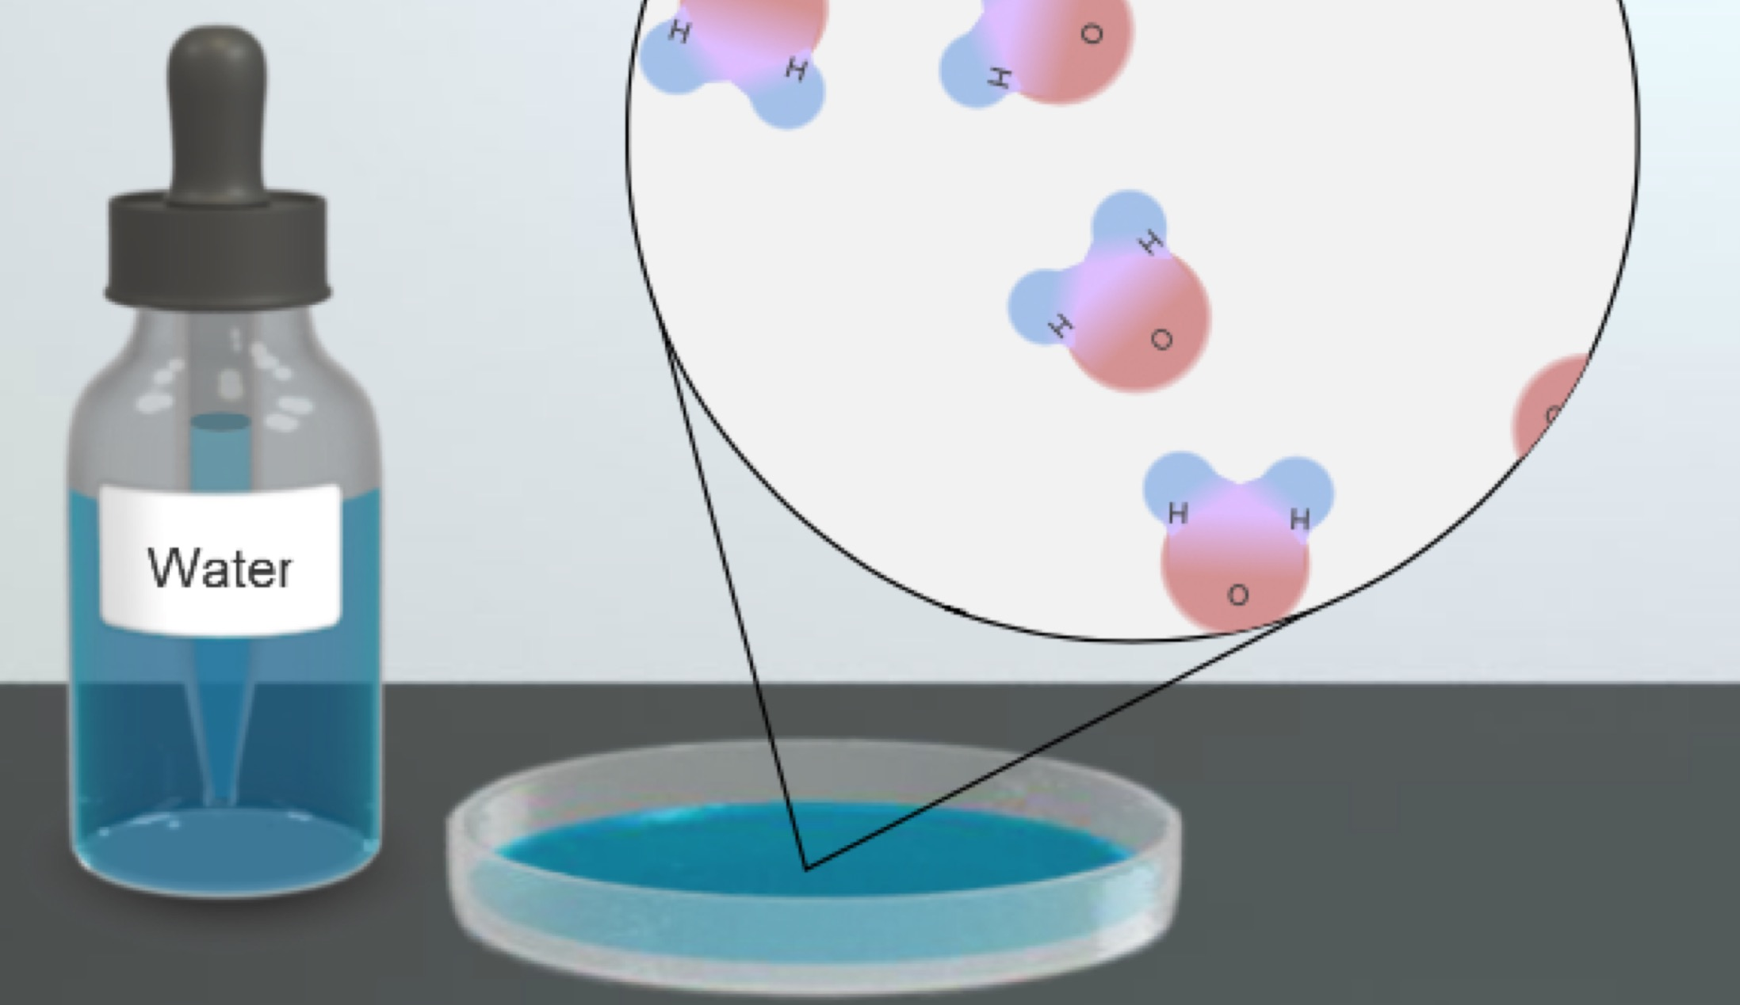

Introduction: All molecules are neutral overall. However, the charges within molecules are not always arranged in the same way. In a polar molecule the positive and negative charges are separated into distinct regions. In a nonpolar molecule the charges are evenly dispersed.

Question: Are polar or nonpolar molecules more “sticky?”

- Classify: Based on what you observe, are water molecules polar or nonpolar?

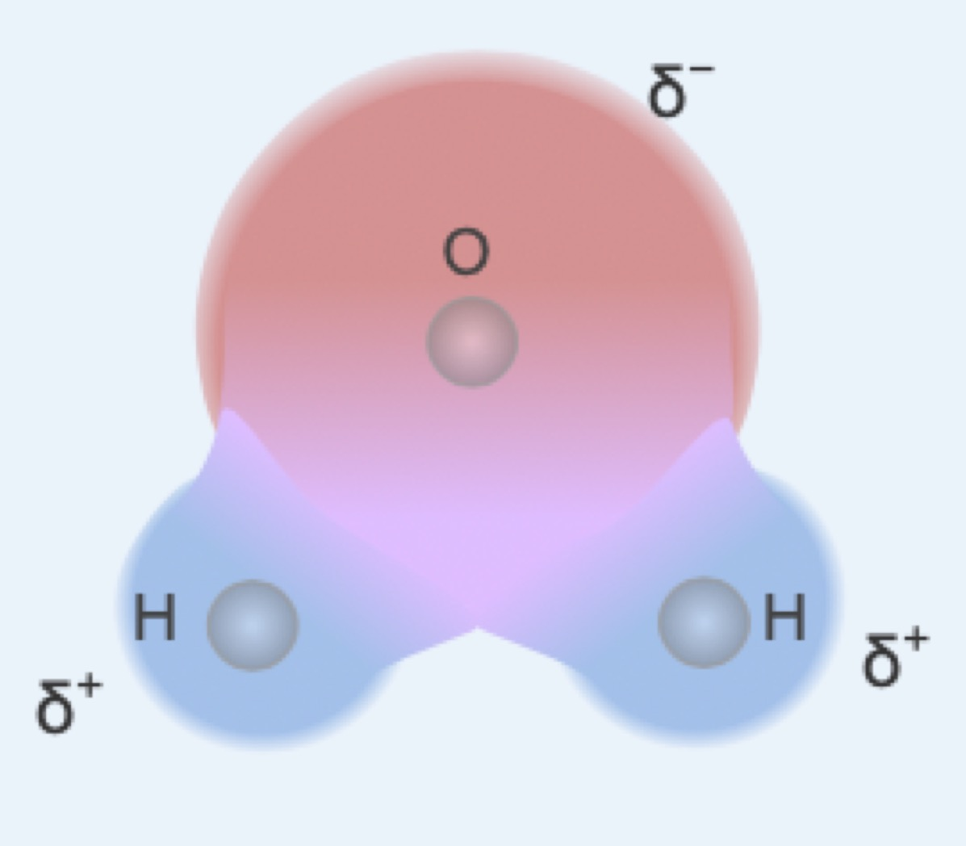
Indicate your choice in the data table using the drop-down menu.

The presence of charged regions indicates a polar molecule. However, these charged regions do not represent full charges as found in compounds such as sodium chloride. Instead they are partial positive (δ+) and partial negative (δ–) charges, which are much weaker than full charges.

- Hypothesize: Note the yellow lines that form between molecules, which represent hydrogen bonds. A hydrogen bond (H-bond) is an example of an intermolecular force (IMF). IMFs occur between all molecules, but hydrogen bonds are the strongest.

- What causes these H-bonds to form? (Hint: Look at the charged regions.)

Why do you think the H-bonds only last a short time before breaking and reforming?

- Explore: Replace water with hexane (an ingredient in paint thinner). Examine the molecules.

- Do you see any charged regions? Do any H-bonds form?

- Is hexane polar or nonpolar? Indicate this in the data table.

- Observe and classify the other two liquids. Which one is polar?

Which one is nonpolar? Indicate this in the data table.

- Summarize: Molecules that are attracted to one another can be called “sticky.”

Which types of molecules, polar or nonpolar, are the “stickiest”?

What causes this stickiness?
Activity B:  Cohesion and adhesion | Get the Gizmo ready:  - Drag the Drop diameter tool (a piece of wax paper) to the simulation area. | 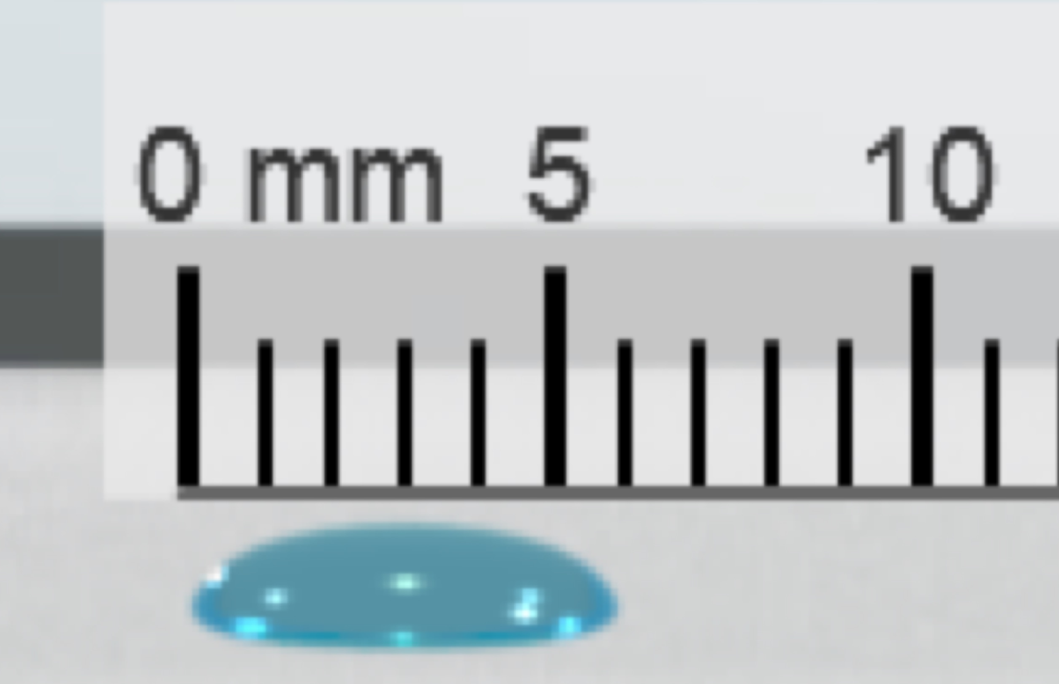

Introduction: When molecules of the same substance stick together, cohesion occurs. When molecules of different substances stick together, such as a drop of liquid to a solid surface, adhesion is taking place. Both cohesion and adhesion occur due to intermolecular forces of attraction. Cohesive forces tend to be stronger than adhesive forces.

Question: How can the strength of cohesive and adhesive forces be determined?

- Predict: All drops do not look the same—some are rounded while others are flatter.

- Do you expect polar or nonpolar liquids to form the roundest drops?

- Explain your reasoning.

- Measure: Drag the dropper bottle of water to the simulation area. Add a drop of water to the wax paper. The drop holds together and assumes its shape due to cohesive forces.

- Describe the shape of the water drop.

- Use the ruler to measure the diameter of the drop. What is its diameter?

Enter this measurement in the data table.

- Analyze: Measure the drop diameter for each of the other substances.

- Enter these values in the data table and then record below:

Hexane Glycerin Mineral oil

- Was the prediction you made in 1A confirmed?

- How do the drops of polar liquids differ from those of nonpolar liquids?

- How do intermolecular forces affect the shape of a drop?

(Activity B continued on next page)
Activity B (continued from previous page)

Predict: Drag the Tilt angle tool to the simulation area. Adhesive forces can be measured using this instrument, which can be tilted to form an inclined plane. The greater the adhesion, the greater the angle at which it can be tilted before the drop begins to slide.

Which substances do you think will experience the greatest adhesive force? Why?

- Investigate: Drag the dropper bottle of water to the simulation area. Add a drop to the tilt angle instrument. Using the slider, gradually increase the incline until the drop starts moving.

- At what angle does the drop begin to slide? Enter this value in the table.

- Repeat the above procedure with the other substances. Enter the angle at which each drop begins to slide in the data table, and then record below:

Hexane Glycerin Mineral oil

- As the angle increases, do polar or nonpolar molecules tend to slide first?

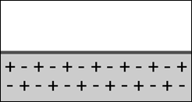
- Explain: To understand adhesion, consider the charges on the surface of the inclined plane. Since it is nonpolar, the positive and negative charges are evenly distributed, as shown to the right. The negative charges (electrons) can freely move, while positive charges (protons) tend to be fixed in place.

- If the positive end of a water molecule were to encounter the surface shown above, what might happen to the surface’s negative charges? Explain your reasoning.

- On the image at bottom right, draw in the charges after a water molecule contacts the surface.

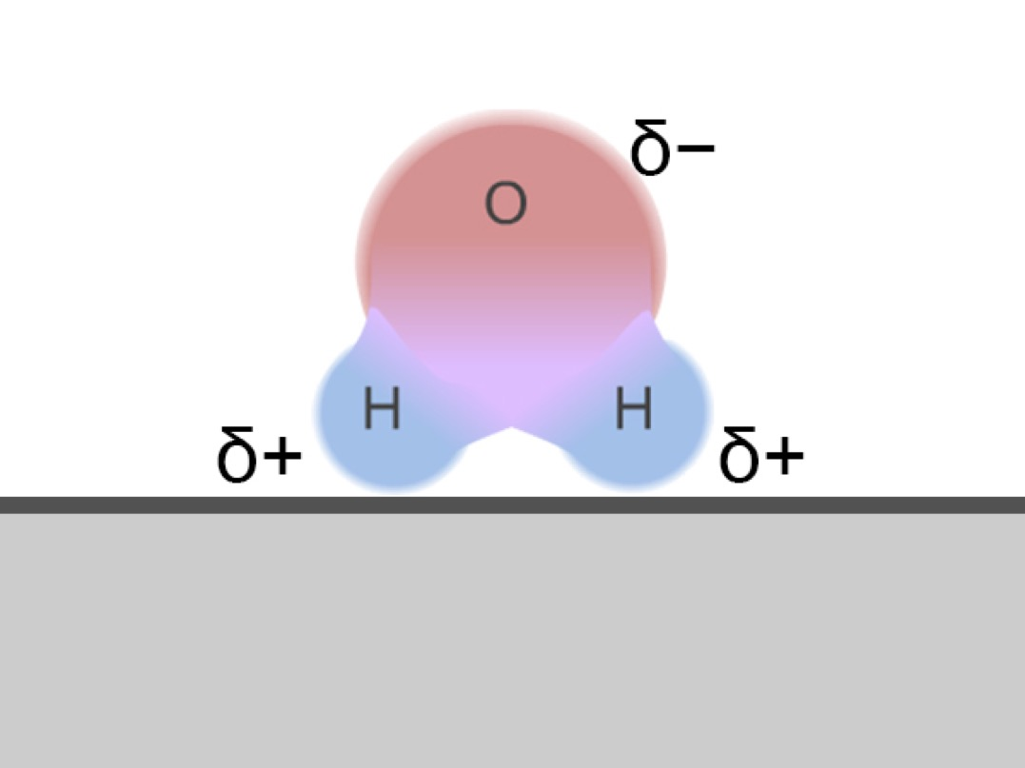
- How does this explain why polar molecules have better adhesion than nonpolar molecules?

Activity C:  Surface tension and capillary action | Get the Gizmo ready:  - Drag the Surface tension tool (a tensiometer) to the simulation area. | 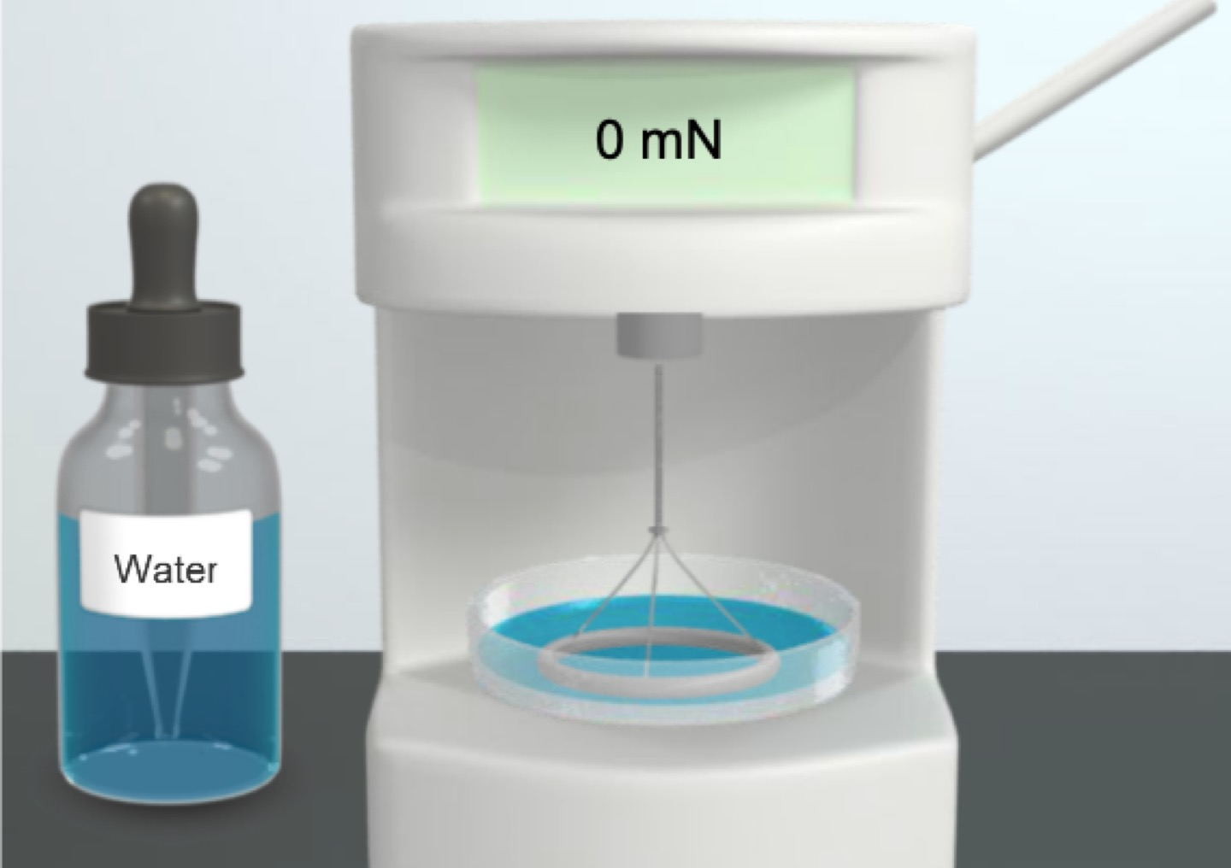

Introduction: Cohesion and adhesion give rise to a variety of phenomena. Surface tension represents the force exerted by the surface of a liquid. Capillary action occurs when a liquid creeps up the sides of a thin tube, in apparent defiance of gravity.

Question: How do intermolecular forces create surface tension and capillary action?

- Predict: A tensiometer contains a ring immersed in a liquid. A sensor connected to the lever registers the force needed to lift the ring out of the fluid. The greater the surface tension of the liquid, the greater the force required to lift the ring out of the fluid.

In which substances would you expect to see greater surface tension? Why?

- Experiment: Drag the dropper bottle of water to the simulation area. Add some water to the dish. Pull down on the lever until the ring breaks free from the surface of the water. Note that the force is measured in units of millinewtons (mN). 1 mN = 1/1000 of a newton (N).

- How much force was required? Enter the measurement in the data table.

- Repeat this procedure with the other liquids. Enter the force required to break the surface tension in the data table, and then record below:

Hexane Glycerin Mineral oil

- Do polar or nonpolar liquids have greater surface tension?

- Explain how polarity affects surface tension.

- Compare: Examine the measurements for drop diameter in the data table. What is the relationship between surface tension and drop diameter?

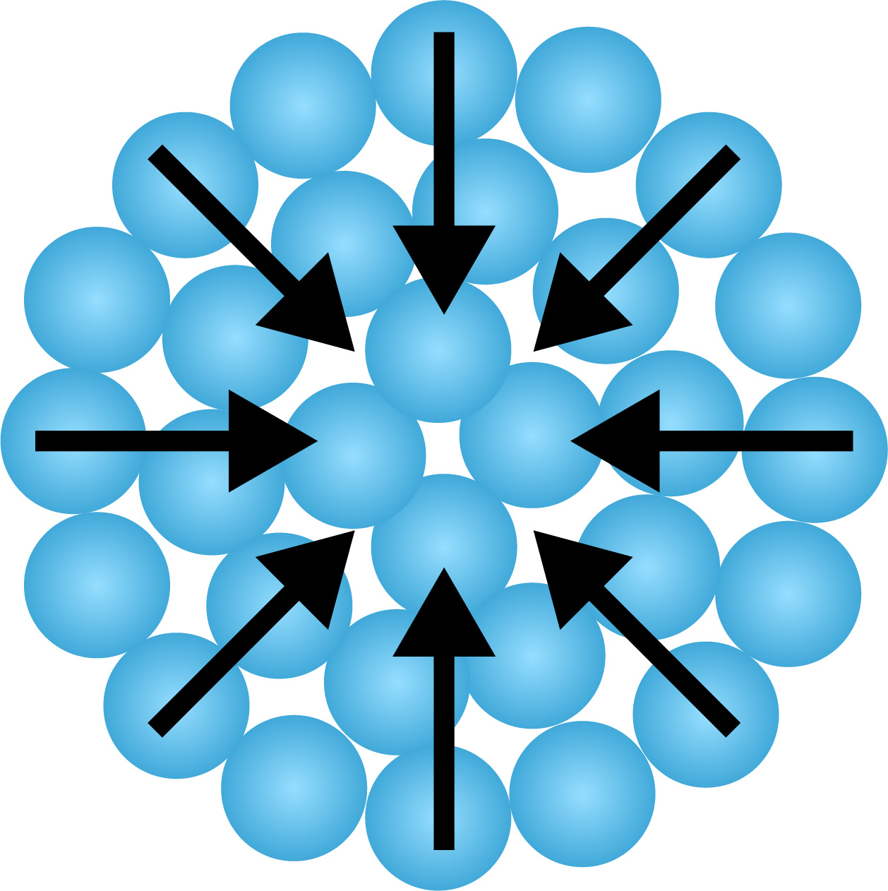
Surface tension is responsible for a drop’s rounded shape, with cohesive forces holding its molecules together. The interior molecules are pulled equally in all directions, but those on the surface are only pulled inward. As a result, the drop shrinks to the shape with the smallest possible surface area, which is a sphere.

(Activity C continued on next page)
Activity C (continued from previous page)

- Investigate: Drag the Capillary rise tool (a capillary tube) to the simulation area. Fluids have a tendency to rise up into these thin glass tubes due to capillary action.

- Which liquids do you think will rise the highest?

- Drag the dropper bottle of water to the simulation area and add water to the dish. Make sure the tube diameter is set to 1 mm. Measure the height of the water.

How high did it rise? Enter this measurement in the data table.

- Repeat this procedure with the other liquids. Enter the capillary rise in the data table, and then record below:

Hexane Glycerin Mineral oil

- What patterns do you see?

Capillary action depends on the balance between cohesion and adhesion. In order for a liquid to rise up a tube, the force of adhesion between the liquid molecules and the sides of the tube must be stronger than the cohesive forces within the liquid.

- Explore: Select Water. Use the Tube diameter slider to adjust the width of the tube.

- How do you think the width of the tube might affect how high the fluid rises?

- Adjust the width of the tube. Why do you think width affects capillary rise?

- Summarize: Use the arrows beneath the data table to adjust the columns so the polar substances are grouped together and the nonpolar substances are grouped together.

- What do the polar substances have in common?

- What do the nonpolar substances have in common?

