Vocabulary: Sticky Molecules

Vocabulary

- Adhesion – the tendency of unlike molecules or surfaces to be attracted to one another.
  - Adhesion occurs as a result of intermolecular forces.
  - Adhesion enables drops of water to cling to a pane of glass or particles of lint to stick to your clothes.
  - Adhesive forces tend to be weaker than cohesive forces.

- Capillary action – the movement of a liquid through a tube or other narrow space, often in defiance of gravity.
  - Capillary action occurs when the adhesive forces between the liquid and walls of the tube overpower the cohesive forces holding the liquid molecules to one another.
  - The smaller the diameter of the tube, the greater the capillary rise.
  - Polar liquids tend to experience more capillary action than nonpolar liquids.

- Capillary tube – a thin-walled tube through which liquids can travel via capillary action.

- Cohesion – the tendency of like molecules to be attracted to one another.
  - Cohesion is due to relatively strong intermolecular forces.
  - Water drops form as a result of cohesion between H₂O molecules.
  - Polar molecules tend to have stronger cohesive forces between them than do nonpolar molecules.
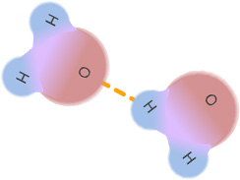
- Hydrogen bond – a special type of intermolecular force in which the positive hydrogen atom of one molecule is attracted to the negative atom (often oxygen) of an adjacent molecule.
  - Hydrogen bonds are among the strongest types of intermolecular force.

- Intermolecular force – (IMF) a weak bond, or force of attraction, between molecules.

- Molecule – a stable particle composed of two or more atoms.
  - A water molecule (H₂O) is made of two hydrogen atoms and one oxygen atom.

- Newton – (N) SI unit of force.
  - 1 newton is the force needed to accelerate a 1 kg mass at a rate of 1 m/s².

- Nonpolar – having an overall even distribution of positive and negative charges.
  - Intermolecular forces between nonpolar molecules are weaker than those between polar molecules.

- Partial negative charge – the label given to that region of a polar molecule with a greater concentration of electrons.
  - A partial negative charge has a smaller absolute value than a full negative charge (–1).
  - A partial negative charge is represented by a $δ$– sign.

- Partial positive charge – the label given to that region of a polar molecule with a greater concentration of positive charge.
  - A partial positive charge has a value less than that of a full positive charge (+1).
  - A partial positive charge is represented by a $δ$⁺ sign.

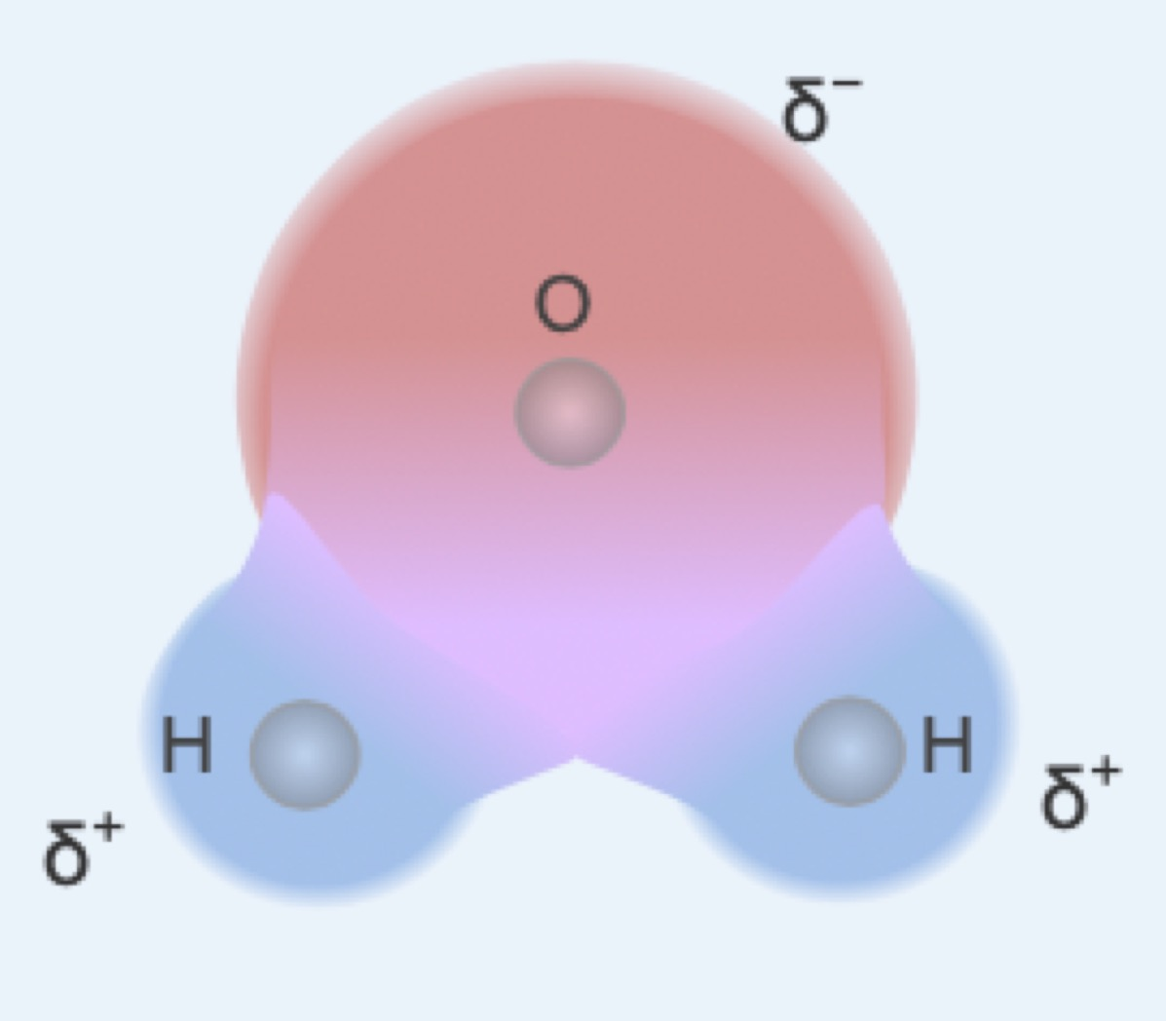
- Polar – having distinct regions of positive and negative charge.
  - A polar substance, such as water, will have both a partial positive and a partial negative side but will be neutral overall
  - Intermolecular forces between polar molecules are relatively strong.
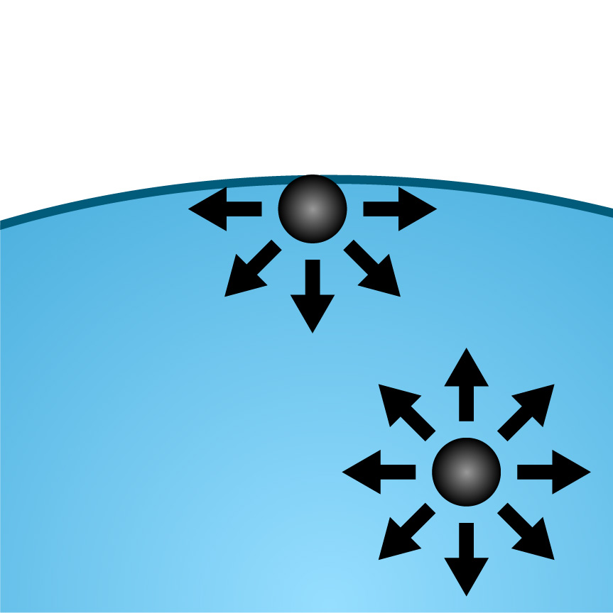
- Surface tension – the force exerted by a liquid’s surface, due to cohesive forces between its molecules.
  - Surface tension acts on the surface of a liquid as there is no opposing force to counteract the net inward pull from the interior molecules.
  - The SI unit for surface tension is N/m.
  - The surface tension of some polar liquids can be strong enough to prevent denser objects, such as paper clips and razor blades, from sinking.

- Tensiometer – an instrument used to measure surface tension.
  - A tensiometer measures the force required to lift a ring out of a fluid.
  - Fluids with greater surface tension require greater force to break the film that forms when a ring is lifted from the fluid.

