Name: Date:

Student Exploration: Subtracting Whole Numbers
and Decimals

Vocabulary: base-10 blocks, base-10 system, decimal, difference, regroup

Prior Knowledge Questions (Do these BEFORE using the Gizmo.)
Laurie is making French toast for a Girl Scout troop. She needs 46 slices of bread and 22 eggs.

- Laurie has six full loaves of bread (10 slices each) and an opened loaf with 4 slices.

  - How many slices of bread does she have? _________

  - How many will she have when the French toast is done? __________

- Laurie has two full cartons of eggs (12 eggs each) and an open carton with 7 eggs.

  - How many eggs does Laurie have? __________

  - How many will she have when the French toast is done? __________

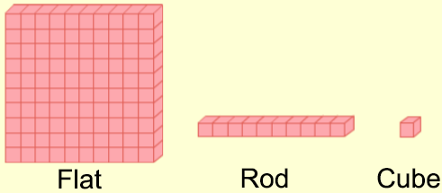
Gizmo Warm-up
The Subtracting Whole Numbers and Decimals Gizmo uses base-10 blocks to model subtraction. Numbers can be modeled with cubes (single blocks), rods (rows of 10 cubes), and flats (squares of 100 cubes).

First you will model the subtraction problem 125 – 12.

- Check that Set block values is set to 100, 10, 1, and that Model first number is selected. Use the blocks to model 125.

How many flats, rods, and cubes did you use? Flats: _____ Rods: _____ Cubes: _____

- Select Model subtraction. Drag blocks from the first number into the green Subtraction bin until you have modeled 12 in this bin.

How many of each did you drag down? Flats: _____ Rods: _____ Cubes: _____

- Count the blocks remaining in the top (yellow) bin. What does 125 – 12 equal? __________
This is the difference between 125 and 12. To check, turn on Show difference.
Activity A:  Selling stamps | Get the Gizmo ready:  - Click Clear, and turn off Show difference.  - Be sure Set block values is set to 100, 10, 1.  - Select Model first number. | 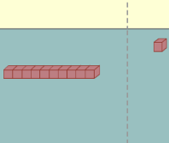

- Mr. Brown at the post office sells stamps. Currently, he has 3 sheets of 100 stamps each, 2 packs of 10 stamps each, and 4 loose stamps. Model this amount in the Gizmo.

  - How many flats, rods, and cubes did you use? Flats: ___ Rods: ___ Cubes: ___

  - How many stamps does Mr. Brown have, total? __________

- Margaret Skinner asks for 75 stamps. To model subtracting 75 stamps in the Gizmo, you will need to move blocks with a total value of 75 into the Subtraction bin.

  - What could you do to have 5 “loose” cubes to drag into the Subtraction bin? (Hint: You can move rods into the Ones section, and flats into the Tens section.)

___________________________________________________________________

  - Do that swap. How many do you have now? Flats: ___ Rods: ___ Cubes: ___

  - What will you need to do before you can drag 7 rods into the Subtraction bin?

___________________________________________________________________

  - Do that swap. How many do you have now? Flats: ___ Rods: ___ Cubes: ___

- After regrouping, Mr. Brown is ready to give Margaret her stamps. To model this in the Gizmo, select Model subtraction. Then drag 75 blocks into the green subtraction bin.

How many stamps does Mr. Brown have left after this? ___________

- Turn on Show difference. What do the three blue numbers written over the 324 mean?

_________________________________________________________________________

_________________________________________________________________________

- Mouseover the 3 numbers in the subtraction. Which part of the model represents these?

  - The 324 is __________________________________________________________

  - The 75 is ___________________________________________________________

  - The difference between 324 and 75 is _____________________________________

Activity B:  Counting pennies | Get the Gizmo ready:  - Click Clear, and turn off Show difference.  - Under Set block values, select 1, 0.1, 0.01.  - Select Model first number. | 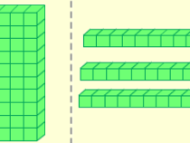

- Marisa has 4 dollar bills (4 wholes), 6 dimes (6 tenths), and 2 pennies (2 hundredths). Model this in the Gizmo.

- How many flats, rods, and cubes did you use? Flats: ___ Rods: ___ Cubes: ___

- How much money does Marisa have? __________

- Marisa wants to buy stamps for $2.84 total. She needs exact change for the stamp machine.

  - To subtract $2.84, Marisa will need 4 pennies (cubes). She currently has 2. What exchange can you make so that you will have enough cubes to subtract?

___________________________________________________________________

  - Do that swap. How many do you have now? Flats: ___ Rods: ___ Cubes: ___

  - To subtract $2.84, Marisa will need 8 dimes (rods). What exchange do you need to make to make this possible?

___________________________________________________________________

  - Do that swap. How many do you have now? Flats: ___ Rods: ___ Cubes: ___

- Select Model subtraction and drag 2.84 to the Subtraction bin. How much
money does Marisa have left (in the yellow top bin) after buying the stamps? ____________

- Turn on Show difference. Explain the three blue numbers written above the 4.62.

_________________________________________________________________________

_________________________________________________________________________

_________________________________________________________________________

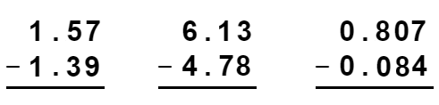
- Click Clear, and turn off Show difference. Solve each problem at right by hand. Then use the Gizmo to model each problem and check answers.

(Note: For the last problem, set the block values to 0.1, 0.01, 0.001.)

Activity C:  Ragged decimals | Get the Gizmo ready:  - Click Clear, and turn off Show difference.  - Under Set block values, select 1, 0.1, 0.01.  - Select Model first number. | 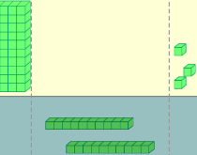

- Charlene has 5 dollars and 1 dime. Model this amount in the Gizmo.

- How many flats, rods, and cubes did you use? Flats: ___ Rods: ___ Cubes: ___

- How much money does Charlene have? __________

- Charlene wants to buy a stamp, which costs 42 cents. Select Model subtraction and drag 4 dimes and 2 pennies (4 rods and 2 cubes) into the Subtraction bin.

- What regrouping did you do before doing the subtracting? _____________________

___________________________________________________________________

- How much money does Charlene have left after subtracting? __________________

- Turn on Show difference. Notice that the original number, 5.10, has been changed.

- Why is the 5 in 5.10 crossed out and replaced with a 4? ______________________

___________________________________________________________________

- Why is there a small 1 written next to the 0 in 5.10? __________________________

___________________________________________________________________

- What do you notice about the decimal points of the three numbers? _____________

___________________________________________________________________

- Click Clear, and turn off Show difference. Set block values to 0.1, 0.01, 0.001. To the right, find 0.8 – 0.019 by hand. Check your answer in the Gizmo.

  - What does 0.8 – 0.019 equal? __________

  - When you subtract decimals, it can be a challenge to line them up correctly. What is a good rule for lining up decimals during subtraction?

___________________________________________________________________

___________________________________________________________________

