Name: Date:

**Student Exploration:** **Surface and Lateral Areas of Pyramids and Cones**

**Vocabulary:** cone, height (of a pyramid or cone), lateral area, net, pyramid, slant height, surface area

**Prior Knowledge Questions** (Do these BEFORE using the Gizmo.)

**6 cm**

**5 cm**

1. The triangle to the right has a base *b* of 6 centimeters and a height *h* of 5 centimeters. Use *b* and *h* to write a formula for the area *A* of a triangle in the first answer blank. Then use the formula to find the area of this triangle.

*A* = *A* =

**3 m**

1. The circle to the right has a radius *r* of 3 meters. Use *r* and *π* (pi) to write a formula for the area of a circle in the first answer blank. Then use the formula and a calculator to find the area of this circle to the nearest hundredth.

*A* = *A* ≈

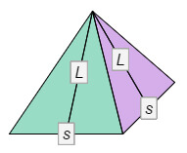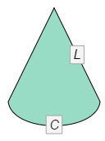

**Gizmo Warm-up**

A **pyramid** is a three-dimensional figure with a polygonal base and triangular lateral faces meeting at the apex. Pyramids with the apex directly above the exact center of the base are *right pyramids*. A **cone** is similar to a pyramid, but with a circular base.

You will explore the areas of right pyramids and cones in the *Surface and Lateral Areas of Pyramids and Cones* Gizmo. To begin, be sure **Square** is selected.

1. Drag the point at the top right corner of the square to change ***s*** (side length). How do the   
   **3-D View** and the **Unfolded View** (**net**) of the prism change?

1. Drag the **Height (*h*)** slider to change the **height** of the pyramid and the **slant height** *L*. (The slant height is the height of each triangular face.) How do the figures change?

|  |  |  |
| --- | --- | --- |
| **Activity A:**  **Surface area of pyramids** | Get the Gizmo ready:   * Be sure **Square** is selected. * Set the **Side Length (*s*)** to 8. * Set the **Height (*h*)** to 7.0 by dragging the slider or entering a value to the right of the slider. | 350SE1 |

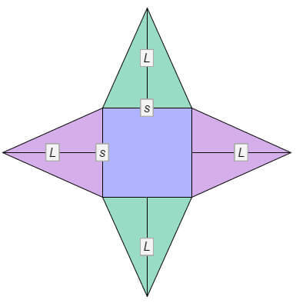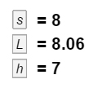

1. To find the **surface area** of a pyramid, add the areas of all the faces of the pyramid. The base is a square with an area of *s*2. Each triangular face has height *L* and base *s*.
2. First, find the area of the base of the pyramid. Write this area on the net to the right.
3. Next, use *A* = 0.5*sL* to find the area of each triangular face. (The slant height *L* is shown next to the net.) Write these areas on the net to the right.
4. Then add the areas of all faces to find the surface area (*S.A.*) of the square pyramid.

*S.A.* ≈

Select **Compute lateral area** and **Compute surface area** to check your area.

1. Turn off **Compute surface area**. Notice that only the triangles are still shaded. These are the lateral faces of the square pyramid.
2. Add the areas of the lateral faces to find the **lateral area** (*L.A.*). *L.A.* ≈

Compare your area to the **Lateral area** given in the Gizmo.

1. The area of each lateral face is 0.5*sL*. Use this to write a general formula for the lateral area of a square pyramid. (Hint: Do not simplify your formula.)

*L.A.* =

1. The perimeter of the base is 4*s*. Rearrange the formula you wrote above so that 4*s* is by itself in parentheses. *L.A.* =
2. Substitute *P* for 4*s* in the formula above. What formula do you end up with?

*L.A.* = Compare your formula to the Gizmo formula.

1. Now simplify what you wrote in part B to write a formula for the lateral area of a right square pyramid in terms of just *s* and *L*. *L.A.* =

**(Activity A continued on next page)**

**Activity A (continued from previous page)**

1. Turn on **Compute surface area**.
2. Look at the formula given for surface area (*S.A* = *L.A.* + *B*). Explain why this formula makes sense.

1. Now just use *s* (side length) and *L* (slant height) to write another formula for the surface area of a right square pyramid.

*S.A.* =

1. What part of the formula you wrote above is the same as the *L.A.* part of the formula given in the Gizmo?
2. What part of the formula you wrote is the same as the *B* part of the formula given in the Gizmo?
3. Turn off **Compute lateral area**. Select **Triangle** from the **Base** menu.
4. How many lateral sides does this pyramid have?
5. What is the perimeter of the base in terms of *s* (side length)? *P* =
6. Use *s* (side length) and *L* (slant height) to write a formula for the lateral area of a right triangular pyramid. *L.A.* =
7. Set the **Side length (*s*)** to 8 and the **Height (*h*)** to 9.0 to create a pyramid with a slant height of 9.29. Use your formula to find the lateral area of the right triangular pyramid. Show your work. Then turn on **Compute lateral area** to check your work.
8. The base area is given below the triangle. What is the base area? *B* =
9. Find the surface area of the right triangular pyramid. *S.A.* ≈

Turn on **Compute surface area** to check your answer in the Gizmo.

|  |  |  |
| --- | --- | --- |
| **Activity B:**  **Surface area of cones** | Get the Gizmo ready:   * Turn off **Compute lateral area**. * Select **Circle**. * Drag the point on the circle to set the **Radius (*r*)** to 5. * Set the **Height (*h*)** to 7.0. | 350SE3 |

1. If you “flatten” the lateral surface of a cone, you get a partial circle, shown in green in the Gizmo. The lateral area (*L.A.*) is pi (*π*) times the radius (*r*) times the slant height (*L*).

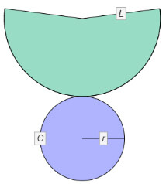

1. Use the formula *L.A.* = *πrL* and a calculator to find the lateral area of the cone whose dimensions are given above to the nearest hundredth. Write the area on the net to the right. Then select **Compute lateral area** to check your answer.
2. The base of the cone is a circle. Use the formula *A* = *πr*2 and a calculator to find the area of the base of this cone to the nearest hundredth. Write the area on the net to the right.
3. Now find the surface area (*S.A.*) of this cone. *S.A.* ≈
4. Write two different general formulas for finding the surface area of a cone. In the first, use *L.A.* (lateral area) and *B* (area of the base). In the second, use *L* (slant height), *π* (pi), and *r* (radius).

*S.A.* = *S.A.* =

Turn on **Compute surface area** to check your formulas and answer above.

1. Turn off **Compute lateral area**. Set the **Radius (*r*)** to 6.5 and the **Height (*h*)** to 9.0. Use the formulas above and a calculator to find the lateral and surface areas of the cone to the nearest hundredth. Show your work. Then check your work in the Gizmo.
2. Find the lateral area.
3. Find the surface area.

|  |  |  |
| --- | --- | --- |
| **Activity C:**  **Using surface and lateral areas** | Get the Gizmo ready:   * Turn off **Compute lateral area**. | 350SE5 |

Solve each problem, using the Gizmo to find the slant height if necessary. Show your work. Then check your answers in the Gizmo.

**5 cm**

**6.4 cm**

1. Find the lateral and surface areas of the right square pyramid shown to the right.

**6 in.**

**4 in.**

1. Find the lateral and surface areas of the cone shown to the right to the nearest hundredth.
2. 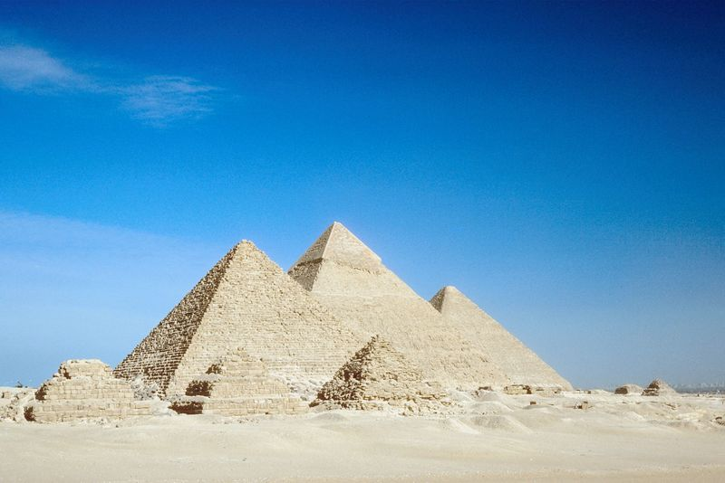The Giza pyramid complex, shown to the right, contains some of the most famous pyramids in Egypt.
3. The largest pyramid in the complex is called the Great Pyramid of Giza. Find the lateral area of this pyramid if the length of each side of the base is about 756 feet and the slant height is about 591.5 feet. Show your work.
4. A gallon of paint covers about 350 square feet. Rounded up to the nearest gallon, how many gallons of paint would it take to paint a pyramid the size of the Great Pyramid of Giza? Show your work.

**(Activity C continued on next page)**

**Activity C (continued from previous page)**

1. For any right triangle, the relationship between the hypotenuse *c* and legs *a* and *b* is described by the Pythagorean Theorem: *a*2 + *b*2 = *c*2.
2. Use the Pythagorean Theorem and the right square pyramid to the right to find the slant height (*L*) in terms of the side length of the base (*s*) and the height of the pyramid (*h*). Show your work. (Hint: Use the red triangle shown inside the pyramid. The legs of the red triangle are *h* and 0.5*s*, and the hypotenuse is *L*.)

***s***

***h***

***L***

***r***

***L***

1. Use the Pythagorean Theorem and the right cone to the right to find the slant height (*L*) in terms of the radius of the base (*r*) and the height of the cone (*h*). Show your work.

***h***

1. Leah is making party hats that are shaped like cones for her sister’s birthday party. The finished hats will be 10 inches tall with a radius of 2.6 inches. Find the amount of material she will need to make one hat to the nearest tenth. Then check your answer in the Gizmo.