Vocabulary: Surface and Lateral Areas of

Pyramids and Cones

dictionary2

**Vocabulary**

* Cone – a three-dimensional figure with one circular base and a curved lateral surface that tapers to a point.
* The point at the top of a cone is called the *apex*.

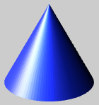

**Right cone**

**apex**

**base**

**height**

**Oblique cone**

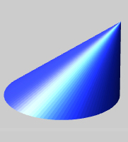

* A cone that is straight up and down (apex directly above the center of the base) is *right*.
* A cone that is skewed (tilted to one side) is *oblique*.
* Height (of a pyramid or cone) – the perpendicular distance between the apex and the base.
* Lateral area – the sum of areas of the lateral surfaces of a three-dimensional figure.
* Net – a two-dimensional pattern of a three-dimensional figure that can be folded to form the figure.
* Pyramid – a three-dimensional figure with one polygonal base and lateral faces that are triangular.
* All of the triangular lateral faces meet in one point called the *apex*.
* The base of a pyramid determines its type.
* For example, the figures to the right have square bases and are *square pyramids*.

**apex**

**base**

**height**

**face**

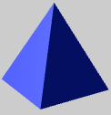

**Right pyramid**



**Oblique pyramid**

* A pyramid that is straight upand down (apex sits directly above the exact center of the base) is *right*.
* A pyramid that is skewed (tilted to one side) is *oblique*.

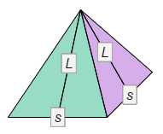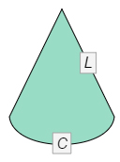

* Slant height – the height of each lateral face of a pyramid or lateral surface of a cone.
* The slant heights of the pyramid and cone shown to the right are both labeled *L*.
* Surface area – the sum of areas of all faces and curved surfaces of a three-dimensional figure.