Name: Date:

**Student Exploration: Systems of Linear Inequalities (Slope-intercept form)**

**Vocabulary:** linear inequality, system of inequalities

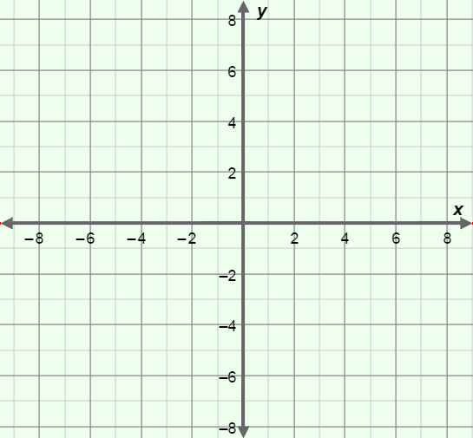

**Prior Knowledge Questions** (Do these BEFORE using the Gizmo.)

1. Graph *y* = 2*x* – 3 on the grid to the right.
2. Now, graph the **linear inequality** *y* ≤ 2*x* – 3 by shading below the line.
3. Plot the point (–3, –6).
4. Does (–3, –6) make the equation   
   *y* = 2*x* – 3 true?
5. Does (–3, –6) make the inequality *y* ≤ 2*x* – 3 true?

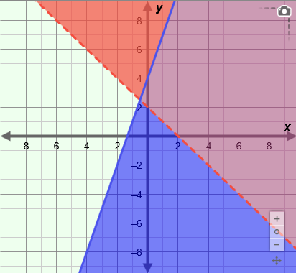**Gizmo Warm-up**

In the *Systems of Linear Inequalities (Slope-Intercept Form)* Gizmo, you can graph and explore the solution to a **system of inequalities**.

1. 41Select the top (red) inequality. Set ***m*** to –1 and ***b*** to 2, and select the “greater than” button ( ) to graph *y* > –*x* + 2. Select the bottom (blue) inequality. Set ***m*** to 3 and ***b*** to 4, and select the “less than or equal to” button ( ) to graph   
   *y* ≤ 3*x* + 4. (To set the values of ***m*** and ***b***, drag the sliders or enter the value into the text field to the right of the slider.)
2. What part of the graph represents *y* > –*x* + 2?
3. What part of the graph represents *y* ≤ 3*x* + 4?
4. In the graph of these inequalities, why is the red line dashed and the blue line solid?

|  |  |  |
| --- | --- | --- |
| **Activity A:**  **Solving systems of linear inequalities** | Get the Gizmo ready:   * Be sure *y* > –*x* + 2 and *y* ≤ 3*x* + 4 are graphed. | 162SE2 |

1. Consider the point (0, 0).
   1. Does (0, 0) lie in the shaded region of *y* > –*x* + 2?
   2. Substitute 0 for *x* and 0 for *y* in the inequality *y* > –*x* + 2, and simplify. Show your work in the space to the right.

Is the inequality true?

* 1. Does (0, 0) lie in the shaded region of *y* ≤ 3*x* + 4?
  2. Substitute 0 for *x* and 0 for *y* in the inequality *y* ≤ 3*x* + 4, and simplify. Show your work in the space to the right.

Is the inequality true?

* 1. Turn on **Show solution test** and check that the green point is at (0, 0). Is (0, 0) a solution to the system of inequalities? Explain.

1. Turn off **Show solution test**. Consider the point (4, –1).
2. Does (4, –1) lie in the shaded region of *y* > –*x* + 2?
3. Does (4, –1) lie in the shaded region of *y* ≤ 3*x* + 4?
4. Turn on **Show solution test** and drag the green point to (4, –1). Is (4, –1) a solution to the system of inequalities? Explain.
5. Name another point in the solution to *y* > –*x* + 2 and *y* ≤ 3*x* + 4. ( , )
6. Why do you think the point you named above is in the solution set?

Check your answer in the Gizmo.

**(Activity A continued on next page)**

**Activity A (continued from previous page)**

1. Consider the system *y* ≥ *x* – 1 and *y* < –2*x* + 5.



1. Graph the boundary lines of the system on the grid to the right. Use dashed or solid lines as appropriate.
2. Shade the side of each line that shows all of the solutions to each inequality.
3. Plot two points that are in the solution set of this inequality. Write the coordinates of your points below.

( , ) ( , )

Graph the system in the Gizmo to check your answer.

1. Graph the system *y* ≤ 4*x* + 1 and *y* > –6*x* – 4 in the Gizmo.
2. Change the inequality symbols to write a new system that has (–4, 2) as a solution.

1. Use substitution to check that (–4, 2) is a solution to the system you wrote above. Show your work. Then check your answer in the Gizmo.

*y* > *x* 1

*y* –7*x* +

1. Fill in the missing numbers and symbols in the inequalities to the right so that (6, –3) is a solution to the system. Then check your answer in the Gizmo.
2. The solution to a system of linear inequalities includes the point (5, –1). One of the inequalities in the system is *y* < 2*x* – 9.
3. Write another possible inequality in this system.

Check your answer in the Gizmo.

1. Is this the only inequality that can be used to form this system?

Explain.

|  |  |  |
| --- | --- | --- |
| **Activity B:**  **Special types of solutions** | Get the Gizmo ready:   * Turn off **Show solution test**. |  |

1. Graph the system *y* < *x* + 3 and *y* ≥ *x* + 5 in the Gizmo.
2. Do you think this system has a solution? Explain.

1. Consider the point (0, 0). Use substitution to check to see if (0, 0) is a solution to the system. Show your work.
2. Now consider the point (1, 5). Use substitution to check to see if (1, 5) is a solution to the system. Show your work. Then turn on **Show solution test** to check this answer and the answer above.
3. Drag the green point around and test several other points in the Gizmo. Are there any points that make both of these inequalities true?
4. Suppose you change the inequality symbol for the first equation to form the system *y* > *x* + 3 and *y* ≥ *x* + 5.
5. Do you think this system has a solution? Explain.

1. Graph the system in the Gizmo. Drag the green point around to test several points. What set of points makes both of these inequalities true?

|  |  |  |
| --- | --- | --- |
| **Activity C:**  **Using systems of linear inequalities** | Get the Gizmo ready:   * Turn on **Show solution test**. | 162SE4 |

Pam is a wedding planner She is setting up a room to seat at least 100 guests. She has some tables that seat 10 people and some tables that seat 5 people. She only has 10 of the tables that seat 5.

1. Let *x* = the number of 10-person tables, and *y* = the number of 5-person tables. Write an inequality to describe the number of tables Pam could set up for the wedding.

1. Solve your inequality for *y*. Show your work.
2. Write a second inequality based on the fact that there are only 10 tables that seat 5.

1. 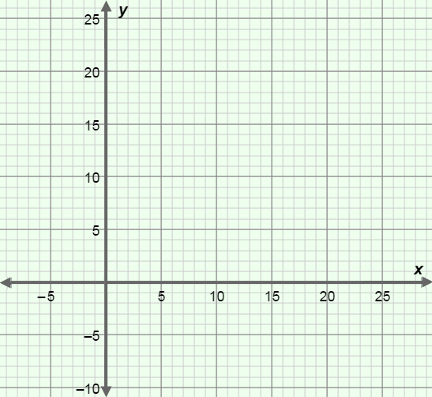The inequalities from questions 2 and 3 form a system that can be used to find the possible combinations of tables. Graph this system on the grid to the right. Then check it in the Gizmo.

(You can use the controls to the right of the graph in the Gizmo to zoom in and out. You can also click on the graph and drag to pan it.)

1. What part of the graph contains points that are solutions to this system?

1. Are all of the points in the solution set of this system possible combinations of tables?

Explain.