Vocabulary: Systems of Linear Inequalities   
(Slope-intercept form)

dictionary2

**Vocabulary**

* 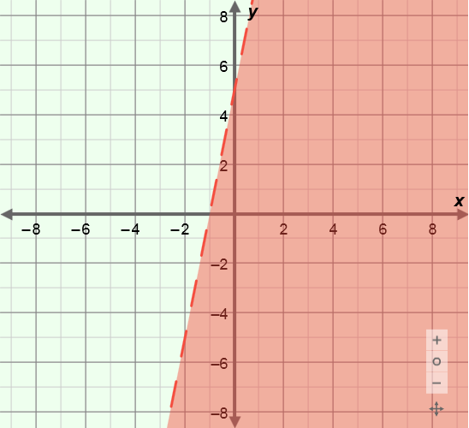Linear inequality – an inequality whose graph is a half-plane with a linear boundary.
* The linear inequality graphed to the right is   
  *y* < 5*x* + 5.
* The shaded part of the graph contains all points that are solutions of this inequality.
* The *boundary* is the line with the equation *y* = 5*x* + 5, and is dashed because the inequality symbol used (<) does not include the “equal to” part.
* 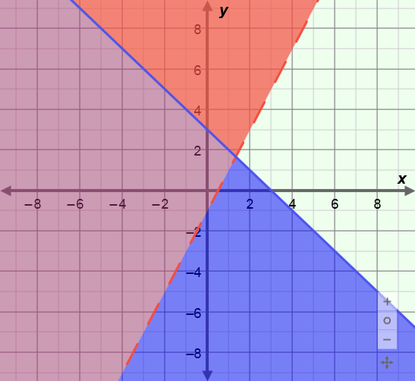System of inequalities – a set of two or more inequalities that contain the same variables.
* The solution to a system of inequalities is the set of all points that make all the inequalities in the system true.
* The system of linear inequalities graphed to the right is *y* > 2*x* – 1 and *y* ≤ –*x* + 3.
* The solution to this system is the purple shaded region of the graph.