Name: ______________________________________ Date: ________________________

Student Exploration: Time Estimation

Vocabulary: error, percent error

Prior Knowledge Questions (Do these BEFORE using the Gizmo.)
Suppose you were trapped in a cave with no watch. Your friends have gone for help.

- What would be the best way to estimate how much time passes as you await your rescue?

_________________________________________________________________________

_________________________________________________________________________

- Your friends come back 30 minutes after they left for help. Do you think you would have underestimated or overestimated how much time has passed? _______________________

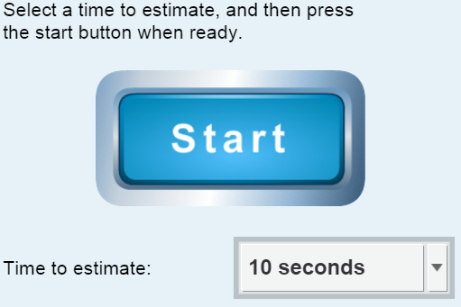
Gizmo Warm-up
People have fairly accurate internal clocks they can use to estimate how much time has elapsed. For example, drummers use their internal clocks to know when to hit the next beat. Other people can use their internal clock to wake up at a certain time without using an alarm clock.

You can test your own internal clock with the Time Estimation Gizmo. To begin, check that the Time to estimate is set to 10 seconds.

- Click Start, and then click Stop after you think 10 seconds have passed.

What was your actual time? ____________________

- Your error is the difference between your actual time and goal time. To calculate error, subtract the goal time from your actual time. What was your error? ____________________

- Your percent error is equal to the error divided by the goal time and multiplied by 100: (error ÷ goal time × 100). What was your percent error? ____________________

Activity:  Estimating time | Get the Gizmo ready:  - On the TABLE tab, click Clear data. | 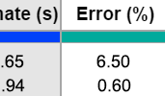

Question: How does our ability to estimate time depend on the chosen time interval?

- Predict: Do you think you will be best at estimating short or long intervals of time? Why?

_________________________________________________________________________

_________________________________________________________________________

_________________________________________________________________________

- Gather data: Estimate time once for each goal time. Record your data below.

Goal time (s) | Estimate (s) | Error (s) | Error (%)
10 s
20 s
30 s
60 s
90 s
120 s
180 s

- Analyze: Examine the data you collected.

  - What do you notice about the error as the goal time increases? _________________

___________________________________________________________________

  - What do you notice about the percent error as the goal time increases? __________

___________________________________________________________________

  - Which statistic do you think is more relevant, error or percent error? Why?

___________________________________________________________________

___________________________________________________________________

___________________________________________________________________

(Activity continued on next page)
Activity (continued from previous page)

- Graph: Look at the GRAPH tab. Zoom out so that all of your data is visible. Sketch your data on the graph below, and connect the dots with line segments in order to make a line graph.

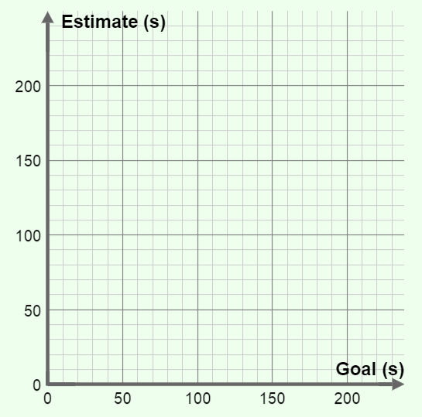

- Interpret: Study the graph you completed above.
  - Do you notice a trend? If so, describe it. ___________________________________

___________________________________________________________________

  - What does the graph show about your ability to estimate different lengths of time?

___________________________________________________________________

___________________________________________________________________

  - Why do you think you can estimate some lengths of time better than others?

___________________________________________________________________

___________________________________________________________________

- Compare: If possible, compare your results to those of your classmates. What trends appear when you look at data for the whole class? _______________________________________
_________________________________________________________________________

_________________________________________________________________________

Extension:  Design an experiment | Get the Gizmo ready:  - On the GRAPH or TABLE tab, click Clear data. | 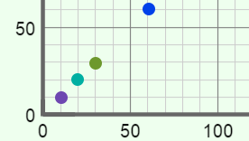

Introduction: Humans often use environmental cues to help them estimate time. When we are removed from these external cues, our ability to estimate time deteriorates. You can use the Time Estimation Gizmo to determine how different environmental cues help people estimate time or how time estimation skills vary amongst different groups of people. The first step is to come up with an interesting question to investigate.

Choose a question
Here are a few suggestions to get you started. You can choose a topic from this list or come up with a topic on your own.

- How does listening to music affect our ability to estimate time?
- How does chewing gum affect our ability to estimate time?
- How does being blind-folded affect our ability to estimate time?
- How do randomly flashing lights affect our ability to estimate time?
- What is the best technique for estimating the passage of time?
- Are males or females better at estimating time?
- Are children or adults better at estimating time?

Which question are you going to investigate? ________________________________________

____________________________________________________________________________

Design your experiment
The key to designing a successful experiment is to control your variables. Everything in your experiments should be the same except for the one variable you are investigating. For example, if you are testing how music affects our ability to estimate time, have each subject try to estimate time while listening to the same song and while not listening to any music at all. Be sure there are no clocks in the room.

Before beginning the experiment, explain your project and experimental design to your teacher. Ask if there is any paperwork that you need to fill out. (Many science fairs require specific paperwork to be filed for any project involving human subjects.)

Briefly describe your experimental design: __________________________________________

____________________________________________________________________________

____________________________________________________________________________

____________________________________________________________________________

____________________________________________________________________________

(Extension continued on next page)
Extension (continued from previous page)

Carry out your experiment
A well-designed experiment isn’t any good unless you carry it out according to your plan. Gather data from as many subjects as possible. In general, the more data you collect, the more reliable your results will be. After your data has been collected, analyze the data using the statistical tools (error and percent error) discussed in the previous activity. Draw conclusions based on your data, not on what you expected to happen.

In the space below, summarize your results and state your conclusions: ___________________

____________________________________________________________________________

____________________________________________________________________________

____________________________________________________________________________

____________________________________________________________________________

____________________________________________________________________________

____________________________________________________________________________

Present your results
The last step is to present your experiment in a clear and visually appealing way. Include tables and graphs that show the trends in your data. If you are presenting at a school science fair, a nice touch might be to include a computer in your display so passersby can test their own time-estimation ability. Good luck and have fun!

