Name: ______________________________________ Date: ________________________

Student Exploration: Titration

Vocabulary: acid, analyte, base, dissociate, equivalence point, indicator, litmus paper, molarity, neutralize, pH, strong acid, strong base, titrant, titration, titration curve, weak acid, weak base

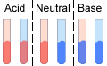

Prior Knowledge Questions (Do these BEFORE using the Gizmo.)
There are several definitions of acids and bases. According to the Brønsted-Lowry definition, an acid is a substance that is capable of donating a proton to another substance. A base is a substance that accepts protons. When an acid and a base are combined, the acid is neutralized as the base accepts the protons produced by the acid.

One way to determine if a solution is acidic or basic is to use litmus paper, as shown above. There are two types of litmus papers: red and blue.

How does litmus paper indicate an acid? ___________________________________________

How does litmus paper indicate a neutral substance? _________________________________

How does litmus paper indicate a base? ____________________________________________

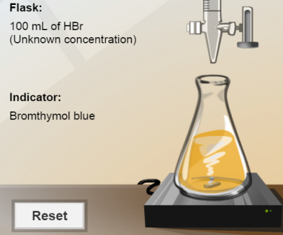
Gizmo Warm-up
Litmus is an example of an indicator, a substance that changes color depending on its pH (pH is a measure of the concentration of protons, or H⁺ ions). In the Titration Gizmo, you will use indicators to show how acids are neutralized by bases, and vice versa.

To begin, check that 1.00 M NaOH is selected for the Burette, Mystery HBr is selected for the Flask, and Bromthymol blue is selected for the Indicator.

- Look at the flask. What is the color of the bromthymol blue indicator? __________________

- What does this tell you about the pH of the solution in the flask? ______________________

Solutions with a pH below 7.0 are acidic, while those with a pH above 7.0 are basic.

- Move the slider on the burette to the top to add about 25 mL of NaOH to the flask. What happens, and what does this tell you about the pH of the flask?

_________________________________________________________________________

Activity A:  Acids and bases | Get the Gizmo ready:  - Click Reset. Select 1.0 M HNO₃ for the Burette and Mystery NaOH for the Flask.  - Select Phenolphthalein for the Indicator.  - You will need a scientific calculator for this activity. | 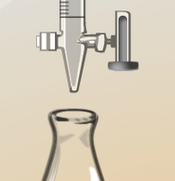

Introduction: When most acids dissolve in water, they dissociate into ions. For example, nitric acid (HNO₃) dissociates into H⁺ and NO₃– ions.

Question: How do acids and bases interact in solution?

- Calculate: Concentration is measured by molarity (M), or moles per liter. Brackets are also used to symbolize molarity. For example, if 0.6 moles of HNO₃ are dissolved in a liter of water, you would say [HNO₃] = 0.6 M.

- Because HNO₃ is a strong acid, it dissociates almost completely in water. That means the concentration of H⁺ is very nearly equal to that of HNO₃.

What is [H⁺] if [HNO₃] is 0.01 M? _________

- The pH of a solution is equal to the negative log of H⁺ concentration: pH = –log[H⁺]

What is the pH of this solution? (Use the “log” button on your calculator.) _________

- What is the pH of a 0.6 M HNO₃ solution? _________

- Describe: The equation for the reaction of nitric acid (HNO₃) and sodium hydroxide (NaOH) is shown on the bottom right of the Gizmo.

- What are the reactants in this reaction? ___________________________________

- What are the products of this reaction? ____________________________________

- Measure: A titration can be used to determine the concentration of an acid or base by measuring the amount of a solution with a known concentration, called the titrant, which reacts completely with a solution of unknown concentration, called the analyte. The point at which this occurs is called the equivalence point.

Carefully add HNO₃ into the flask until the phenolphthalein begins to lose its color. Stop adding HNO₃ when the color change is permanent.

- How much (HNO₃) was required to cause the indicator to change color? __________

- What can you say about the pH before and after the last drop of HNO₃ was added?

___________________________________________________________________

(Activity A continued on next page)
Activity A (continued from previous page)

- Explore: Click Reset and change the indicator to Bromthymol blue. Add exactly 8.8 mL of HNO₃ to the flask.

- What does the color of the indicator tell you about the current pH of the flask?

___________________________________________________________________

- Add one more drop of HNO₃. What does the color tell you about the pH now?

___________________________________________________________________

- If you combine the results of this question with the results from question 3B, what do you know about the total pH change caused by adding the last 0.1 mL of HNO₃?

___________________________________________________________________

- Apply: Water has a pH of 7. If 0.1 mL (about one drop) of 1.0 M HNO₃ is added to 100 mL of water, the result is a solution with a concentration of 0.001 M HNO₃.

- What is the pH of 0.001 M HNO₃? __________

- How much did one drop of HNO₃ cause the pH of water to change? _____________
- How does this relate to what you determined in question 4C? __________________

___________________________________________________________________

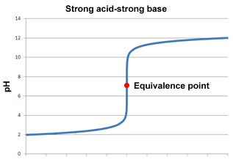

Volume titrant (mL)

- Explain: A titration curve is a graph of pH vs. volume of titrant. The graph at right shows a typical titration curve for the titration of a strong acid by a strong base. (A strong base is one that has relatively high dissociation in water.)

- How would you describe the shape of the titration curve? _________________________
_____________________________________

_____________________________________

- Why do you think the titration curve has the shape it has? _____________________

___________________________________________________________________

___________________________________________________________________

Activity B:  Determining concentration | Get the Gizmo ready:  - Click Reset. Select 1.00 M NaOH for the Burette and Mystery H₂SO₄ for the Flask.  - Select Bromthymol blue for the Indicator. | 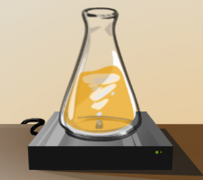

Introduction: Adding a drop of strong acid or base into a neutralized solution is similar to adding a drop of strong acid or base to water—it causes an abrupt change in pH. By using an appropriate indicator, a chemist can tell when a solution is neutralized by monitoring its color.

Question: How is titration used to determine an unknown concentration?

- Measure: Titrate the sulfuric acid analyte (H₂SO₄) with the sodium hydroxide titrant (NaOH).

How much 1.00 M NaOH is needed to neutralize the H₂SO₄ solution? __________________

- Interpret: The balanced equation for the reaction of H₂SO₄ and NaOH is given at bottom right. Based on this equation, how many moles of NaOH react with 1 mole of H₂SO₄? _____

- Manipulate: Recall that molarity is equal to the number of moles of a substance dissolved in one liter of solution: molarity = moles ÷ volume.

- Write an equation for determining the number of moles of NaOH that are added to the flask based on [NaOH] and volume of NaOH titrant (mL NaOH):

Moles NaOH =

- Write a similar expression for the number of moles of H₂SO₄ in the flask based on [H₂SO₄] and the volume of H₂SO₄ (mL).

Moles H₂SO₄ =

- Because there are twice as many moles of NaOH as moles of H₂SO₄ in this reaction, you can say:
Moles NaOH = 2 · Moles H₂SO₄

Substitute your expressions from 3A and 3B into this equation and solve for [H₂SO₄]:

- Now calculate [H₂SO₄] based on the data from the Gizmo. [H₂SO₄] = ___________

(Activity B continued on next page)
Activity B (continued from previous page)

- Calculate: Select the Worksheet tab. This tab helps you calculate the analyte concentration.
- Fill in the first set of boxes (“moles H₂SO₄” and “moles NaOH”) based on the coefficients in the balanced equation. (If there is no coefficient, the value is 1.)
- Record the appropriate volumes in the “mL NaOH” and “mL H₂SO₄” boxes.
- Record the concentration of the titrant in the M NaOH box.

Click Calculate. What is the concentration listed? ___________________________

Click Check. Is this the correct concentration? ___________________________

If you get an error message, revise your work until you get a correct value. (You may have to redo the titration if you do not have the correct volume of titrant.)

- Practice: Perform the following titrations and determine the concentrations of the following solutions. In each experiment, list the volume of titrant needed to neutralize the analyte and the indicator used. Use the Worksheet tab of the Gizmo to calculate each analyte concentration. Include all units.

Titrant | Analyte | Indicator | Titrant volume | Analyte concentration
0.70 M KOH | HBr
0.50 M HCl | Ca(OH)₂
0.80 M H₂SO₄ | NaOH

- Apply: Once you know the concentration of a strong acid or a strong base, you can estimate its pH. Use pH = –log₁₀[H⁺] to calculate the pH of each of the strong acid mystery solutions (Mystery HBr and Mystery H2SO4) based on the concentrations you determined in questions 4 and 5. Check your answers with the Gizmo. (Because dissociation is not always complete, your answers may vary slightly from values in the Gizmo.)

[H₂SO₄] = _____ pH H₂SO₄ = _____ [HBr] = _____ pH HBr = _____

- Apply: For a strong base, the concentration of hydroxide ions [OH–] is estimated to be the same as the concentration of the base. The pH of a strong base is found with the equation pH = 14 + log₁₀[OH–]. Based on their concentrations, find the [OH–] and pH of each of the strong bases. Check your answers with the Gizmo.

[NaOH] = _____ [OH–] = ______ pH NaOH = _____

[Ca(OH)₂] = _____ [OH–]* = ______ pH Ca(OH)₂ = _____

*Note: For Ca(OH)₂, the OH– concentration is double the Ca(OH)₂ concentration because there are two OH– ions in each Ca(OH)₂ molecule.
Activity C:  Weak acids and bases | Get the Gizmo ready:  - Click Reset.  - Select 1.00 M NaOH for the Burette and Mystery CH₃COOH for the Flask. | 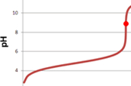

Introduction: Unlike strong acids and bases, weak acids and weak bases dissociate relatively little in water. Some ions are formed, but the remaining molecules remain whole. As a result, the pH of a weak acid or base is closer to neutral than the pH of a strong acid or base.

When weak acids or bases react with strong bases or acids, the resulting salts often act as bases or acids themselves, causing the pH at the equivalence point to vary from 7.0. This can impact your choice of indicator.

Question: What happens when weak acids and bases are titrated?

- Gather data: For each indicator given in the Gizmo, what is the pH range over which it changes color?

Bromthymol blue: _________ Methyl orange: _________ Phenolphthalein: _________

- Interpret: The salt produced by the reaction of acetic acid and sodium hydroxide is a weak base, CH₃COONa. As a result, the pH of the equivalence point is slightly basic. The titration curve for this reaction is shown below:
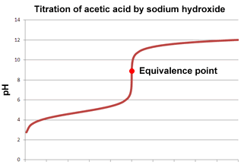
Volume NaOH
- Why is methyl orange not a good indicator to use for this titration? ______________

___________________________________________________________________

___________________________________________________________________

- What would be a better indicator to use, and why? ___________________________

___________________________________________________________________

(Activity C continued on next page)
Activity C (continued from previous page)

- Experiment: Perform two titrations, the first using methyl orange as an indicator and the second using phenolphthalein as an indicator. Record the volume required to reach a color change with each indicator:

Volume NaOH (methyl orange): ________ Volume NaOH (phenolphthalein): ________

- Why did you get such different results with each indicator? ____________________
___________________________________________________________________

___________________________________________________________________

___________________________________________________________________

- Which value would you use to calculate the acetic acid concentration, and why?

___________________________________________________________________

___________________________________________________________________

- Infer: The salt produced by the reaction of a weak base and a strong acid is acidic.

- Based on this fact, what can you say about the equivalence point of this reaction?

___________________________________________________________________

- Which indicator would you use for a titration of a weak base such as NH₃? Explain.

___________________________________________________________________

___________________________________________________________________

- Calculate: Use the Gizmo to find the concentration of the Mystery CH₃COOH and the Mystery NH₃. List the titrant and indicator you used for each titration.

Titrant | Analyte | Indicator | Titrant volume | Analyte concentration
 | CH₃COOH
 | NH₃

- On your own: If you like, you can continue to practice titration calculations by selecting Random for the Flask. Click New to change the analyte. Record your results on a separate sheet of paper.

