Name: ______________________________________ Date: ________________________

Student Exploration: Torque and Moment of Inertia

Vocabulary: angular acceleration, fulcrum, lever, moment of inertia, Newton’s second law, torque, weight

Prior Knowledge Question (Do this BEFORE using the Gizmo.)
During recess, Tom and his little sister Marcie want to play on the see-saw. Tom is quite a bit heavier than Marcie. Where should they sit so the see-saw is balanced? Sketch their positions on the image below.

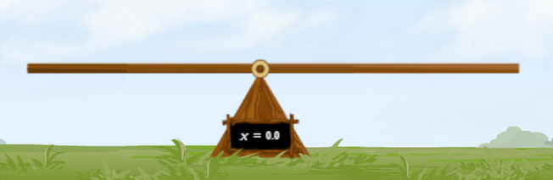
Explain your reasoning: ____________

_______________________________

_______________________________

_______________________________

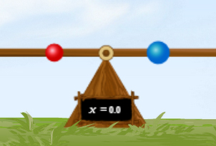
Gizmo Warm-up
The Torque and Moment of Inertia Gizmo shows a see-saw, which is a type of lever. The see-saw can hold up to eight objects. To begin, check that the Number of objects is 2. Check that the mass of object A is 1.0 kg and the mass of object B is 2.0 kg. The two objects are equidistant from the triangular fulcrum that supports the lever.

- Click Release. What happens? _____________________________________________

______________________________________________________________________

- Click Reset. Without changing the masses, experiment with different positions of objects A and B by dragging them around.

Can you create a scenario in which object A goes down and object B goes up? _______

Explain: _______________________________________________________________

- Can you create a scenario in which object A perfectly balances object B? ___________

Explain: _______________________________________________________________

Activity A:  Principle of the lever | Get the Gizmo ready:  - Click Reset. Turn on Show ruler.  - Check that object A is 1.0 kg and B is 2.0 kg. | 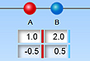

Question: How can you use a light object to balance a heavy object?

- Explore: Experiment with the Gizmo to see how you can balance a heavy object with a light object. What do you notice about the distances of each object from the fulcrum?

_________________________________________________________________________

- Gather data: For each mass and location of object A, find a location for object B so it perfectly balances object A. You can change the mass of object A by typing the mass into the text box and hitting “Enter” on your keyboard. Leave the mass of object B the same
(1 kg) in each experiment. Include all units in the table.

Object A mass | Object A location | Object B mass | Object B location | Object A  m × d | Object B  m × d
1.0 kg | -0.4 m | 1.0 kg
2.0 kg | -0.4 m | 1.0 kg
3.0 kg | -0.4 m | 1.0 kg
4.0 kg | -0.4 m | 1.0 kg

- Analyze: What patterns do you notice in your data? ________________________________

_________________________________________________________________________

- Calculate: Fill in the last two columns by multiplying each object’s mass by its distance from the fulcrum. The units are kg·m. (Note: The distance d is always a positive number.)

What do you notice? ________________________________________________________

- Generalize: In general, how can you calculate the distance of object B from the fulcrum so that it balances object A? ____________________________________________________

- Apply: Suppose you wanted to lift a heavy rock with a lever. Would you place the fulcrum near the rock or near the part of the lever where you are pushing? Explain.

_________________________________________________________________________

_________________________________________________________________________

Activity B:  Torque | Get the Gizmo ready:  - Click Reset. Turn on Show initial torque.  - Set the Number of objects to 1.  - Set Mass A to 2.0 kg. | 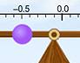

Question: What is the rotational force that an object exerts on a lever?

- Calculate: When object A is positioned on the see-saw, it is pulled down by the force of gravity. The gravitational force on an object, or its weight (w), is equal to its mass multiplied by gravitational acceleration (g). Gravitational acceleration is 9.81 m/s² on Earth’s surface.

What is the weight of object A? __________ [Note: The unit for weight is the newton (N).]

- Predict: The twisting force an object exerts on a see-saw is called torque (τ). How do you think the torque depends on the distance of object A from the fulcrum?

_________________________________________________________________________

- Gather data: Place object A at several locations on the see-saw, on both sides of the fulcrum. Use a different mass in each experiment. In each trial, click Release and record the initial torque. Record object A’s mass, weight, location, and torque in the table below.

Object A mass  (kg) | Object A weight  (N) | Object A location (m) | Object A torque (N·m)

- Analyze: Based on your data, write an equation for torque. Use the symbol r to represent distance. For now, ignore the sign of the torque. Test your equation with the Gizmo.
τ =

- Make a rule: Now focus on the sign of each torque value in your table. How does the sign relate to the direction of rotation? (Fill in each blank with “clockwise” or “counterclockwise.”)

If torque is positive, the resulting motion is __________________________.

If torque is negative, the resulting motion is _________________________.

(Activity B continued on next page)
Activity B (continued from previous page)

- Apply: What is the torque exerted by a 4.2-kg mass that is located 1.8 m to the right of the fulcrum? __________ Check your answer with the Gizmo.

- Explore: Set the Number of objects to 2. Set the Mass of object A to 5 kg and its Location to 1.2 m. Set the Mass of object B to 3.0 kg and is Location to 0.5 m.

- What torque does object A exert on the see-saw? ________________________

- What torque does object B exert on the see-saw? ________________________

- What do you think is the total torque on the see-saw? ________________________

- Check that Show initial torque is on and click Release.

What is the total torque? ________________________

- Practice: A lever supports four objects:

- Object A is 3.0 kg and located 2.0 m left of the fulcrum.
- Object B is 7.0 kg and located 0.5 m left of the fulcrum.
- Object C is 8.0 kg and located 0.1 m right of the fulcrum.
- Object D is 4.5 kg and located 1.6 m right of the fulcrum.

- What is the total torque on the lever? ________________________

(Hint: Recall that objects to the right of the fulcrum will have a negative torque.)

Show your work:

- When released, will the left rotate clockwise or counterclockwise? _______________

- Check your answers on the Gizmo. Were you correct? ________________________

- Explain: If two kids are playing on the see-saw, why should the larger kid sit closer to the fulcrum than the smaller kid? Use the term “torque” in your explanation.

_________________________________________________________________________

_________________________________________________________________________

Activity C:  Moment of inertia | Get the Gizmo ready:  - Click Reset.  - Check that the Number of objects is 1.  - Set Mass A to 2.0 kg.

Introduction: When describing the motion of rotating objects (such as see-saws), physicists use several terms that are equivalent to those used for linear motion. For example, torque (τ) is the rotational equivalent of force, while angular acceleration (α) is the rotational equivalent of linear acceleration.

Question: What factors affect how quickly a see-saw accelerates?

- Predict: Two children of equal mass decide to have a see-saw race. Each child sits on an identical see-saw with nothing on the other side. William sits at the end of his see-saw as far away as possible from the fulcrum. Kate sits near the middle of her see-saw close to the fulcrum. Their friends lift both see saws to the top and release them simultaneously.

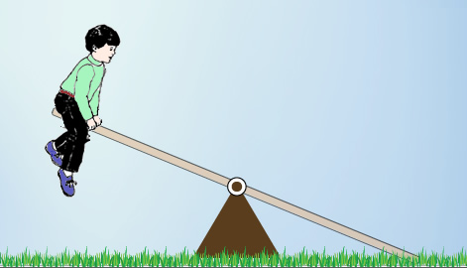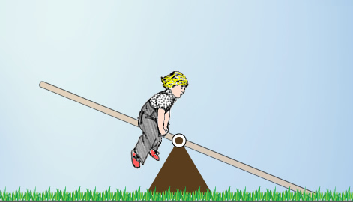

Which see-saw do you think will hit the ground first, and why? ________________________

_________________________________________________________________________

- Experiment: Move object A to the end of the see-saw as far as possible from the fulcrum. Click Release, and record how long it takes for the see-saw to hit the ground. Click Reset and place object A close to the fulcrum. Click Release and record the time again.

Time to hit ground when object A is far from the fulcrum: ____________________________

Time to hit ground when object A is close to the fulcrum: ____________________________

- Compare: The rate at which a rotating object accelerates is related to its moment of inertia. Click Reset. Turn on Show moment of inertia and compare the moment of inertia for a mass close to the fulcrum and the same mass far from the fulcrum. (Click Release to see the moment of inertia.) How does moment of inertia relate to the distance to the fulcrum?

_________________________________________________________________________

(Activity C continued on next page)
Activity C (continued from previous page)

- Calculate: Place a 5.0-kg mass 2.0 m from the fulcrum. To find the moment of inertia for a mass located a distance r from the fulcrum, use the equation: I = mr².

What is the moment of inertia of this mass? _________________ (Note: Units are kg·m².)

Check your answer by turning on Show moment of inertia and clicking Release.

- Compare: You may have been surprised that the see-saw accelerated more slowly when the mass was far from the fulcrum and the torque was greater. That is because the angular acceleration of the see-saw depends on two factors: torque and moment of inertia (I). Just as mass is a measure of an object’s resistance to acceleration, moment of inertia is a measure of an object’s resistance to angular acceleration. Compare these two equations:

Newton’s second law (linear motion) Newton’s second law (rotational motion)

F = ma τ = Iα

How are these equations similar? ______________________________________________

_________________________________________________________________________

- Manipulate: Start with the rotational version of Newton’s second law (τ = Iα).

- Solve this equation for the angular acceleration. α =

- Substitute mr² for I in this equation. α =

- Recall that torque is defined as force multiplied by α =
radius. Substitute Fr for τ into your equation.

- For an object on the see-saw, the force on the object is α =
equal to its weight, mg. Substitute mg for F in your equation.

- Cancel everything that can be canceled to find a simplified α =
expression for the angular acceleration of the see-saw.

- Interpret: Look at your expression for the angular acceleration. (If possible, check this equation with your teacher.)

- Does the angular acceleration depend on the mass of the object? _______________

Explain: ____________________________________________________________

- How does the angular acceleration change as the distance (r) increases? _________ ___________________________________________________________________

