Vocabulary: Translating and Scaling Functions

Vocabulary
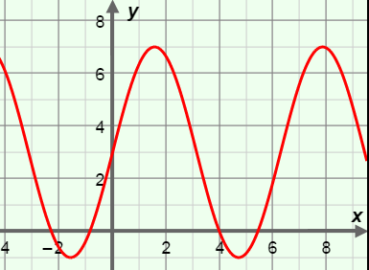
- Amplitude – half the distance between the maximum and minimum y-values of a periodic function.
  - For example, the function y = 4 sin(x) + 3, shown to the right, has an amplitude of 4.

- Parent function – the basic form of a function in a family of functions.
  - For example, the parent function of y = 4 sin(x) + 3 is y = sin(x).

- Periodic function – a function with y-values that repeat at constant intervals.

- Scale (a function) – to stretch or shrink a graph by multiplying the x- or y-values of a function by a constant.
  - For example, the graph of y = 4 sin(x) + 3, shown above, has been vertically scaled (stretched) by a factor of 4.

- Transform (a function) – to scale, translate, rotate, or reflect the graph of a function.

- Translate (a function) – to shift a graph by increasing or decreasing the x- or y-values of a function by a constant.
  - For example, the graph of y = 4 sin(x) + 3, shown above, has been translated up by 3 units.

