Name: Date:

**Student Exploration: Translating and Scaling  
Sine and Cosine Functions**

***θ***

***x***

***y***

**1**

**(cos(*θ*), sin(*θ*))**

**Vocabulary:** amplitude, cosine, midline, period, radian, sine

**Prior Knowledge Questions** (Do these BEFORE using the Gizmo.)

Recall that, for an angle *θ* in a unit circle, the **sine** of *θ* is the *y*-value of the point where *θ* intersects the circle. The **cosine** of *θ* is the   
*x*-value of the point on the circle.

1. Write the sine of each angle.

(0°, ) (90°, ) (180°, )

(270°, ) (360°, )

Graph the “key points” above on the grid below. Connect them to graph *y* = sin(*θ*).

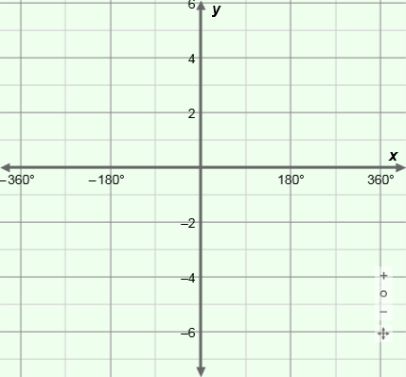

***y* = sin(*x*)**

1. Write the cosine of each angle.

(0°, ) (90°, ) (180°, )

(270°, ) (360°, )

Graph the “key points” above on the grid below. Connect them to graph *y* = cos(*θ*).



***y* = cos(*x*)**

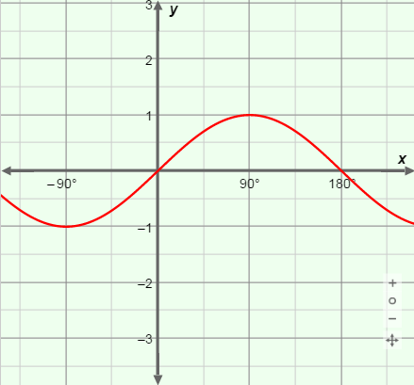**Gizmo Warm-up**

In the *Translating and Scaling Sine and Cosine Functions* Gizmo, you can explore how different values transform the graphs of the parent functions *y* = sin(*θ*) and *y* = cos(*θ*).

1. Under **Select parent function**, choose **Sine**. Under **Select units for *h***, choose **Degrees**.

Vary ***h*** for **Sine**. Then do the same for **Cosine**. How do the graphs change?

1. Vary ***k*** for **Sine** and **Cosine**. How do the graphs change?

|  |  |  |
| --- | --- | --- |
| **Activity A:**  **Shifting sine and cosine functions** | Get the Gizmo ready:   * Select **Sine** and **Radians**. * Set ***a*** and ***b*** to 1, ***h*** to 0**, and ***k*** to 0. (To quickly set a value, type it in the text box, and hit **Enter**.) |  |

1. The graph shown is *y* = sin(*x*), and the unit on the *x*-axis is **radians** (2** radians = 360°).
2. Sketch the graph of *y* = sin(*x*) below. Plot these 5 key points: maximum, minimum, and intercepts.

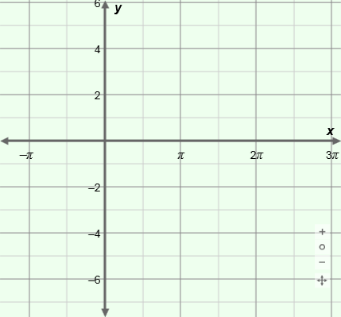

***y* = sin(*x*)**

1. Select **Cosine**. Sketch the graph of   
   *y* = cos(*x*) below. Plot the maximum, minimum, and intercepts.



***y* = cos(*x*)**

1. What are these “key points” on *y* = sin(*x*) and *y* = cos(*x*)? (Fill in the blanks below.)

Points on *y* = sin(*x*): (0, ) (0.5**, ) (**, ) (1.5**, ) (2**, )

Points on *y* = cos(*x*): (0, ) (0.5**, ) (**, ) (1.5**, ) (2**, )

1. What is the maximum value of sine and cosine? What is the minimum?
2. What is the equation of the **midline** (horizontal line that passes through the middle) of each graph?
3. Sine and cosine are *periodic* (repeating) functions. What is their **period** (length of one full cycle of *y*-values)? Turn on **Show amplitude and period** to check.
4. Be sure that **Radians** is still selected. In the Gizmo, set ***k*** to 2 to graph *y* = sin(*x*) + 2.
5. How is the graph of *y* = sin(*x*) + 2 different from the graph of *y* = sin(*x*)?

1. The midline of *y* = sin(*x*) is *y* = 0. What is midline of *y* = sin(*x*) + 2?
2. What is the maximum value of *y* = sin(*x*) + 2? What is the minimum?

Explain why.

**(Activity A continued on next page)**

**Activity A (continued from previous page)**

1. Consider the functions *y* = sin(*x*) – 3 and *y* = cos(*x*) + 4. (Do not graph them yet.)
2. How do you think the graphs of *y* = sin(*x*) – 3 and *y* = cos(*x*) + 4 differ from the graphs of their parent functions, *y* = sin(*x*) and *y* = cos(*x*)? (Complete the sentences.)

The graph of *y* = sin(*x*) – 3 is

The graph of *y* = cos(*x*) + 4 is

Graph *y* = sin(*x*) – 3 and *y* = cos(*x*) + 4 in the Gizmo to check your answers.

1. Vary ***k*** for both sine and cosine. In general, how does *k* change the graphs?

This is a *vertical shift*.

1. Next, set ***k*** to 0, and ***h*** to 0.5**, to graph *y* = sin(*x* – 0.5**).
2. One of the maximum points on *y* = sin(*x*) is at (0.5**, 1). Where is this maximum on the graph of *y* = sin(*x* – 0.5**)? Check in the Gizmo.
3. Next graph *y* = sin(*x* + 0.5**). How does this graph differ from the graph of *y* = sin(*x*)?

1. How do you think the graph of *y* = cos(*x* – 0.25**) will differ from that of *y* = cos(*x*)?

Check in the Gizmo.

1. Vary ***h*** for sine and cosine. The value of *h* translates a graph left or right. (This is a *phase shift*.) In general, how do you know which direction *h* will move a graph?

1. Write a function for each graph below. Then graph your functions in the Gizmo to check.
2. 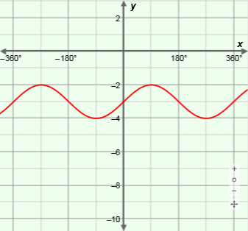

*y* = cos

1. 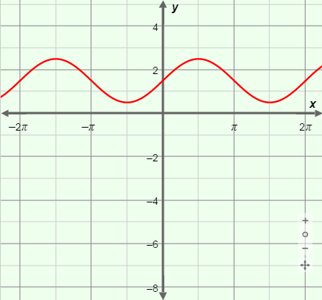

*y* = sin

|  |  |  |
| --- | --- | --- |
| **Activity B:**  **Scaling sine and cosine functions** | Get the Gizmo ready:   * Be sure **Radians** is selected. |  |

1. Under **Select parent function**, select **Sine**, and then **Cosine**. Examine the two graphs.
2. Sketch the graph of *y* = sin(*x*) below. Plot these 5 key points: maximum, minimum, and intercepts.



***y* = sin(*x*)**

1. Sketch *y* = cos(*x*) below. Plot the same 5 key points: maximum, minimum, and intercepts.



***y* = cos(*x*)**

1. Now consider *y* = 2 sin(*x*). How do you think its graph will differ from *y* = sin(*x*)?

Explain why.

In the Gizmo, graph *y* = 2 sin(*x*) to check.

1. Describe the graph of *y* = –0.5 sin(*x*).
2. Think about the function *y* = 6 cos(*x*). (Do not graph it yet.) How do you think the graph of *y* = 6 cos(*x*) will differ from the graph of its parent function, *y* = cos(*x*)?

Check in the Gizmo.

1. Use the slider to try other values of ***a***. Do this for both parent functions, **Sine** and **Cosine**.
   1. The vertical distance from the midline to the maximum of a periodic function is called the **amplitude**. How does the value of *a* relate to the amplitude?

* 1. The amplitude of a function is never negative, even if *a* is negative. Why is this true?

* 1. Why does *a* not move the midline of the graph?

**(Activity B continued on next page)**

**Activity B (continued from previous page)**

1. Next you will explore the value of *b*. Start by graphing *y* = sin(*x*) in the Gizmo. Then slowly drag the ***b*** slider to the right to increase the value of *b*.
   1. How does the graph change?
   2. What point does *not* change as you change the value of *b*?
2. Select **Radians** and set ***b*** to 1, 2, and then 4, to graph *y* = sin(*x*), *y* = sin(2*x*) and *y* = sin(4*x*).
3. What is the period of *y* = sin(*x*)? Of *y* = sin(2*x*)? Of *y* = sin(4*x*)?
4. Select **Cosine**. What is the period of *y* = cos(2*x*)? Of *y* = cos(4*x*)?
5. What do you think is the period of *y* = sin(0.5*x*)? Of *y* = cos(0.5*x*)?

Explain why.

1. Try some negative values of ***b***. How do negative values of *b* affect the graphs?

1. What do you think is the period of *y* = sin(–0.5*x*)? Use the Gizmo to check.
2. Explain why the period is positive even when *b* is negative.

1. In general, how does the value of *b* affect sine and cosine graphs?

1. Fill in the blanks to write a function for each graph. Then check your functions in the Gizmo.

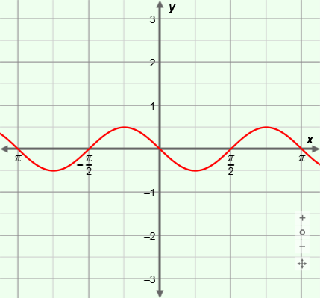

**(0.25**, –0.5)**

*y* = sin

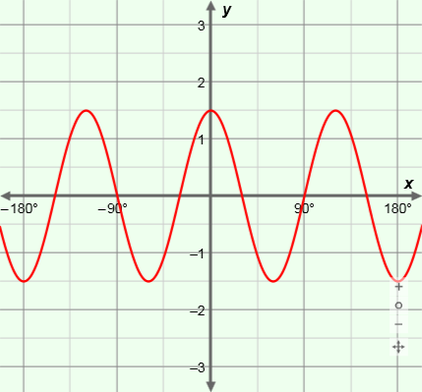

**(0, 1.5)**

*y* = cos

|  |  |  |
| --- | --- | --- |
| **Activity C:**  **Putting it all together** | Get the Gizmo ready:   * Select **Sine** and **Radians**. * Set ***a*** to 2, ***b*** to 1, ***h*** to 0**, and ***k*** to 0. * Turn off **Show amplitude and period**. |  |

1. With the values given above, the function graphed in the Gizmo should be *y* = 2 sin(*x*).
2. What is the amplitude of *y* = 2 sin(*x*)? What is the midline? *y* =
3. 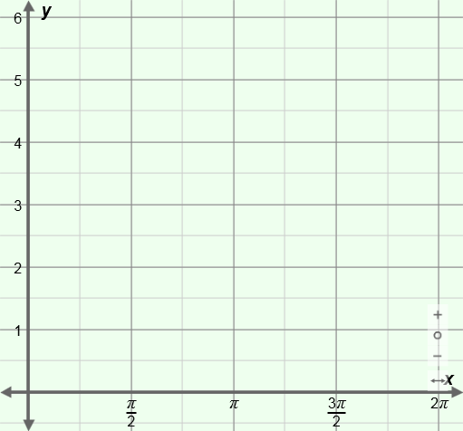Change ***k*** to 3 to graph *y* = 2 sin(*x*) + 3. How does this affect the graph and midline?

1. Sketch the midline of *y* = 2 sin(*x*) + 3 to the right. Then plot and label the 5 “key points” of *y* = 2 sin(*x*) + 3, from *x* = 0 to 2**.
2. Connect the points with a smooth curve to sketch the graph.
3. State the midline, phase shift, amplitude, and period of each of the following sine functions. Then sketch the graph of each function. Check your answers in the Gizmo.
4. 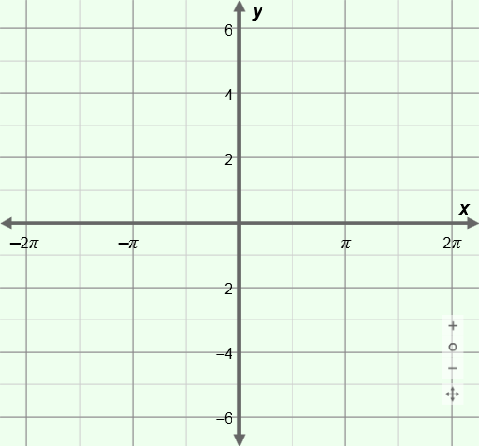*y* = sin(0.5(*x* – **))

Equation of midline:

Phase shift:

Amplitude:

Period:

1. *y* = –sin(0.5(*x* – **)) + 2

Equation of midline:

Phase shift:

Amplitude:

Period:

**(Activity C continued on next page)**

**Activity C (continued from previous page)**

1. State the midline, phase shift, amplitude, and period of each cosine function given below. Then sketch a graph of each function. Check your answers in the Gizmo.
2. *y* = 1.5 cos(*x* + 0.5**)

Midline:

Phase shift:

Amplitude:

Period:

1. *y* = –1.5 cos(2(*x* + 0.5**)) – 2

Midline:

Phase shift:

Amplitude:

Period:

1. The graph of a sine function is shown below. Fill in the blanks below about the graph. Then write a function for the graph.

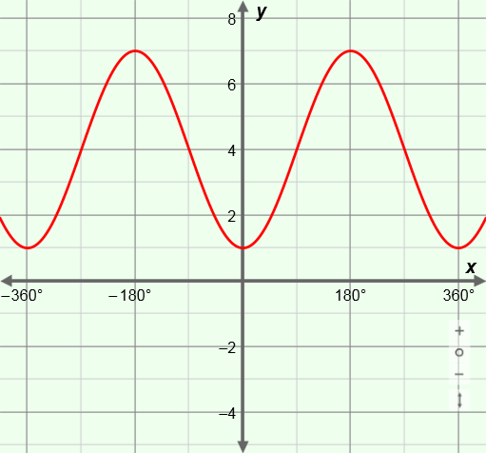Midline:

Phase shift:

Amplitude:

Period:

Function:

Check your answers in the Gizmo.

1. Write 4 different functions (2 using sine and 2 using cosine) with graphs identical to the graph of *y* = sin(*x*).

*y* = *y* =

*y* = *y* =