Name: Date:

**Student Exploration: Translations**

**Vocabulary:** image, matrix, preimage, translation

**Prior Knowledge Questions** (Do these BEFORE using the Gizmo.)



**N**

**E**

**S**

**W**

1. Ron lives at the corner of 2nd Avenue and 4th Street.
2. Mark the location of his home on the map to the right. Label the point “Home.”
3. Ron leaves home and walks 3 blocks east and then 2 blocks south to the library. Mark this point on the map and label it “Library.” Where is the library located?

1. Ron walks from the library to a park at the corner of Norte Avenue and 6th Street. Mark this point on the map and label it “Park.” Describe a path he can take if he makes only one turn.

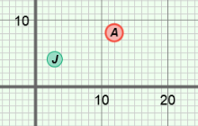

**Gizmo Warm-up**

When you move a point to a different location on the coordinate grid, you are performing a **translation** of the point. The *Translations* Gizmo allows you to translate a variety of figures.

1. Be sure **Point** is selected from the **Figure type** menu.
2. Under **Translation**, drag the ***x*** slider to the right and then to the left. Notice that you now see point *J*. Point *J* is the translated **image** of point *A* (the **preimage**).

How does point *J* move?

1. Now drag the ***y*** slider to the right and left. What happens to point *J*?

1. Drag point *A* around the grid. How does point *J* move?

|  |  |  |
| --- | --- | --- |
| **Activity A:**  **Translating geometric figures** | Get the Gizmo ready:   * Be sure **Point** is selected in the **Figure type** dropdown menu. | 201SE2 |

1. Recall that point *J* is the translation of point *A*.
2. Mouseover point *A*. Look at the **matrix** (rectangular array of numbers) under **Preimage matrix**. How is the preimage matrix related to the coordinates of *A*?



1. What will the preimage matrix look like when point *A* has coordinates (8, 5)? Fill in the blanks to the right, and then check your answer in the Gizmo by entering the numbers under **Preimage matrix**. (Click on a number in the text field, type in a new value, and hit **Enter**.)
2. Under **Translation**, set ***x***to 4 and ***y*** to –2. Mouseover point *J*. How can you use the translation values to get the coordinates of point *J* from the coordinates of point *A*?

1. Select **Segment** from the **Figure type** dropdown menu.
2. How is the preimage matrix related to ?

1. Drag point *A* to (–4, 6) and point *B* to (3, –7). Find the coordinates of points *J* and *K* if ***x*** is set to 7 and ***y*** is set to –3. Show your work. Check your answers in the Gizmo.

Point *J*:

Point *K*:

1. Select **Show ruler** to open both Gizmo rulers. Attach one ruler’s “donuts” to points *A* and *B*, and the other ruler’s “donuts” to points *J* and *K*. What is true about  and ?
2. Drag points *A* and *B* around and experiment with different *x-* and *y*-translation values. Is  always congruent to ? Explain.

**(Activity A continued on next page)**

**Activity A (continued from previous page)**

1. Select **Triangle** from the **Figure type** menu. Under **Translation**, set both ***x*** and ***y*** to 0.



1. Fill in the blanks to the right to show the preimage matrix if the vertices of Δ*ABC* are at *A*(–4, 3), *B*(2, 5), and *C*(–5, –4). Enter the values in the preimage matrix in the Gizmo. Then sketch Δ*ABC* on the grid below.
2. 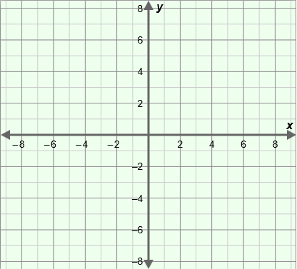Suppose each vertex of Δ*ABC* is translated 5 units to the right and 4 units down to get the vertices of Δ*JKL*. What translation values should you use in the Gizmo to show this translation?

*x* = *y* =

1. Sketch Δ*ABC* and Δ*JKL* on the grid to the right. Then check your graph in the Gizmo.
2. Does Δ*ABC* appear to be congruent to Δ*JKL*?

Check your answer in the Gizmo.

1. Solve each of the following problems. Write your steps in the space below each problem. Then check your answers in the Gizmo.
2. Suppose  is translated 1 unit left and 6 units up to . If the endpoints of  are *J*(–8, –1) and *K*(–3, 7), where are the endpoints of  located?
3. Suppose Δ*ABC* is translated 8 units right and 4 units down to Δ*JKL*. If the vertices of Δ*ABC* are located at *A*(–6, –4), *B*(12, –9), and *C*(8, 10), where are the vertices of Δ*JKL* located?
4. Suppose point *A* is at (7, 4) and point *J* is at (3, 8). Find the *x*- and *y*-translation values needed to translate point *A* to point *J*.

|  |  |  |
| --- | --- | --- |
| **Activity B:**  **Translations and matrices** | Get the Gizmo ready:   * Under **Figure type**, select **Point**. | 201SE4 |

1. With **Point** selected, set the **Preimage matrix** to . Under **Translation**, set ***x*** to 8 and ***y*** to 4. Examine the matrix equation displayed above the graph.
2. Compare the first matrix to the **Preimage matrix**. What do you notice?

1. How do the elements in the second matrix relate to the *x*- and *y*-translation values?

The second matrix is the *translation matrix*.

1. How do the elements in the third matrix relate to the coordinates of point *J*?

The third matrix is the *image matrix*.

1. How does each element in the image matrix relate to the corresponding elements of the preimage and translation matrices?

1. Experiment with other points and translations in the Gizmo. Is the image matrix always the sum of the preimage matrix and the translation matrix?
2. Select **Segment** from the **Figure type** menu.
3. Notice that the translation matrix now has 2 rows and 2 columns, and that the numbers in each row are the same. Why does this happen?
4. What do you think the translation matrix for a triangle will look like?

Select **Triangle** from the **Figure type** menu to check.

**(Activity B continued on next page)**

**Activity B (continued from previous page)**

 +  = 

1. The matrix equation shown to the right describes a translation.
2. 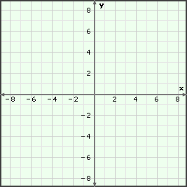What type of figure is being translated?

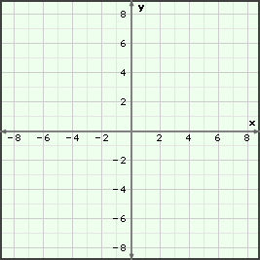

***A***

***B***

***C***

***J***

***K***

***L***



***A***

***B***

1. Look at the translation matrix. How does the translation matrix tell you to move the figure?

1. Sketch the preimage (Δ*ABC*) and image (Δ*JKL*) on the grid to the right. Check your answer in the Gizmo.
2. Segment *AB* shown on the grid to the right is translated 7 units right and 8 units down to .
3. In the space below, write the matrix equation for zthis translation.
4. Use the image matrix to help you sketch  on the grid. Check your answer in the Gizmo.
5. In the space below, write the matrix equation for the translation shown on the graph to the right (Δ*ABC* is the preimage). Check your answer in the Gizmo.