Vocabulary: Trebuchet

Vocabulary

- Air resistance – the force air exerts on a moving object.
  - Air resistance is also called drag.
  - Air resistance increases as the speed of the object increases and as the surface area of the object increases.

- Counterweight – a weight that balances another weight or force.
  - On a trebuchet, the counterweight is usually very heavy and is attached to the short arm of the trebuchet.

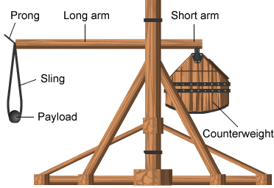
- Counterweight trebuchet – a siege engine that uses the force of gravity to hurl projectiles.
  - In a counterweight trebuchet, the payload is secured in a sling attached to the long arm. When the trebuchet is fired, the counterweight falls, swinging the long arm and sling. As it swings, one end of the sling detaches from the prong to launch the payload.

- Efficiency – the percentage of input energy (or work) that is converted to output energy.
  - The efficiency of a trebuchet can be estimated by dividing the total energy of the projectile at launch by the change in energy of the counterweight.

- Gravitational potential energy – the energy an object has because of its position relative to a gravitational field.
  - Gravitational potential energy depends on mass, height, and the strength of gravity at that point.
  - On Earth’s surface, the formula for gravitational potential energy is GPE = mgh where m is mass, g is gravitational acceleration (9.8 m/s² on Earth’s surface), and h is height.

- Kinetic energy – the energy an object has because of its motion.
  - The faster an object moves, the greater its kinetic energy is.
  - The formula for kinetic energy is KE = m • v², where m is mass and v is velocity (or speed).

- Launch angle – the angle that a projectile’s initial path makes with the launch surface.

- Payload – the mass that a device is designed to transport.

- Projectile – an object that is thrown by a force.
  - Examples of projectiles include cannon balls, bullets, arrows, and baseballs. In the Trebuchet Gizmo™, the projectile is a boulder.
  - The payload of a trebuchet becomes a projectile once it is launched into the air.

- Siege engine – a device designed to attack fortified walls during a siege.
  - Examples of siege engines include battering rams, siege towers, catapults, and trebuchets.

- Torque – a twisting force that causes rotation.
  - The torque on a rigid beam is equal to the perpendicular force on the beam multiplied by the distance between the force and the center of rotation, or fulcrum.

