Vocabulary: Triangle Inequalities

dictionary2

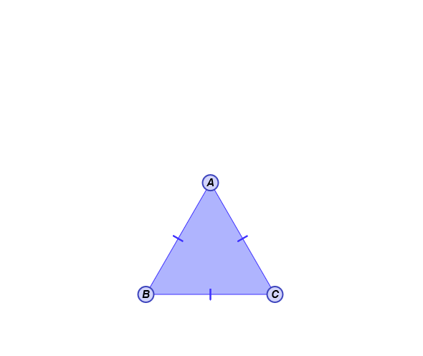**Vocabulary**

* Equilateral – having all sides congruent.
* An *equilateral triangle* has three congruent sides.
* For example, Δ*ABC* shown to the right is equilateral.
* Inequality – a statement showing that one quantity or expression is greater than (>) or less than (<) another quantity or expression.
* 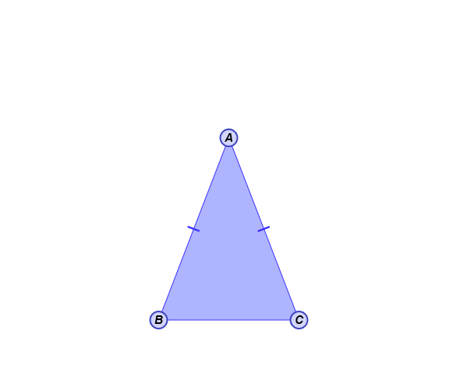For example, 8 > 2, and also 5 < 2 • 3.
* Isosceles – having at least two sides congruent.
* An *isosceles triangle* has at least two congruent sides.
* For example, Δ*ABC* shown to the right is isosceles.