Name: ______________________________________ Date: ________________________

Student Exploration: Vectors

Vocabulary: component, dot product, magnitude, resultant, scalar, unit vector notation, vector

Prior Knowledge Question (Do this BEFORE using the Gizmo.)

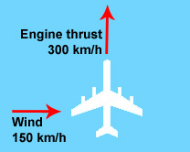
An airplane is traveling north at 300 km/h. Suddenly, it is hit by a strong crosswind blowing 150 km/h from west to east.

Draw an arrow on the diagram showing the direction you think the plane will most likely move. Explain your answer.

__________________________________________________

__________________________________________________

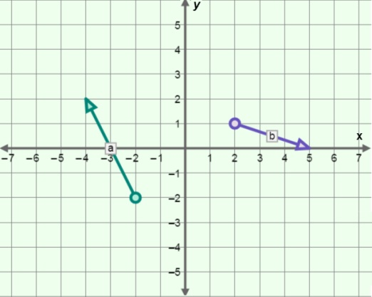
Gizmo Warm-up
Displacement, velocity, momentum, acceleration, and force are all examples of quantities that have both direction and magnitude. Anything with direction and magnitude can be represented using a vector.

Look at vectors a and b on the Vectors Gizmo grid. The initial point of each vector is shown with a circle. The terminal point of each vector is located at the tip of the arrow. Each vector is described by two components: the i component and the j component.

- The two components written together make up the unit vector notation. What is the unit vector notation of vector a? ___________________________________________________

- Move the initial point of vector a to the origin (0, 0) on the grid.
    - How did the components of vector a change? _______________________________
    - Drag the terminal point of vector a so that it lines up with the x-axis. Which component describes the vector’s position along the x-axis? ___________________
    - Drag the terminal point of a so that it lines up with the y-axis. Which component describes the vector’s position along the y-axis? ____________________________
Activity A:  Vector magnitude and angle | Get the Gizmo ready:  - Change vector a so that its notation is 0i + 3j.  - You will need a scientific calculator for this activity. | 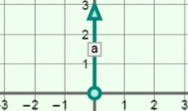

Question: How can you determine a vector’s magnitude and angle?

- Observe: The magnitude of a vector is the distance from the vector’s initial point to its terminal point. The magnitude of a vector is written: ||x||. Magnitude is a scalar, or a number that does not indicate direction.

- What is the magnitude of vector a? ||a|| = ______________
Turn on Show ruler and use the ruler to check your answer.

- Turn off the ruler. Drag the tip of vector a so that its notation is 4i + 3j. What do you think the magnitude of vector a is now? ||a|| = ______________

- Explore: A vector can be broken down into perpendicular vectors that describe its length along the x and y axes. Turn on Show x, y components. How do the x and y vectors that appear for vector a relate to the i and j notation?

_________________________________________________________________________

_________________________________________________________________________

- Calculate: The x, y components of vector a form the two sides of a right triangle. The length of the hypotenuse of that triangle will equal the length (and, thus, the magnitude) of vector a.

The Pythagorean theorem states that for a right triangle, the square of the hypotenuse equals the sum of the squares of the other two sides:

(length of hypotenuse)² = (length of one side)² + (length of other side)²

Use the Pythagorean theorem to calculate the magnitude of vector a.

||a|| = ______________

Turn on Show ruler and use the ruler to check your answer.

- Apply: What are the magnitudes of the following vectors?

||3i – 5j|| = _________ ||–1i – 2j|| = _________ ||–14i + 3j|| = _________

(Activity A continued on next page)
Activity A (continued from previous page)

- Identify: Besides a quantity’s magnitude, vectors also indicate direction. For example, on the Gizmo’s grid, suppose the y-axis represents displacement to the north or south and the x-axis represents displacement to the east or west. Reposition vector a so that its notation reads 0i + 3j.

What is the direction of vector a: north, south, east, or west? _________________________

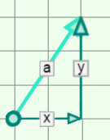
- Calculate: Move vector a so that its notation is 2i + 3j. Vector a now has a direction that is difficult to describe using words. However, the direction of vector a can be described as an angle (θ) away from the x-axis.

Remember that the x, y components of vector a form the two sides of a right triangle. For a right triangle, the tangent (tan) of any of the triangle’s angles is equal to the ratio of the opposite and adjacent sides:

From this equation, you can derive the following formula for the angle of vector a:

Use a scientific calculator to find the angle of vector a: θ = ____________

This is the angle between vector a and the x-axis (or east-west direction). Note that because the magnitudes of x and y are always positive, the angle of the vector relative to the x axis is positive as well.

- Check your work: To check your calculation, select Show angle measure tool. Place the protractor’s center circle on the initial point of vector a. Place one end of the protractor on the terminal point of the x component and the other end on the terminal point of vector a.

What is the angle of vector a? ____________

- Apply: What are the angles of the following vectors?

3i – 5j: –i – 2j: –14i + 3j:

θ = ________ θ = ________ θ = ________

Activity B:  Vector Sums | Get the Gizmo ready:  - Turn Show x, y components off.  - Place the initial points of vectors a and b on (0, 0).  - Set the vectors so that a = 5i + j and b = –i + 3j. | 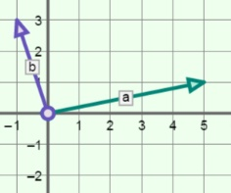

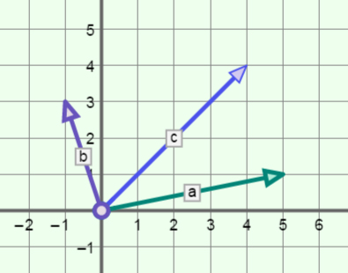
Question: How can you add vectors together?

- Predict: Suppose a boat is crossing a river with a swift current. In the diagram, vector a represents the speed and direction of the boat relative to the water, and vector b represents the speed and direction of the current.

On the grid at right, draw a vector to represent the resulting motion of the boat.

- Observe: Turn on Show resultant. Vector c is the resultant, or the sum of vectors a and b. The resultant represents the total motion of the boat.

- What is the angle of vector c? ___________________________________________

- Select Show ruler. What is the magnitude of vector c? ___________

- Analyze: Turn off the ruler. Shift vector b so that its initial point is on the terminal point of a.

- What do you notice about the terminal point of b? ___________________________

___________________________________________________________________

- Move b back to the origin, and shift a so that its initial point is on the terminal point of b. What do you notice? ________________________________________________

___________________________________________________________________

- Infer: Now, look at the i and j components for vector c.

- How is the i component of the resultant vector c related to the i components of vectors a and b? _____________________________________________________

- How is the j component of the resultant vector c related to the j components of vectors a and b? _____________________________________________________
(Activity B continued on next page)
Activity B (continued from previous page)

- Make a rule: How do you think the notation of c can be found using those of a and b?

_________________________________________________________________________

_________________________________________________________________________

- Apply: Suppose a = 2i – 3j and b = 4i + 0j.

- Without using the Gizmo, find the resultant of adding these two vectors.

___________________________________________________________________

- Turn on Show sum computation. Were you correct? If not, what was the actual resultant? ___________________________________________________________

- Solve: Find the sums of the following vectors.
a = 5i – 8j and b = –4i – 2j a = 28i + 14j and b = 10i – 3j
c = _________________ c = _________________

a = 3i + 12j and b = –2i + 16j a = 5i – 11j and b = –6i – 7j
c = _________________ c = _________________

a = i – j and b = –i – j a = 15i + 10j and b = 10i – 20j
c = _________________ c = _________________

- Explain: Move the vectors so that a = –2i – 3j and b = 2i + 3j. Why does the resultant vector c no longer have an arrow? ___________________________________________________
_________________________________________________________________________

When two vectors cancel each other out they are said to be in a state of equilibrium.

- Identify: Name another pair of vectors that would create a state of equilibrium.

_________________________________________________________________________

Activity C:  Dot products | Get the Gizmo ready:  - Turn off Show resultant.  - Set the vectors so that a = 2i – 3j and b = 4i + 5j. | 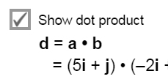

Introduction: While vector addition is straightforward to understand and apply, vector multiplication is not. There are several ways to express the product of two vectors, including the dot product.

Question: What is a dot product?

- Describe: Turn on Show dot product and examine the calculation shown on the Gizmo.

How is a dot product found? __________________________________________________

_________________________________________________________________________

_________________________________________________________________________

_________________________________________________________________________

- Explore: Turn off Show dot product. For each combination of vectors listed in the table below, calculate the dot product. Then sketch the two vectors in the space below. Check each calculation by turning on Show dot product.

Case | a | b | a • b
1 | 3i – 2j | 3i – 2j
2 | 3i – 2j | 2i + 3j
3 | 3i – 2j | –3i + 2j
4 | 3i – 2j | –2i – 3j

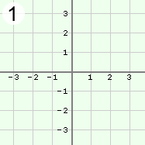 | 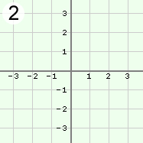 | 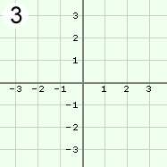 | 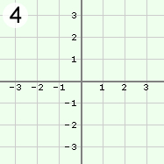

(Activity C continued on next page)
Activity C (continued from previous page)

- Analyze: Look at the dot products and sketches on the previous page.

- What is the dot product of two vectors at right angles? ________________________
- What do you notice about the dot product when the angle between the vectors is obtuse? ____________________________________________________________
- Use the Gizmo to confirm these two rules. Do they hold true generally? __________

- Challenge: A second way to find the dot product of two vectors is to multiply the magnitudes of the vectors, then multiply this product by the cosine (cos) of the angle (θ) between them:

a • b = ||a||·||b||cos(θ)

The dot product can be used to find the angle between two vectors. Rearrange the terms of the equation above to solve for the angle between vectors a and b.

What is the angle between a and b if a = 3i + 4j and b = 12i + 5j? _____________________

Show your work in the space below.

- Apply: One application of the dot product is to calculate how much work is done on an object by a force. Work, a scalar quantity, is the product of force and displacement, both vector quantities (W = F • d). The unit for work is the joule (J).

Suppose vector a represents a force of 3i + 4j newtons that is applied to a model train on a track. Vector b represents the train’s displacement and is equal to 12i + 5j meters.

How much work was done on the object? _____________________

Show your work in the space below.

