Name: ______________________________________ Date: ________________________

Student Exploration: Virus Lytic Cycle

Vocabulary: bacteriophage, capsid, host cell, lyse, lytic cycle, virus

Prior Knowledge Questions (Do these BEFORE using the Gizmo.)

- A computer virus is a program that can copy itself and infect a computer without the permission of the owner. How do you think a computer virus compares to a real virus?

_________________________________________________________________________

_________________________________________________________________________

- Have you ever been infected with a virus, such as the cold virus or flu virus? ____________

- If so, how did the virus affect you? _____________________________________________

_________________________________________________________________________

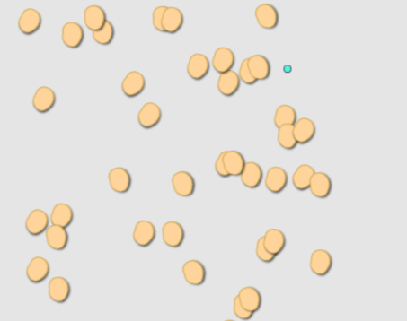
Gizmo Warm-up
A virus is a microscopic particle that can infect a cell. Viruses are primarily composed of a protein coat, called a capsid, and nucleic acid. In the Virus Lytic Cycle Gizmo™, you will learn how a virus infects a cell and uses the cell to produce more viruses.

- Viruses are extremely small. A typical virus is about 100 times smaller than a single cell, such as a bacterium. Label the virus and a bacterial cell in the image at right.
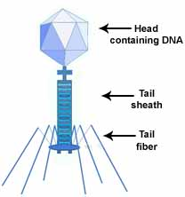
- Bacteriophages are viruses that infect bacteria. Based on the diagram at left, label the head, tail, tail fibers, and the strand of nucleic acid in the image at right.

Activity A:  Lytic cycle | Get the Gizmo ready:  - If necessary, click Reset ().

Introduction: Unlike living organisms, viruses cannot reproduce on their own. Instead, viruses infect host cells, taking over the cell’s machinery to produce more viruses. This process is called the lytic cycle.

Question: What are the steps of the lytic cycle?

- Observe: Use the navigation arrows on the DESCRIPTION tab to read about the stages of the lytic cycle. Using your own words, summarize each step of the cycle.

Step |  | Summary
1
 |  | ↓
2 | 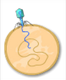
 |  | ↓
3 | 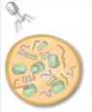
 |  | ↓
4 | 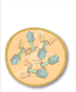
 |  | ↓
5 | 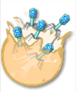

(Activity A continued on next page)
Activity A (continued from previous page)

- Analyze: The yellow ring inside the bacterial cell represents the bacterial DNA. Why does this structure disappear by step 3 of the lytic cycle?

_________________________________________________________________________

_________________________________________________________________________

- Describe: How does a virus destroy the host cell’s DNA? ____________________________

_________________________________________________________________________

_________________________________________________________________________

- Describe: How are new viruses reproduced? _____________________________________

_________________________________________________________________________

_________________________________________________________________________

_________________________________________________________________________

- Think and discuss: Why can’t a virus reproduce on its own? _________________________
_________________________________________________________________________

_________________________________________________________________________

- Justify: To lyse is to burst apart or explode. Why do you think a virus’s reproduction cycle is called the “lytic cycle”?

_________________________________________________________________________

_________________________________________________________________________

_________________________________________________________________________
Activity B:  Spread of infection | Get the Gizmo ready:  - If necessary, click Reset.

Question: How does a viral infection spread?

- Predict: Suppose that a virus infects a small population of bacteria. Predict how the numbers of viruses, infected cells, and uninfected cells will change as the infection progresses. On the blanks below, write increase, decrease, or stay the same.

Viruses: _______________________ Infected cells: _______________________

Uninfected cells: _______________________

- Observe: Click Play (), and watch the simulation. Describe what you see.

_________________________________________________________________________

_________________________________________________________________________

- Test: Click Reset, and Select the BAR CHART tab. Turn on Show numerical values. Click Play, and watch each bar as the simulation runs. What do you notice, and how does this compare to your predictions?

_________________________________________________________________________

_________________________________________________________________________

_________________________________________________________________________

- Record data: Select the TABLE tab, and use the data to complete the second column of the table below. To complete each cell in the third column, subtract the previous time value from the current time value. For example, if it took 80 minutes to reach 40 cells and 100 minutes to reach 30 cells, then the time difference is 20 minutes.

Number of  healthy cells | Time (minutes) | Amount of time to decrease population by 10
50 | 0 minutes | --
40
30
20
10

(Activity B continued on next page)
Activity B (continued from previous page)

- Analyze: What trend do you see in the third column of your data table? ________________ _________________________________________________________________________
_________________________________________________________________________

- Explain: How would you explain this trend? ______________________________________

_________________________________________________________________________

_________________________________________________________________________

- Interpret: Select the GRAPH tab. Run the Gizmo again, and observe what happens in the SIMULATION pane when the graph shows a decrease in the viruses’ population size.

    - Why does the number of viruses sometimes increase and sometimes decrease?

___________________________________________________________________

___________________________________________________________________

    - Sometimes when a virus enters a cell, it becomes dormant for a while. Why might this make it difficult for a doctor to diagnose a viral infection?

___________________________________________________________________

___________________________________________________________________
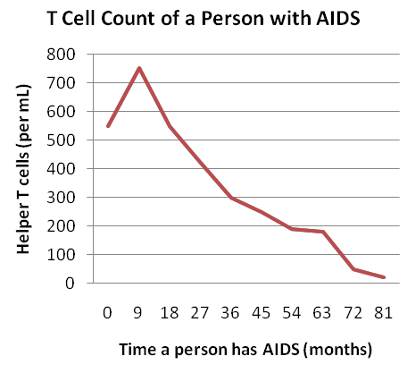

- Extend your thinking: AIDS is one disease caused by a virus infection. The virus attacks immune system cells known as T cells.

Based on your observations from the Gizmo, how would you explain the data shown on this graph?

____________________________________

____________________________________

____________________________________

_________________________________________________________________________

_________________________________________________________________________

