Name: ______________________________________ Date: ________________________

Student Exploration: Water Cycle

Vocabulary: aquifer, condensation, evaporation, freezing, glacier, melting, phase change, precipitation, reservoir, runoff, transpiration, water cycle

Prior Knowledge Question (Do this BEFORE using the Gizmo.)

The water that comes out of your faucet at home used to be in the ocean. How did water get from the ocean to your water faucet? ______________________________________________
____________________________________________________________________________

____________________________________________________________________________

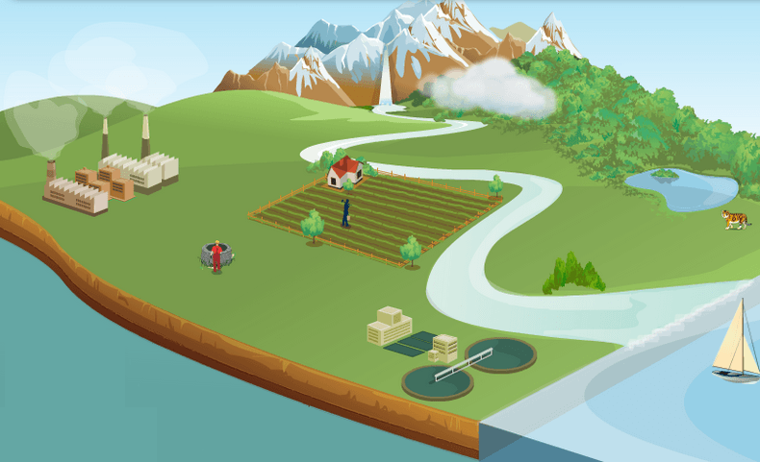
Gizmo Warm-up
Water on Earth is always in motion. These motions form a repeating circuit called the water cycle. The Water Cycle Gizmo allows you to explore the different paths water takes as it moves from Earth’s surface to the atmosphere and back.

- Click Oceans. What percentage of Earth’s water is found in the oceans? _______________________

- Click Atmosphere. How does the Sun cause water to move from the oceans to the atmosphere? ______________________________________________________________

- Click Clouds. How do clouds form? ____________________________________________

- Click Precip (rain). (“Precip” is short for precipitation, or water falling to Earth’s surface.)

What causes it to rain? ______________________________________________________

- Click Oceans again, and then choose the PATH tab. Because it has the same beginning and end, the path is a complete cycle. How many steps does this cycle have? ___________
Activity:  The water cycle | Get the Gizmo ready:  - Select the SIMULATION tab, and click Reset. | 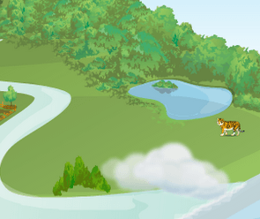

Question: What are the parts of the water cycle?

- Collect data: Create two water cycles using the Gizmo. Each cycle should have at least four steps and should begin and end at the same location. Choose any starting point from the list on the right. When the cycle is complete, choose the PATH tab and write the steps below.

Cycle 1: ________________________________________________________________

________________________________________________________________

Cycle 2: ________________________________________________________________

________________________________________________________________

- Analyze: Use the information presented in the Gizmo to answer the following questions.

    - What percentage of Earth’s water can be found in soil? _______________________

    - What percentage of Earth’s water is stored in ice and snow? ___________________

    - What percentage of Earth’s fresh water is stored in ice and snow? ______________

    - What percentage of Earth’s water is found in lakes? _________________________

    - What is transpiration? (Hint: Click the Vegetation button.) ____________________

___________________________________________________________________

    - What human activity uses the most water worldwide? ________________________

    - What human activity uses the most water in the United States? _________________

    - What organisms break down chemical wastes in a treatment plant? _____________

    - What is an aquifer? ___________________________________________________

    - What is a reservoir? __________________________________________________

    - In what ways can runoff be a problem? ___________________________________

___________________________________________________________________

(Activity continued on next page)
Activity (continued from previous page)

- Define: A phase change is a change from one state to another, such as from a liquid to a gas. Based on what you have read in the Gizmo, fill in the blanks with the words “liquid,” “gas,” or “solid” to define each change.

Evaporation: Change from a _______________ to a _______________.

Condensation: Change from a _______________ to a _______________.

Melting: Change from a _______________ to a _______________.

Freezing: Change from a _______________ to a _______________.

- Practice: Fill in the process that causes each transition. Your choices are evaporation, condensation, precipitation, melting, and freezing.

    - Ocean Atmosphere _______________________

    - Atmosphere Clouds _______________________

    - Cloud Snow _______________________

    - Glacier (river of ice) River _______________________

    - Cloud Soil _______________________

- Practice: Fill in the two processes that cause each of the following transitions.

    - Ocean Cloud _______________________, _______________________

    - Cloud Glacier _______________________, _______________________

- Think and discuss: Water covers over two-thirds of Earth’s surface. Yet water shortages are a major problem for many people around the world. Why do you think this is the case?

_________________________________________________________________________

_________________________________________________________________________

_________________________________________________________________________

_________________________________________________________________________

_________________________________________________________________________

_________________________________________________________________________

